

Dear Candidate,

Required from 6th January 2025 to support our students at South Devon University Technical College (SDUTC is part of Education South West).

The South Devon UTC is looking foran Intervention Teacher who will to coordinate, undertake and lead on reading and numeracy intervention provision across key stage 4.

***We are keen to recruit like-minded people who go above and beyond for the sake of our students to ensure that they fulfil their potential****.*

*This is an exciting opportunity to join our team which has a strong sense of purpose and enjoys variety and challenge.*

What we can offer you:

* The opportunity to work in a small specialist college where all staff are viewed as part of the family.
* Somewhere where leaders look after you as well as encourage you to pursue your aspirations and goals.
* A college where the learning experience focused on technical and employability skills for young people is the centre of everything that we do.
* A college with a healthy view of work life balance

If you are interested in joining us please email your completed application to: [Julie.scagell@southdevonutc.org.uk](mailto:Julie.scagell@southdevonutc.org.uk) on **21/10/24 at 9.00am** with interviews likely to take place on **25/10/24.**

ESW is committed to safeguarding and protecting the welfare of children, and applicants must be willing to undergo child protection screening appropriate to the post, including checks with past employers and an enhanced disclosure via the Disclosure and Barring Service.

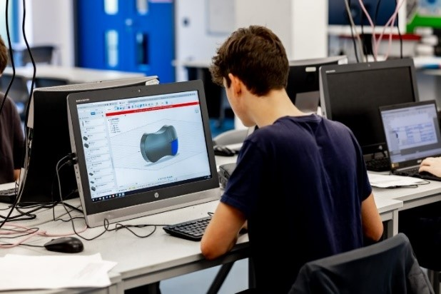



**Job description**

Post title: Intervention Teacher

Start date: 6.1.25

Contract: Fixed term till 31.8.26

Salary point: M6/UPS1

Contract type: 0.60 fte

Responsible to: Deputy Headteacher

**Role description**

To coordinate, undertake and lead on reading and numeracy intervention provision across key stage 4.

**Key responsibilities.**

* To devise, in collaboration with the senior leadership team and SEND lead, reading and numeracy intervention programmes
* To undertake small-group and/or one-to-one interventions with targeted students to enable them to make progress in their literacy and numeracy.
* To train colleagues across the UTC in how to support struggling readers within their curriculum areas
* To liaise with the SEND team and SLT Raising Standards lead to plan and implement a suitable phonics programme as an intervention tool to ensure students are supported in improving their vocabulary skills.
* To work with the English department to ensure there are appropriate texts in the library and included in the Tutor Reading Programme
* To support the completion of baseline reading and numeracy tests at the start of the year and the subsequent re-testing of readers to monitor progress and implement timely and effective interventions.
* To analyse reading assessment data to monitor the development of reading across pupil cohorts and to ensure interventions remain appropriate to need
* To work alongside learning support mentors to ensure cohesion across all three departments and that data intervention details are shared effectively.
* To promote and support activities which nurture an appreciation of reading for pleasure

**Other duties**

* To follow the UTC ICT Policy for the safe use of ICT.
* To be aware of and assume the appropriate level of responsibility for safeguarding and promoting the welfare of children and to report any concerns in accordance with the Trust’s safeguarding policy.
* To comply with legislation, policies and procedures related to confidentiality and data protection, reporting any concerns to the appropriate person.
* To work in compliance with the codes of conduct, regulations and policies of the Trust and its commitment to equal opportunities.
* To comply with the trusts, health and safety policy and statutory requirements as detailed in the Health and Safety at Work Manual.
* To recognise own strengths and areas of expertise and use these to advise and support others and undertake any training and personal development identified by your line manager.
* To undertake any other duties deemed appropriate by their teacher.
* To contribute to the values and strategic direction of the UTC
* Attend and participate in meetings as directed.

**How to apply:**

**Application deadline**

Completed applications must be received by

Please submit your application to Julie Scagell [Julie.scagell@southdevonutc.org.uk](mailto:Julie.scagell@southdevonutc.org.uk)

**Completing your application**

Candidates are asked to complete all the standard information required on the application form, and to submit a supporting statement outlining your suitability for the role.

The Governors are committed to safeguarding and promoting the welfare of children and applicants must be willing to undergo child protection screening appropriate to the post, including checks with past employers and an enhanced disclosure via the Disclosure and Barring Service.

It is the Governors’ Policy to ask to see original certificates for all qualifications of A Level or equivalent, and above, at interview.

**Discussion and visits**

Informal discussions with the Headteacher are welcomed, as well as visits to the college.  Please arrange a suitable time with Julie Scagell [Julie.scagell@southdevonutc.org.uk](mailto:Julie.scagell@southdevonutc.org.uk)  Telephone:  01626 240201

**References**

Candidates are advised that online checks will be made as part of the shortlisting process.  References will be taken up immediately after shortlisting. Candidates are asked to ensure that their referees are informed of the need to respond within the timescale set. In all cases, at least one professional reference is required.

The post will be offered subject to satisfactory completion of pre-employment checks.

**Welcome to South Devon UTC**

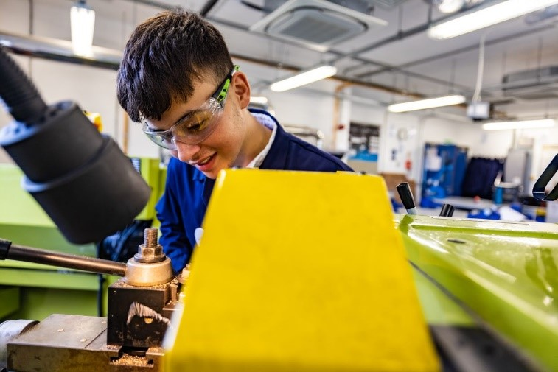

At 14-16 (Key Stage 4) we provide a core education in GCSEs English, Maths and Double Science as well a specialist technical route in either in Engineering, Health Sciences or Digital Technology (from September 2022). In the Sixth Form (Key Stage 5) students can continue the same three pathways following courses up to an equivalent of 3 A Levels.

The primary focus of our UTC is to provide students with an educational experience which prepares them for employment in either engineering, health or the world of digital technology. These three industries provide huge employment opportunities for young people when they leave college or university. A UTC education is built upon the principles of employability and the skills required to be successful at work.

What makes our education pathways different is that our curriculum is built to work in partnership with employers. A range of industrial and university partners provide experiences for students which stretch beyond the college setting.

South Devon UTC opened in 2015 as an engineering centre with specialist equipment which enriches and enhances the educational experience for students. Since March 2021 the UTC has become part of Education South West, a large multi academy trust stretching across South Devon. This new partnership has resulted in significant investment to develop facilities and provide new pathways in Health Sciences.

**Our Vision**

Developing a new generation of Engineers, Health Scientists and Digital Technology leaders who will transform the world we live in.

**Our Mission**

To present to the workforce resilient students who are competent, technically capable and innovative contributors to a just and tolerant society.

**A Unique Learning Experience**

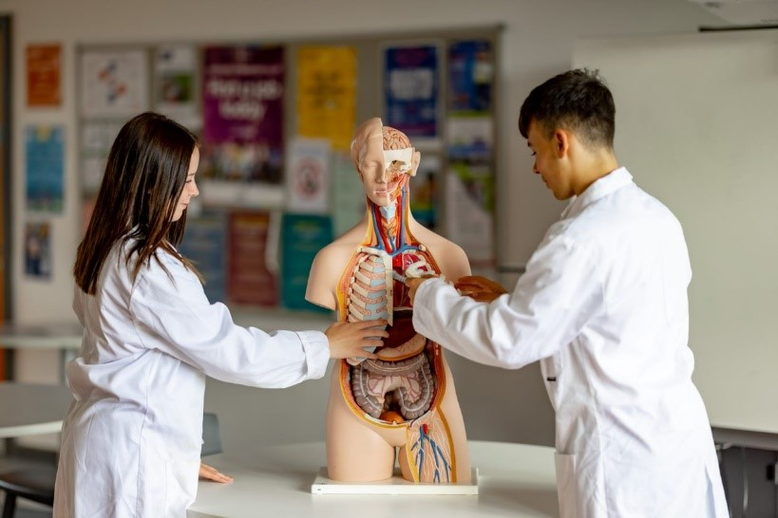

South Devon UTC will provide excellent standards of academic and technical education and a high quality, inspirational and unique learning experience.

**Successful Progression**

Students will have an opportunity to gain the qualifications, skills and experience needed to progress successfully to university, higher level apprenticeship or employment.

**An Exciting Alternative**

South Devon UTC promises to offer an exciting alternative, providing a bright future for young people, employers locally, nationally and internationally.

**Education South West (ESW)**

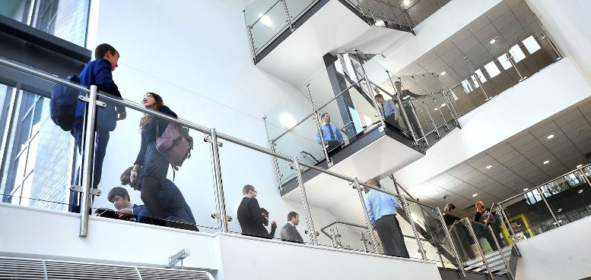

Thank you for your interest in Education South West - we are always on the lookout for exceptional talent to join us and contribute to our team of creative education professionals.

At Education South West we believe that education makes children’s lives better. We believe that every child has the right to achieve all that they are capable of and more, regardless of their background or raw ability.

Across all our colleges our staff aim to provide an educational experience which is outstanding; our colleges all believe strongly in the power of and broad and balanced curriculum. Sport, art, technology drama and music play a key role in all our colleges.

We encourage innovation, creativity, and individuality. By sharing this individuality and creativity we believe that colleges and communities become stronger through unity and collaboration.

We are caring and compassionate. Every individual in our colleges matters and we believe strongly that children and staff should enjoy their time at college, and work. A positive can-do attitude to their work and study is necessary. The happier and more stimulated a person is the more motivated they are to improve.

We believe in developing a positive attitude to learning and to life, in having clear goals and in providing a supportive environment to help the realisation of these.

We support and challenge our college leaders and the staff in our colleges to be the best they can, leading effective teams at every level, growing future leaders, and working together to provide an exciting education for all.

We welcome and support aspirational and ambitious teachers and classroom support staff, dedicated to supporting children through their time at college.

We offer excellent opportunities and professional development through in-college CPD, our Research College status, through our teaching colleges and through our links with the wider education community. We are ambitious for our children and our employees and always looking to support, challenge and develop talent, whatever stage you are in your career.

When recruiting staff to work with children we place immense importance on:

* people who go the extra mile.
* a commitment to professional development and a desire to continue learning, via research, private study and in learning from others.
* a desire to ensure that everything that is done within colleges is the best it can be.
* a firm commitment to the philosophy that we work in education to improve young people’s lives and improve society; we serve our communities and the wider populace.
* the ability to develop positive relationships with pupils, students, and parents.
* good interpersonal and communication skills when liaising with stakeholders.
* a good sense of humour.
* a commitment to working in partnership with others and sharing selflessly best practice within and outside of ESW.

Your journey with ESW starts here and we look forward to meeting you in the future.

**Special Educational Needs Team**

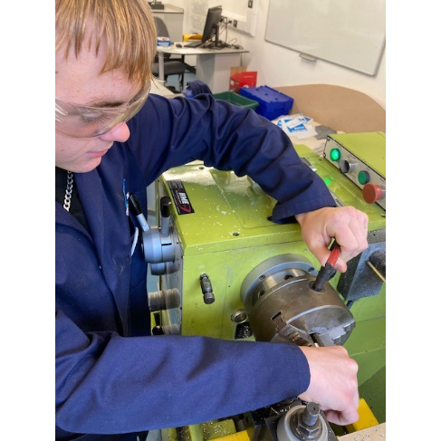

South Devon UTC is a small but growing specialist technical college. We deliver a core curriculum of English, Maths, Science, PE and PSHE alongside specialist qualifications in Engineering and Health Care Sciences. We will be introducing a digital pathway from September 2022.

**THE COLLEGE’S FACILITIES**

The South Devon UTC is situated in Newton Abbott. It was a brand-new specialist facility which opened in 2015. It has specialist facilities in Engineering, Health Care Sciences and IT. All of the curriculum is delivered in modern well-equipped classrooms.

**STAFF AND STUDENTS OF THE College**

 All staff are considered leaders within the college and given the opportunity to participate in the decision-making process through regular team, pastoral and staff meetings – and whole college events.  UTC teachers are expected to link with their specialist teams at Coombeshead Academy.

Relationships between staff and students here are excellent. We see evidence of this in the time which staff devote to giving students individual help outside of classes and the time and energy they commit to trips. Our students are well motivated and responsible, and we receive many plaudits when they are active on visits.

**CONTINUING PROFESSIONAL DEVELOPMENT**

We are very clear in our belief that the staff are our best resource and invest a lot of time and resources in continuous professional development.  We place a great deal of importance in supporting trainee teachers and NQTs.  All our NQTs have an individual curriculum team-based mentor as well as mentoring from the Professional Development Leader.  We do our absolute best to offer all our staff a continuous training programme as their career enters various stages from NQT through to preparation for middle and senior leadership, and then on eventually to headship.  Our policy is to train our own staff who can then lead others.