

Upper Nidderdale Primary Federation
Glasshouses Community Primary School
St Cuthbert’s CE Primary School – Pateley Bridge

GTA KS1 & KS2
Interventions Teaching Assistant
to work across both schools in the federation

CONTENTS

Headteacher’s letter

Welcome to The Upper Nidderdale Primary Federation

How to Find Us
Job Description & Person Specification

HEADTEACHER’S LETTER

Dear Applicant

On behalf of the pupils, parents and staff of The Upper Nidderdale Primary Federation may I say thank you for your interest in the role of GTA (Learning Support Leader) at the Upper Nidderdale Primary Federation.

I have been fortunate enough to be the Executive Headteacher of the federation since April 2021 and at Glasshouses Community Primary School since 2017. Our schools are great places to be, with a team of people who all work together with the children’s learning and wellbeing at the heart of everything they do. It is an exciting time to be a part the federation as we continue to explore the many opportunities for our children and staff to work together and learn from each other, it is a privilege to work within this community.

Our schools are a mix of a Community and a Church of England School, we have close links with both our local community and local Church and we expect all staff to respect and uphold our school values.

We encourage all prospective candidates to come and visit our school where you will receive a warm welcome. You will find details of how to contact us within this application pack.

Once again, thank you for your interest in the role and we look forward to receiving your application - Good luck!

Nicola Thornber
Executive Headteacher
WELCOME TO OUR FEDERATION

Glasshouses
At Glasshouses we have three Classes:
Class 1 – Early Years/KS 1
Class 2 – KS1/ lower KS2
Class3 – upper KS2

St Cuthbert’s
At St Cuthbert’s we have three classes:
Class 1 – Nursery, Reception and Year 1
Class 2 – KS1/lower KS2
Class 3 – KS2

Our Federation offers a vibrant and inspirational curriculum underpinned by a unique ethos of kindness and care for all pupils. We are proud to be recognised for our commitment and work as Unicef Rights Respecting schools and Glasshouses is a school of sanctuary. We are based in the idyllic village settings enjoying the privilege of being in Nidderdale National Landscape which is a great resource for learning.
We are blessed with a hardworking and united team, including any temporary staff, who work relentlessly to ensure that every child in both of our schools receives the best education and the best support to meet the SEMH and SEND needs. Our ethos is very much about helping the children to be the best that they can be by developing the skills that are essential to them becoming upstanding members of the community. We believe that when you develop the personal characteristics for learning first, children have the confidence to shine.
The successful applicant will be supported by the SLT and wider leadership team and will have opportunities for CPD. Each school also has a base leader.

This is an exciting time for our schools as we further develop the curriculum with staff development, training and updated resources. Our children only have one primary education our passion must ensure we strive to create inspiring and engaging opportunities for every single pupil to achieve their very best academically and personally.

We foster strong links between home and school as we feel that parental involvement is vital and employ a Family Support Worker. We have a strong PTA group who raise funds for trips, resources and treats for the children and our staff are fully involved in fundraising events that take place in school.
Further information can be found on our website:

https://uppernidderdalefed.school

HOW TO FIND US

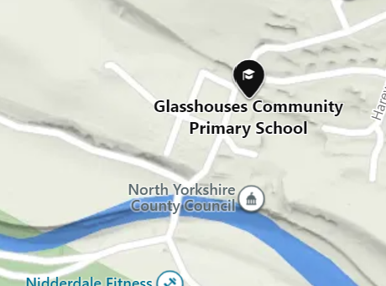
Glasshouses Community Primary School
Glasshouses
Harrogate
HG3 5QH

Telephone: 01423 711440
Email: admingh@uppernidderdalefed.school

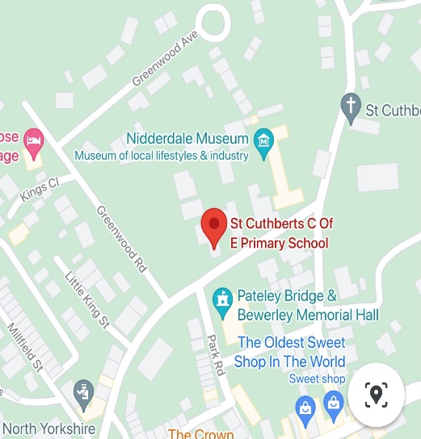
St Cuthbert’s CE Primary School
King Street
Pateley Bridge
Harrogate
HG3 5LE

Telephone: 01423 711407
Email: adminstc@uppernidderdalefed.school

JOB DESCRIPTION

GTA Interventions Teaching Assistant

JOB PURPOSE: To work with teachers to support teaching and learning by working with individuals or small groups of pupils under the direction of teaching staff, and may be responsible for some learning activities within the overall teaching plan. May work in the classroom or appropriate location within the school, with access to support and guidance as required.
ACCOUNTABILITIES / MAIN RESPONSIBILITIES
Supporting Learning & Development
- Support pre planned learning/behaviour activities as directed by the teacher
- Using agreed structured observation as directed by the class teacher to feedback on learning, behaviour, participation and achievement, to support the planning and evaluation of the learning process in respect of groups and individual students ·
- Interact with pupils in ways that support the development of their ability to think and learn, including the use of careful questioning
- Assist teachers in the implementation of appropriate behaviour management and teaching & learning strategies
- Run intervention groups for English, Phonics and Maths
- Support pupils in their social and emotional wellbeing, in implementing related programmes, including social, health and physical needs
- Assist in escorting and supervising pupils on educational visits and out of school activities ·
- Undertake break supervision as required
Communication ·
- Under the general direction of the teacher participate in establishing and maintaining effective relationships with pupils, parents/carers and with other agencies/professionals
- Communicate effectively with all pupils, families, carers and other agencies / professionals
Sharing information
- Share information confidentially about pupils with teachers and other professional as required
- Pay due regard to professional boundaries, maintaining appropriate levels of confidentiality
- Participate in staff meetings
Safeguarding and Promoting the Welfare of Children/YoungPeople
- Carry out tasks associated with pupils’ personal hygiene, (including personal intimate care) and welfare, including physical and medical needs, whilst encouraging independence
- Be responsible for promoting and safeguarding the welfare of pupils in line with policy and legislation, raising concerns as appropriate
Administration/Other
- Prepare classroom materials and learning areas, and undertake minor clerical duties e.g. photocopying and displaying pupils work
- Support the use of ICT and adhere to relevant policies
- Supervise and provide access arrangements for pupils sitting internal and external examinations and tests as required, ensuring that examinations comply with the Examination Board Regulations
- Participate in appraisal, training and other learning activities
Health & Safety
- Be aware of and implement your health and safety responsibilities as an employee and where appropriate any additional specialist or managerial health and safety responsibilities as defined in the Health and Safety policy and procedure
- Work with colleagues and others to maintain health, safety and welfare within the working environment
Data Protection
- To comply with the County Council’s policies and supporting documentation in relation to Information Governance this includes Data Protection, Information Security and Confidentiality
Equalities
- Promote inclusion and acceptance of all pupils
- Within own area of responsibility work in accordance with the aims of the Equality policy, treating people with respect for their diversity, culture and values
Customer Service
- The County Council requires a commitment to equity of access and outcomes, this will include due regard to equality, diversity, dignity, respect and human rights and working with others to keep vulnerable people safe from abuse and mistreatment
- The County Council requires that staff offer the best level of service to their customers and behave in a way that gives them confidence. Customers will be treated as individuals, with respect for their diversity, culture and values

Headteacher/line manager’s signature: _______________________________________
Date: _______________________________________

Postholder’s signature: _______________________________________
Date: _______________________________________

PERSON SPECIFICATION

Essential upon appointment | Desirable on appointment
Knowledge  An awareness of child/young person’s development and learning  An understanding that children/Young people have differing needs | An awareness of child/young person’s development and learning  An understanding that children/Young people have differing needs  Good understanding of child development and learning processes  Knowledge of Behaviour management techniques  Knowledge of Child Protection and Health & Safety policies and procedures  Knowledge of inclusive practice
Experience  Experience appropriate to working with children in a learning environment | Experience of delivering evidence based interventions that accelerate learning
Occupational Skills  Good written and verbal communication skills: able to communicate effectively and clearly and build relationships with a range of staff, children, young people, their families and carers  Good reading, writing and numeracy skills | Basic ICT Skills
Qualifications  Level 2 numeracy & literacy qualification or equivalent | Appropriate first aid training
Personal Qualities  Demonstrable interpersonal skills  Ability to work successfully in a team  Able to exercise judgement  Confidentiality  Flexibility | Creativity
Other Requirements

Enhanced DBS clearance

To be committed to the school's policies and ethos

To be committed to Continuing Professional Development

Motivation to work with children and young people

Ability to form and maintain appropriate relationships and personal boundaries with children and young people

Emotional resilience in working with challenging behaviours and attitudes
Ability to use authority and maintaining discipline

An empathy for equality & diversity
The ability to converse at ease with customers and provide advice in accurate spoken English is essential for the post

