
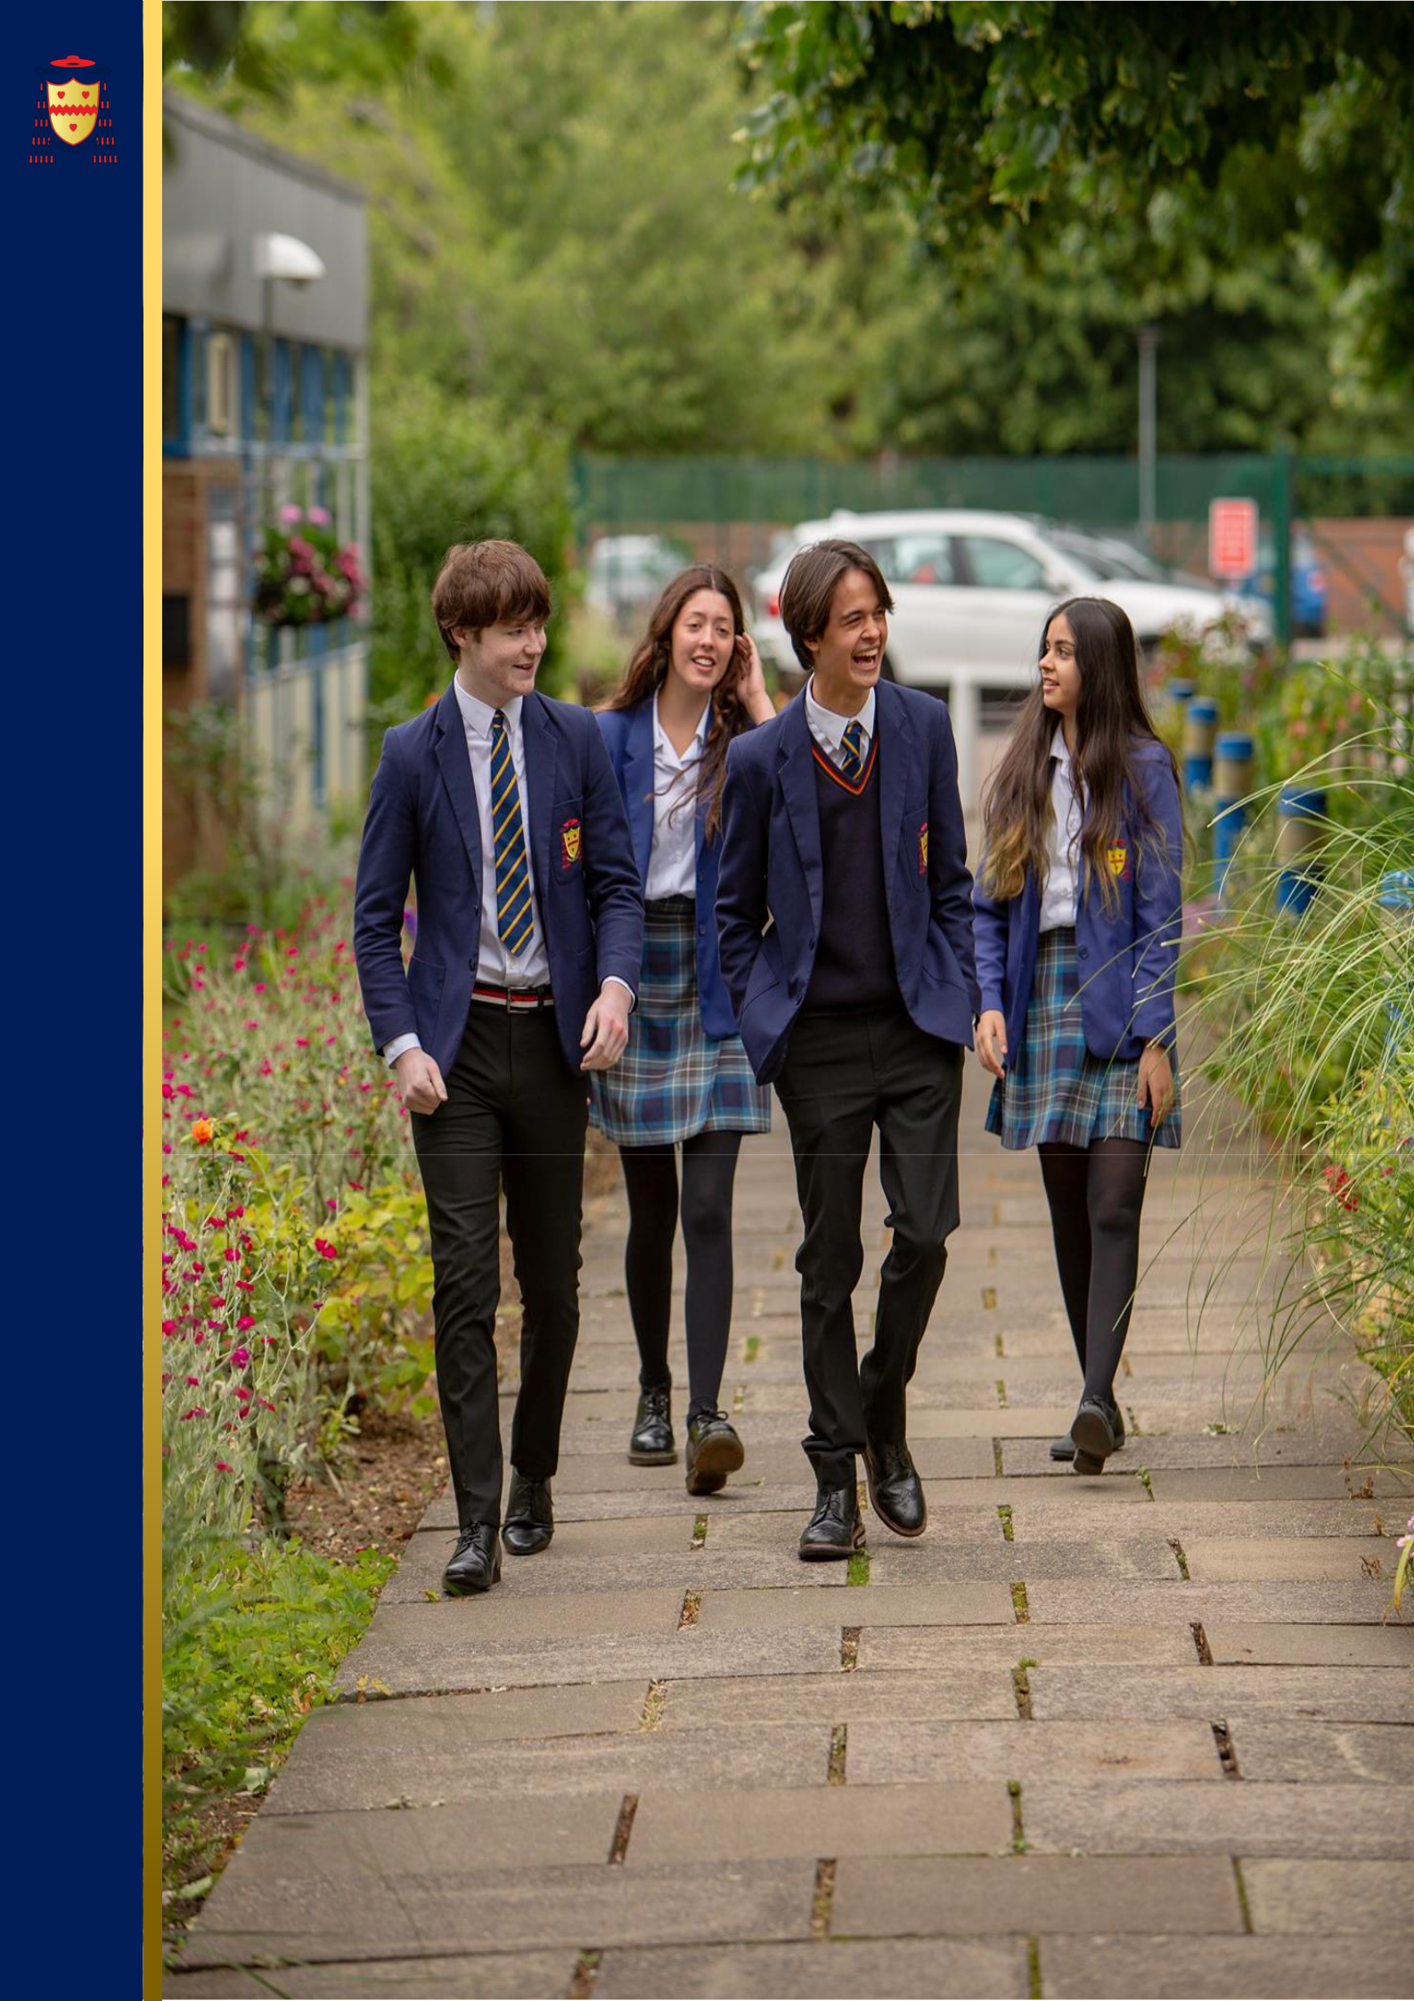
THE SAINT JOHN HENRY NEWMAN
CATHOLIC SCHOOL
Applicant Pack

IT SUPPORT TECHNICIAN
June 2025

Welcome from our Headteacher

Dear Applicant,

Thank you for your interest in working at the Saint John Henry Newman School. I hope you find this information pack a useful introduction to our school. We are delighted that you see our school as a place where you can make an impact.

The Saint John Henry Newman Catholic School is a very distinctive community which unequivocally works to be a living Christian community in which each child and young adult is known and loved for who they are. We want our students to enjoy their education – to be happy, safe and secure and to grow in God’s love so that when they leave the school, they are equipped to change the world and make it a better place.

We firmly believe that our parents are the ‘prime’ educators and that our success is a result of the collaboration between parents, school and child working together for the good of the child. Our parents are encouraged to be fully engaged in their children’s education and there are many opportunities for parents to visit the school and contribute to their children’s adult formation and academic success.

This academic success is highlighted by the high rate of progress our students make. The school’s progress 8 score of 0.71 places the school in the top 8% of schools in the country, whilst at Sixth Form our students continue to achieve in excess of national standards. This success at key stage 4 and 5 means that the Saint John Henry Newman Catholic School continues to be officially recognised as one of the highest-achieving schools in the country.

We are however very clear that our ‘Mission’ is to create an environment in which children can discover who they are and what their role in this life is. In the words of our patron, the Blessed John Henry Newman, we believe that “God has created us to do Him some definite service”.

Thank you for your interest in Saint John Henry Newman School. My colleagues and I look forward to reviewing your application.

Yours faithfully,


David Carrasco
Headteacher

Introduction of Our School

The Saint John Henry Newman school serves the North Hertfordshire Catholic community but our catchment area extends to Bedfordshire, East Hertfordshire and parts of Cambridgeshire. Originally, a 6-form entry School, the intake was increased to 210 in 1999 and increased to 8 form entry in September 2015. There is a high retention rate in the Sixth Form and many students apply to join our Sixth Form from other establishments. Consequently, the School has grown in size from 830 in 1993 to approximately 1600 in September 2023, with 400 students in the Sixth Form. The School became an academy as part of the Diocese of Westminster Academy Trust in 2012 and has benefitted from considerable investment in its buildings as a result, including a £3.5 million Sports and Performing Arts block (The Pavilion).

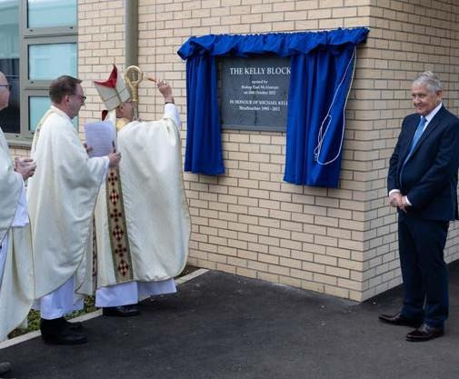
A major refurbishment of the school estate is currently being undertaken with the provision of two new blocks which are open and operational. These home new teaching accommodation, a dedicated sixth-form suite, a greater number of computer rooms and improvements to the Library, Dining and Hall facilities. The existing main block is being demolished as part of the final phase of the works. Following the demolition of the old teaching block the school will landscape the grounds to create a new prayer garden. The first of the new facilities was opened by former Headteacher Mr Kelly in October 2022. The second phase of the work which includes the opening of the new main block known as the Mathew Block will have its formal grand opening in January 2024.

Our Mission Statement emphasises the practical nature of our religious character. We seek to offer a living Christian experience as a community in which each pupil is valued as an individual and is encouraged to achieve success in school life. Our Chapel is a central part of school life but it is in the day-to-day operation of school life that the School sees its aims being fulfilled. We want Students and students to enjoy the experience of being part of the Saint John Henry Newman Catholic School community, to gain in self-confidence and to become young adults instilled with a sense of personal responsibility, social commitment and, hopefully, an awareness of their own distinctive spirituality. We want them to be equipped to change their world.

The pupil population is mostly Catholic and the School is heavily oversubscribed for places. Although not all staff are Catholic (teaching staff 45.9% are Catholics), all maintain and support the distinctive Catholic nature of the School and support the Headteacher in implementing the School Mission Statement. There is presently 90 members of teaching staff and there is a generous complement of support, technical, clerical and maintenance staff.


In years 7 to 9 Students follow a broad and balanced curriculum based on the National Curriculum. Students in Year 10 and 11 follow a core curriculum of English, Maths, Science and RE with three subject choices. At Key Stage 4 we encourage students to follow the EBAC where this is appropriate, but we offer a wide range of GCSEs and the creative subjects (Art, Drama, Dance and Music) are very popular option. We offer a range of vocational courses for Students for whom this is appropriate.

Our current provision offers vocational courses in Child Development, Catering and Sport. We have a large sixth form of approximately 400 students and there is a very wide range of A-level provision. Advanced Vocational courses are also offered in Art and Design, Production Arts, Digital Music Production, Music Performance. Applied Science, Sport and Health and Social Care.

The School has an excellent academic reputation. In 2022/23 the students achieved: 86% GCSE English and Maths at 9-4, 37% of all GCSE grades achieved were 9-7, 56% A Level at A*, A and B. At A-level the pass rate for the last three years has been over 99%.
The pass rate for Vocational courses has consistently been 100%. We are, however, conscious that we have the capacity to improve further and we are determined to do this on behalf of our Students and students. Exam results, important though they are for opening doors for Students in the future, do not determine success and happiness.

Therefore, we have a strong enrichment and well-being program that encompasses every student and a comprehensive career curriculum. We have been awarded with the Kitemark for emotional health and wellbeing for our work supporting students, their families and staff.

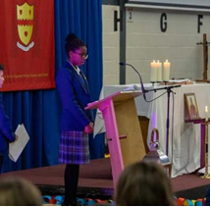
The number of Students entitled to free school meals is relatively low (7%) with 7.4% of Students receiving Pupil Premium. The ethnic composition of the School’s population reflects the community which it serves. It is predominately white British (46%) but with significant proportions of ethnic minorities reflecting the Church’s worldwide mission and the growing number of new migrants employed primarily in health care and scientific research. Attendance is above the national average with very low unauthorised absence figures.

A Diocesan Section 48 inspection in November 2019 concluded that we are an “Outstanding Catholic School”.

The 2018 Short OFSTED inspection concluded; ‘We were immediately struck by the many smiling faces of Students, who enjoy coming to school. When speaking to them, Students universally highlighted how their teachers ‘go above and beyond’ to help them achieve well. Students display a real pride in their school. They talk enthusiastically about their strong relationships with staff and the sense of community where ‘everyone goes out of their way to be friendly and make you feel welcome’. Consistent with its aim of encouraging everyone to reach their full potential, the School places great emphasis on its pastoral care.

We operate at a very human level and recognise that it is our good and caring staff who sustain and develop our school. Our challenge is to maintain high-quality provision, hopefully, to continue to make changes to improve this, but above all, to honour the promise we make to every parent who chooses to send their child to our School - that each child will be recognised and loved for who they are and that they will be offered excellent learning opportunities in a safe, caring and inspirational environment.

We are looking to appoint individuals who will enjoy being part of this distinctive community and who will contribute to it by sharing their individual talents, character and commitment and, hopefully, sense of humour!

The Saint John Henry Newman School is committed to safeguarding and promoting the welfare of children and young people.

All appointments are subject to a satisfactory enhanced DBS check.



Our Vision & Values

OUR MISSION IS TO BE A LIVING, CHRISTIAN EXPERIENCE


Inspired by
- Love of the creator
- Faith in Jesus Christ
- Hope from the holy spirit

In service to

- The needs of our Students and students
- The parents and guardians of our Students and students
- The educational mission of the catholic church

We believe
- In the goodness and beauty of god's creation
- In the goodness, dignity and worth of each person
- That everyone has a unique spiritual identity which they are called to fulfil
- In loving one another and yourself for the person that you are
- That all have rights, roles and responsibilities for which they are accountable
- In discovering and nurturing our god -given gifts
- In celebrating the personal development of each individual
- That the quality of teaching and learning is of fundamental importance
- In developing informed minds capable of making informed and considerate decisions
- That everyone thrives in a secure, safe and structured environment
- In forgiveness and being forgiven
- In celebrating and living our faith, and reaching out to others
- And that learning is a life-long journey through which each person should aspire to make the world a better place

Our Community Values Statement

- We belong to a community where everyone is valued, as we do not prejudge or discriminate.

- We belong to a community where everyone feels safe, as we do not threaten, intimidate or harm others.

- We belong to a community where diversity is respected, as we celebrate difference and treat everyone equitably.

- We belong to a community where success is celebrated, as we encourage and support others to succeed.

- We belong to a community where we can communicate our thoughts, feelings and ideas, and we do this with integrity and sensitivity to the feelings of others.

- We belong to a community where we can make mistakes, and we seek dialogue and reconciliation to restore relationships.

- We belong to a community which respects the environment around us, and we take pride in and look after the school buildings and outdoor spaces.

- We belong to a community which extends beyond the school walls, as we live by these values out of school.

Our Catholic Life

O Lord and Saviour, in your arms I am safe.
Keep me and I have nothing to fear.
I know nothing about the future, but I rely upon you.
I leave it all to you, because you know and I do not.
Help me to know you,
to believe in you,
to love you,
to serve you,
to always aim at bringing you glory,
to live to you and for you,
and to set a good example to all around me.
Amen.

Source: John Henry Newman, 1801-1890 (Adapted)

The Catholic life of our school community continues to be at the core of everything that we do and to be the reason why our school exists. Our Students shine in every aspect of their lives; they are spiritual, powerful, creative and individual, each one of them inspired by God and talented beyond our comprehension and their own expectations. This is their time to discover who they are and what they could become, and our belief is that they could become anything that they wish to be - the page is blank. That is not to say that we have unrealistic expectations or aspirations for them, but it is to say that we believe that God’s plans for them far exceed anything that they can imagine for themselves at this young age.

We believe that each child has his or her unique set of talents – these talents have been entrusted to him or her to be nurtured, developed and multiplied – not to be buried and forgotten. Each child must be given the time and support to become the person that God intended him or her to be. We believe in the need for developing self-respect – valuing our own identity and uniqueness and taking pride in ourselves and our achievements – learning to love ourselves as the person God created us to be.

A great challenge to which we aspire every day...

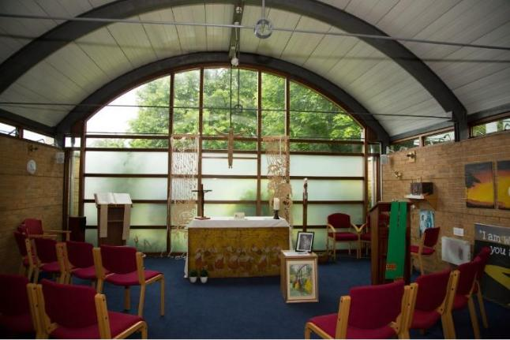

Benefits of working at The Saint John Henry Newman Catholic School
SUPERB WORKING CONDITIONS  - Excellent transport links – close to the A1 and 30 miles to central London. Stevenage to London is just over 20 minutes on the train.  - Stevenage is an area with more affordable housing, than other areas of Hertfordshire. Staff also choose to live in the beautiful villages and market towns of North Hertfordshire.  - Secure free car parking for all members of staff  - Excellent staff facilities including free tea and coffee and microwaves and fridges in the staffrooms  - Staff association which provides gifts, flowers and cards for leavers and staff with significant life events  - Social activities e.g. Friday after school football, staff choir, staff book group, running club, Christmas party, informal nights out, staff pantomime  - Child care voucher scheme  - Flu vaccinations for all staff  - Excellent teaching facilities with the new and refurbished buildings  - Supportive of flexible working  - Ensuring equality and diversity is a priority    - Governors focused on Staff wellbeing | A THRIVING COMMUNITY WHERE YOU CAN ENJOY TEACHING  - Oversubscribed school with close link with the community and supportive parents  - Exemplary student behavior which is always commented on by visitors  - Extensive range of extracurricular activities and enrichment  - All teachers are issued with a laptop  - Workload is constantly being reviewed e.g. email protocols to reduce number of emails, assessment policy to reduce time spent marking  - Generous non-contact time  - Very large sixth form so many opportunities to teach this age group  - Lessons are taught by subject specialists  - Many opportunities to work with students and participate and support in local, national and international fundraising and awareness opportunities  A SERIOUS COMMITMENT TO PROFESSIONAL DEVELOPMENT  - New staff induction program – September-November  - Performance Management that is focused on developing teacher’s careers in the areas that they wish  - Bespoke professional development opportunities – Masters, NPQs, Educator Led Development Program, exam board training, in school opportunities to develop teaching and leadership, ECT and ECT + 1 program  - Whole school CPD focuses on teaching and learning and there are many opportunities for staff to become in involved in the design and facilitating of INSET

Application Process

How to apply:

This recruitment is managed by The Saint John Henry Newman School, in line with the latest guidance on safer recruitment. Please apply online at www.teachinherts.com or send your completed application form to hr@jhn.herts.sch.uk. You can also contact us on 01438 314 643.

Application Form:

Applicants must use the standard application form provided (CVs are not accepted). Please complete all aspects of the form fully. Include your full work history with no unexplained gaps since leaving your education. Include all the training you have completed. Application is done by Teach in Herts, CES or DfE application. However, we will ask successful applicants to backfill an official CES application form.

Person Specification and Personal Statement:

When writing your personal statement, you must address each of the requirements in the person specification. Be sure to evidence additional aspects such as training and qualifications together with your background and experience.

References:

Please make sure your referees are aware of your application and that they are able to provide a swift turnaround. Preferred referees are your last two employers, and you should provide their official organisation email address for us to contact. If you have worked in a school previously one referee should be your last Headteacher.

School Visits:

School tours are a standard part of the interview process. However, School visits are welcomed by prior arrangements. To arrange this, please contact Megan Mcdevitt, HR Manager hr@jhn.herts.sch.uk or by phone 01438 314643.

Please Note:

Please note any job description is not necessarily a comprehensive definition of the post. The duties and responsibilities listed in the job description describe the post as it is at present, the post holder is expected to accept any reasonable alterations that may from time to time be necessary.

The job description will be updated regularly in line with school’s development plan.
JOB DESCRIPTION FOR IT SUPPORT TECHNICIAN

Job title: | IT Support Technician
Date: | June 2025
Salary Range: | H5, SCP 9 FTE £26,409
Reports to: | Trust IT Lead and Schools IT Systems Manager, Mr R Culpin
This job description outlines the main responsibilities and duties of the IT Support Technician role. It is not an exhaustive list and may be subject to change in response to the evolving needs of the school or Trust. The job description will be reviewed regularly in line with the school’s and Trust’s strategic priorities.

- INTRODUCTION

  - You are accountable to the Governing Body through the line management structure shown in the Staff Handbook.

  - You are required to maintain and develop the Catholic character of the school in accordance with the direction given by the Governors and expressed in the Mission Statement. You are required to support the Headteacher in implementing the Mission Statement and in maintaining the distinctive Catholic nature of the school.
- The role of An it sUPPORT TECHNICIAN at the saint John Henry Newman School, PART of THE Diocese of Westminster Academy Trust.

2.1 As an IT Support Technician, you will play a key role in supporting the day-to-day operation of IT systems across The Saint John Henry Newman School. Supporting both the school and Trust sites not only ensures a consistent and scalable Trust-wide IT environment, but also provides valuable experience in working across different educational settings and technical landscapes, supporting your own career development and progression within the Trust.
You will support a broad range of services and infrastructure, including end-user devices, classroom technologies, server and network systems, and cloud-based platforms such as Microsoft 365.

- Key Areas of Responsibility

3.1 Desktop, DEVICE and Application Support
- Install, maintain, and troubleshoot Windows and other operating system clients.
- Provide first-line support for all end-user hardware including desktops, laptops, printers, projectors, and interactive panels.
- Support deployment and maintenance of standard software packages and Trust-wide configurations.
- Maintain Audio and Visual (AV) and peripheral devices, ensuring proper functionality and proactive maintenance.
- Assist in resolving application issues, escalating where necessary to suppliers or third-line support.
- Maintain and support mobile device management (MDM) for tablets and mobile assets.

3.2 Server and Network Support
- Perform routine account and group management tasks in Active Directory and Azure AD.
- Support and maintain on-premises Windows Servers and integration with Microsoft 365 cloud services.
- Monitor system security including anti-virus and endpoint protection tools.
- Assist with management of backup systems (on-site and cloud-based) and verify integrity of backup schedules.
- Support configuration of managed network infrastructure (switches, VLANs, access points).
- Liaise with the ICT Systems Manager and Lead IT Technician on advanced network issues and escalation.

3.3 Configuration, Installation and Supporting
- Assist in imaging, configuration, and rollout of new devices and peripherals.
- Provide basic networking support, including cabling, patching, and port configuration.
- Provide technical setting up and support during school and Trust events (e.g., assemblies, open evenings).

3.4 Continuity, Maintenance, Security and Inventory
Liaise with and assist the designated person responsible for the maintenance of the asset register/inventory.
- Support maintenance of the school and Trust-wide IT asset register.
- Ensure physical security and tracking of equipment.
- Assist in managing internet filtering and safeguarding systems, working with staff to allow site-specific configurations.
- Monitor consumables and ensure availability of essential IT supplies.

3.5 Support Request Management
- Record and respond to support tickets in accordance with internal Trust SLAs.
- Maintain accurate documentation of requests, actions taken, and resolution outcomes.
- Prioritise and escalate issues where appropriate.
- Support Primary School staff and systems, via remote support.

3.6 Team Responsibilities
- Work flexibly and cooperatively within the IT team.
- Participate in shared duties including lunch supervision and occasional out-of-hours support (e.g., events), with prior notice.
- Contribute to team knowledge sharing and documentation.

3.7 Communications
- Assist staff and students with ICT-related queries in a friendly, professional manner.
- Provide guidance and informal training to end-users on the use of devices and systems.

3.8 PROFESSIONAL DEVELOPMENT & TRUST WIDE ENGAGEMENT
Supporting the Trust Schools is an essential part of this role and offers a unique opportunity to broaden your technical skillset across different environments. This responsibility is also designed to support your professional growth, building experience that aligns with Trust-wide IT career pathways and future progression opportunities into senior technical or leadership roles.
Regular engagement with cross-site projects, shared infrastructure, and collaborative systems development is encouraged and supported.

- EQUALITIES

  - Be aware of and support school policies that promote equality within and beyond the school community.

- HEALTH AND SAFETY

  - Be aware of and comply with policies and procedures relating to child protection, health, safety and security, confidentiality and data protection; and report all concerns to an appropriate person.

- DISCLOSURE & BARRING SERVICE

  - This post is classed as having a high degree of contact with children or vulnerable adults and is exempt from the Rehabilitation of Offenders Act 1974. An enhanced disclosure will be sought through the Disclosure and Barring Service as part of the pre-employment checks.

- Safeguarding Children and Safer Recruitment

7.1 You will ensure that child protection and the safeguarding of students are given the highest
priority at all times.

7.2 The Saint John Henry Newman School is committed to safeguarding and promoting the welfare of
children and young people as required under the Education Act 2002 and expects all staff and
volunteers to share this commitment.

Person Specification
SPECIFICATION | ESSENTIAL | DESIRABLE
Education/ Training | A Level / BTEC / Level 3 Apprenticeship or equivalent in computing / IT.
Relevant Experience | Experience of networked PCs (Windows 10 onwards) and Microsoft applications  At least 1-2 years of relevant experience  Experience in the use of Microsoft Office applications | Experience/knowledge of working in an educational environment  Familiarity with Apple MAC Devices.  Experience of working with the public  Experience of Microsoft 365 Admin Centre
Skills/ Aptitudes | Excellent interpersonal skills  Ability to work independently and pro- actively  Ability to work calmly under pressure, often to tight deadlines  Ability to work flexibly as part of a team
Other requirements | A commitment to deliver excellent standards of service for young people  Flexible approach to working hours  Enthusiasm and motivation  Willingness to undergo an enhanced DBS check  A personal commitment to relevant legislation and good practice in relation to equality and diversity and safeguarding and promoting the welfare of young people  Willingness to keep up to date with IT applications and to receive further training.  Ability to carry and move heavy equipment on a day-to-day basis (appropriate training will be provided)

