Nurture, Nature, Knowledge:
Enabling inquisitive thinkers and inspired learners with kind hearts.



KEY STAGE 1 TEACHER AT HIMBLETON CE PRIMARY SCHOOL AND NURSERY

Commencing 28th April (or sooner if possible)

Information for Candidates

Himbleton CE Primary School and Nursery
Neight Hill, Himbleton, Droitwich, Worcestershire, WR9 7LE
Telephone: 01905 391231
Email: office@himbleton.worcs.sch.uk
Web Page: www.himbleton.worcs.sch.uk

The Advertisement

Full time Key Stage 1 Class Teacher – Fixed Term Contract for the Summer Term 2025
Salary: Main Scale
Required to start: Monday 28th April 2025 (or sooner if possible)

We are seeking to appoint a committed and dedicated KS1 class teacher for the Summer Term 2025. Himbleton CE Primary School and Nursery is a voluntary controlled, rural school with 110 children on roll (inclusive of Nursery) with a Pupil Admission Number (PAN) of 14. Children are taught in mixed age classes and the vacancy is for a fixed-term position in our Year 1 and Year 2 class.

We are looking for someone who:
- Demonstrates energy, enthusiasm and commitment to high quality, evidence-informed teaching and learning and school improvement;
- Sets high expectations and standards of themselves and others;
- Has the skills and knowledge to plan for and teach a mixed-age class which ensure the best outcomes for our children in every way;
- Has a clear knowledge and understanding of the Year 1 PSC and optional KS1 SATS;
- Has high organisation skills;
- Has a positive work ethic and is keen to get involved in all aspects of our school life;
- Relishes the prospect of being part of a community and not just a member of staff;
- Is committed to promoting our vision of Nurture, Nature, Knowledge and our Christian values.

We can offer you a school with:
- A warm, welcoming and friendly school with a strong Christian vision, rooted in theological narrative, that is alive and drives all that we do;
- The opportunity to work with our wonderful pupils and become part of the family;
- A supportive Governing Body whose expectations for the school are high;
- An experienced and knowledgeable staff team who are committed to ensuring that our children experience the best opportunities;
- A supportive and engaged wider community.

In your letter of application, please state your curriculum strengths and any particular talents or abilities you could offer. We would encourage you to look at our website www.himbleton.worcs.sch.uk to find out more and, in order to get a true feel for our school, we strongly encourage all candidates to visit. This can be arranged by contacting our School Administrator, Mrs Stewart, on 01905 391231or via email to office@himbleton.worcs.sch.uk

Closing date for applications: Monday 17th March 2025 at 12 noon
Shortlisting: Monday 17th March 2024. Shortlisted candidates will be notified by email.
Planned interview date: Monday 24th March 2025

It is essential that applicants use the Worcestershire agreed application form which is available from our website or as a paper copy from the school office. Please do not send CVs.

Safeguarding and Safer Recruitment:
Himbleton CE Primary School and Nursery has responsibility for and is committed to safeguarding and promoting the welfare of children and young people/vulnerable adults and expects all staff and volunteers to share this commitment. This position is subject to an Enhanced Disclosure and Barring check . Any offer of employment will be subject to satisfactory references and other satisfactory pre-employment checks. This post is exempt from the provisions of the Rehabilitation of Offenders Act 1974 and the amendments to the Exceptions Order 1975, 2013 and 2020. An online search will also be carried out on all shortlisted candidates as part of our Safer Recruitment procedures.

Himbleton CE Primary School and Nursery

Himbleton CE Primary School and Nursery is located in a beautiful, unspoilt, rural village in the heart of the Worcestershire countryside. The school is privileged to have extensive and varied grounds, enabling us to be able to offer a unique curriculum that draws upon this and provides every child with a diversity of carefully designed learning experiences.

At our school, we believe that in order to fulfil their potential, all children need to feel valued, respected and experience a sense of belonging. Our family ethos, rooted in our Christian values of Friendship, Truthfulness, Perseverance, Forgiveness, Courage and Respect enables us to nurture every aspect of each individual so that they can truly flourish.
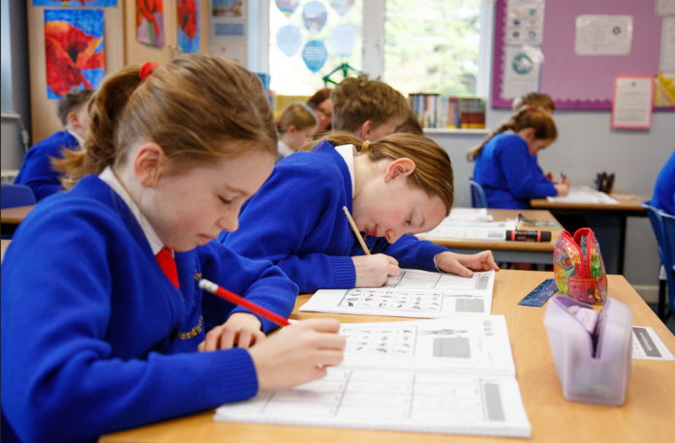
Children attend the school both from the local community and further afield. As we have a Pupil Admission Number (PAN) of 14, children from Nursery to Year 6 are taught in mixed age classes; Nursery and Reception, Year 1 and Year 2 (KS1), Year 3 and Year 4 (LKS2) and Year 5 and Year 6 (UKS2) making a total of 4 classes. The school is set within wonderful grounds which enables the curriculum to be taught The school was graded as ‘Good’ in March 2023.

Himbleton’s Ofsted Report in March 2023 said:
“The motto of this small village school is ‘nurture, nature, knowledge.’ Pupils make the most of the rural location of the school by experiencing valuable outdoor learning opportunities. Pupils enjoy and learn much from these opportunities. They enjoy the caring, family-like atmosphere of the school. Pupils feel safe at school because staff look after them well.”
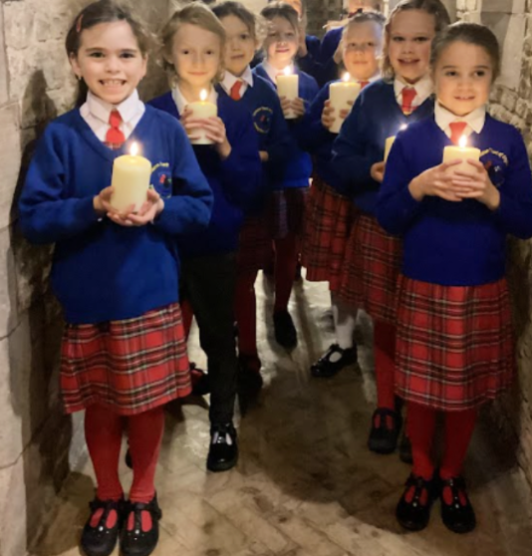
As a church school, Himbleton CE Primary School and Nursery has close links with St Mary Magdalene Church and our Christian values support and underpin our motto of ‘Nurture, Nature, Knowledge’. Our children and staff show respect and kindness towards each other, treating everyone as individuals with their own unique talents and celebrating the similarities and differences which form our community.


We believe that every child should have the opportunity to fulfil their potential and achieve to the best possible standards, giving them a strong foundation for the future. From the moment they start, we provide children with a unique, exciting curriculum, which is carefully designed to both foster a love of learning and to effectively prepare them for life in an ever-changing, diverse world. We aim to inspire, challenge and motivate our children to want to make a difference and have the confidence to do so.

About the Post

Due to a long-term absence, we are seeking an enthusiastic and committed teacher to join our small, but ambitious and friendly team to teach our Year 1 and Year 2 children for the Summer Term. We are looking for someone who has high aspiration and expectations of themselves and children, creative in their approach and someone who is excited to join our small, but dedicated and friendly team.

What To Do Next

We would encourage you to view our website to get a flavour of our school;
www.himbleton.worcs.sch.uk

Arrange an appointment to look around;
email office@himbleton.worcs.sch.worcs.uk or tel. 01905 391231

Send a completed application form complete with a letter of application to the school via email to; office@himbleton.worcs.sch.uk

Closing Date: 9am Monday 17th March 2025

Job Description: Key Stage 1 Teacher

Title: Class Teacher Key Stage 1
Responsible to: Headteacher
Grade: Main scale
Contract Type: Permanent Contract from September 2025
Overall Purpose of this post: The appointment of a Main Scale Teacher is subject to QTS status and the current conditions of employment for teachers contained in the School Teachers’ Pay and Conditions Document (STC PD 2019) and other current legislation, including expectations set out in the Teachers’ Standards.

Duties and responsibilities
To be a consistently reflective and effective classroom practitioner and support the leadership and management of the school by:
- Undertake duties as required in the ‘Teachers’ Standards’;
- Be an advocate of the school’s ethos, Christian Vision and values, promoting change and school improvement that improves the life chances for all groups of pupils;
- Be familiar with the school’s systems, structures, policies and procedures;
- Take responsibility both personally and collectively;
- Uphold and support the school’s Behaviour Policy through effective classroom management;
- Provide consistently high-quality teaching for all groups of pupils that promotes high standards of learning and achievement;
- Adapt teaching styles to suit all pupils and providing a high quality, supportive learning environment;
- Be familiar with the ‘Special educational needs and disability code of practice: 0 to 25 years’, and support pupils with SEND appropriately;
- Work with the SENDCo to ensure pupils with SEND are appropriately supported;
- Scaffold work and adapt resources and equipment so lessons can be accessed by all pupils;
- Be a reflective practitioner and self-evaluate their teaching to improve effectiveness;
- Encourage pupils to develop and use their creativity and initiative, gain increased independence, and undertake new responsibilities.
- Actively support school activities where required, including attending educational trips, extra-curricular activities and parents’ evenings, which may require some out- of-hours availability;
- Actively participate and contribute in staff meetings as required;
- Build an effective partnership with parents so that they feel a shared responsibility to secure successful outcomes for their child;
- Communicate clearly with pupils and all stakeholders;
- Contribute to the school’s process of self-evaluation and development.

Planning and Assessment:
The teacher will:
- Have a thorough knowledge of all pupils in the class, understanding their starting points and capabilities;
- Set high expectations which inspire, motivate and challenge pupils;
- Demonstrate good subject and curriculum knowledge in the Primary Phase;
- Plan, adapt and teach well-structured lessons to assigned classes, following the school’s plans, curriculum and schemes of work to ensure all pupils reach their potential;
- Systematically review, assess and record pupils’ academic progress and other areas of their progress and use the results to inform next steps;
- Using data, analyse pupils’ progress and achievements, barriers to learning and plans to support individuals at termly Pupil Progress meetings;
- Administer the Y1 PSC for pupils in Y1 and pupils in Y2 who need to re-take;
- Administer the Y2 optional SATs assessments;
- Report pupils’ progress to parents in the Summer Term;
- Develop an understanding of how to use current research findings to inform practice.

Personal and professional conduct
- Uphold public trust in the profession and maintain high standards of ethics and behaviour, within and outside school;
- Have proper and professional regard for the ethos, policies and practices of the school, and maintain high standards of attendance and punctuality;
- Understand and act within the statutory frameworks setting out their professional duties and responsibilities.

Safeguarding
- Work in line with statutory safeguarding guidance (e.g. Keeping Children Safe in Education, Prevent) and our safeguarding and child protection policies;
- Understand the school’s safeguarding procedures and actively promote pupils’ wellbeing and safety, sharing concerns in a timely fashion;
- Promote the health, safety and wellbeing of all pupils, working with the DSL and deputy to ensure safeguarding is promoted.

Please note that this is illustrative of the general nature and level of responsibility of the role. It is not a comprehensive list of all tasks that the teacher will carry out. The postholder may be required to do other duties appropriate to the level of the role, as directed by the headteacher or line manager.

Person Specification

Criteria | Essential | Desirable
Relevant Experience | - Teaching experience in Key Stage 1  - Willingness to work closely with colleagues in preparing for teaching and learning  - Experience and understanding of positive behaviour management strategies  - Experience of assessment to inform teaching and learning  - Experience of the Y1 PSC and optional KS1 SATS | - Further qualifications and or evidence of CPD relevant to primary education  - Ability to offer extra-curricular activities in Reception, KS1 or KS2
Education and Training | - Qualified teacher status  - Evidence of relevant training  - English and maths training in the relevant curriculum  - Evidence of continuous commitment to further professional development | - Evidence of creative and innovative teaching
Knowledge and Understanding | Up to date knowledge and understanding of;  - Current educational developments in teaching and learning and accelerated ways of learning  - Providing effectively for the individual needs of all children, including disadvantaged children, children with special educational needs and those who are more able, gifted or talented  - A clear understanding of adapting tasks for a mixed age group  - The statutory National Curriculum  - Monitoring, assessment, recording and reporting of pupils’ progress  - Positive links necessary within school and the importance of community cohesion | - Evidence of involvement in the wider school community
Personal qualities | - Ability to work cooperatively as part of an effective team with colleagues, parents and the wider community  - Demonstrate creative ideas and support for the future development of the school  - Have high expectations for children’s attainment and progress  - An ability to inspire children with innovative and exciting learning opportunities to encourage learning from mistakes  - Demonstrate flexibility and adaptability – with a willingness to take a whole school perspective, support colleagues within the ethos of the whole school family and cope positively with change  - Have good interpersonal and communication skills  - Show a willingness to be involved in extracurricular activities and events and engage in all aspects of school life  - Be supportive of the Christian ethos of a Church School and demonstrate the school’s Christian values  - Demonstrate commitment to the school’s vision  - Show commitment to maintaining confidentiality at all times  - Two excellent references  - DBS check

