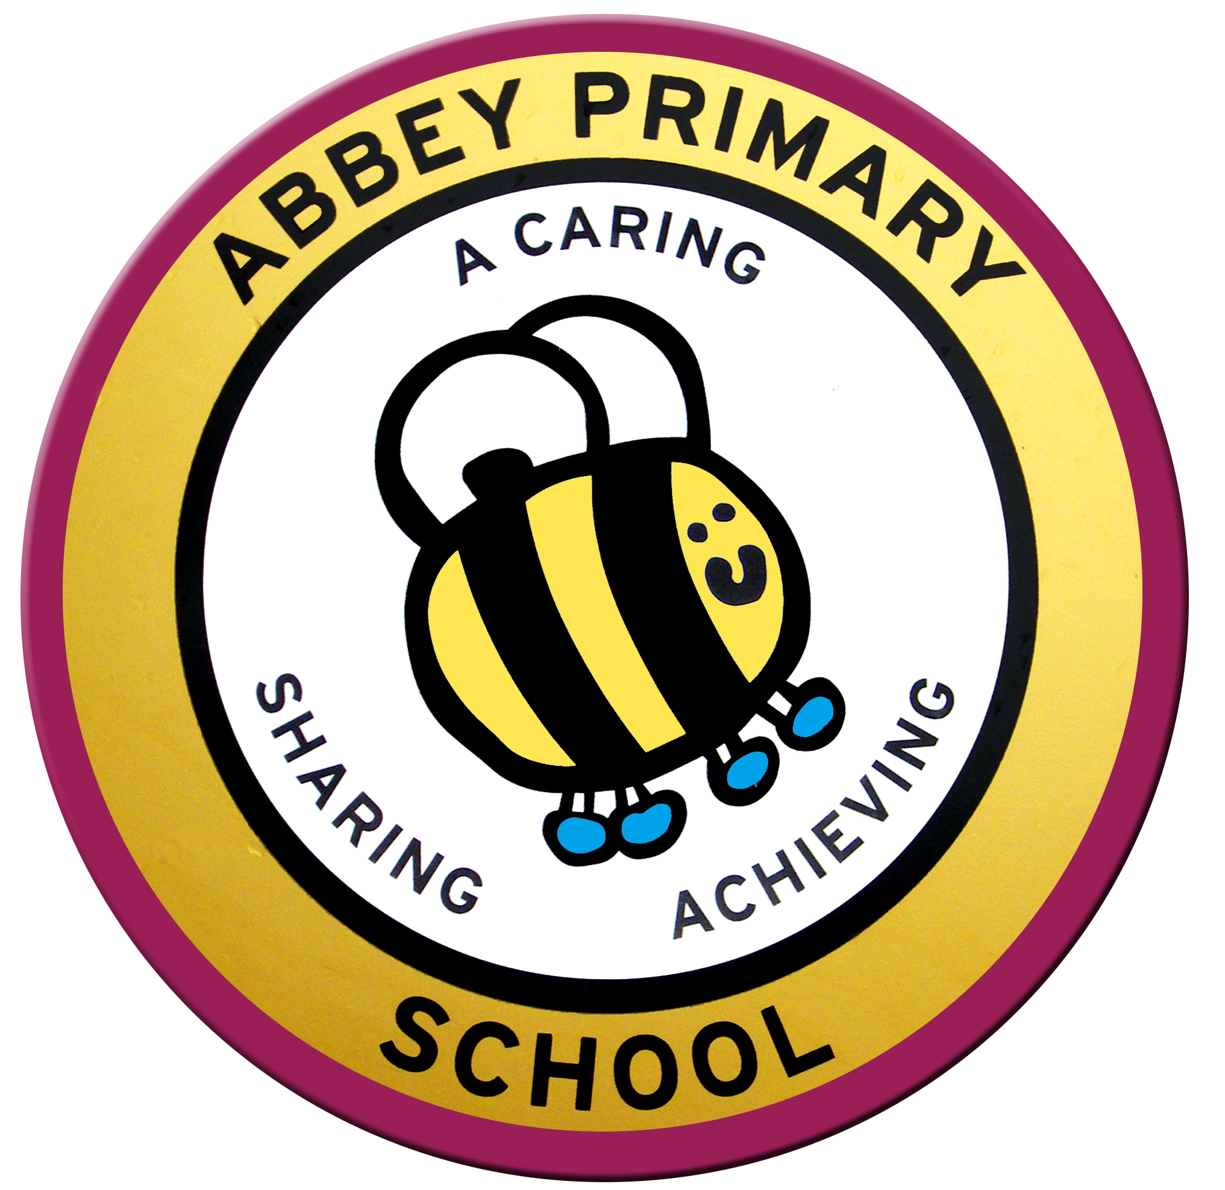
PERSON SPECIFICATION

SCHOOL: ABBEY PRIMARY SCHOOL
POST TITLE: Class Teacher (Main Pay Range)

 | Requirement | Essential | Desirable | Check
Experience | - Knowledge and understanding of the Primary National Curriculum  - Experience of teaching in either Key Stage 1 or Key Stage 2  - Knowledge of the characteristics of high standards of teaching, learning and achievement | ✓  ✓  ✓
Education  and Training | - Qualified Teacher Status  - Degree  - ICT competent (across the curriculum and personally)  - Evidence of participation in recent professional development  - Awareness of current developments in education | ✓  ✓  ✓  ✓  ✓
Personal Qualities | - Hard-working and committed  - Enthusiastic, energetic and warm  - Optimistic  - Creative, dynamic and motivated  - Empathetic  - Collaborative  - Well-organised  - Solution-focused  - Willing to be involved in the wider life of the school  - Committed to equal opportunity and inclusion | ✓  ✓  ✓  ✓  ✓  ✓  ✓  ✓  ✓  ✓
Interpersonal skills | - Ability to communicate clearly  - Ability to foster effective relationships with pupils, staff, parents/carers and governors  - Commitment to inclusion and diversity | ✓  ✓  ✓
Professional  Skills | - Ability to accept responsibility for leading a subject (once ECT induction is complete if relevant)  - Ability to communicate and work professionally with parents/carers, community groups, colleagues and governors  - Ability to maintain an orderly, attractive and well-managed classroom  - High expectations of pupils to work hard and reach their full potential  - Ability to equip pupils to operate independently in learning and wider life  - Ability to positively promote the school within the community | ✓  ✓  ✓  ✓  ✓  ✓
School Specific | - Commitment to the school’s ethos and vision  - Commitment to school improvement  - Commitment to high standards of teaching and learning in all areas of the curriculum  - Commitment to children’s personal and social development, as well as the academic  - A willingness to be fully involved in the wider life of the school | ✓  ✓  ✓  ✓  ✓
Suitability to work with children:  It is the responsibility of all teachers to provide and safeguard the welfare of children and young people she/he is responsible for - both directly and within the wider school community |  | ✓

