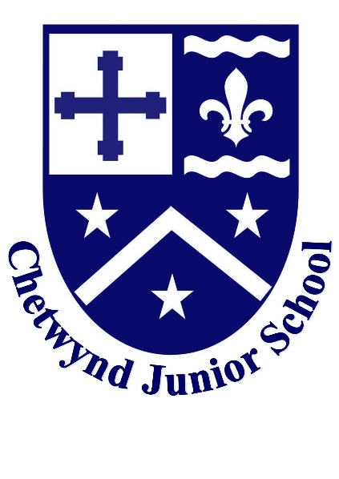
Headteacher: Miss Stephanie Lawes
Caroline Close, Nuneaton, Warwickshire, CV11 4SE
Tel: 02476 340154
www.chetwyndjuniorschool.co.uk
“Chetwynd should be seen as an extension to the family”

April 2021
Teacher Vacancy. This is a one year fixed term position effective from September 2021

Dear Applicant

Thank you for considering the role of Class Teacher at Chetwynd Junior School.

Chetwynd Junior School has been a part of our community since 1972. It has a well-deserved reputation for being a good school and as a staff, we are proud to continue to strengthen and develop this for pupils and parents. We have a great team who work together to create a real sense of caring as well as ‘fun’ at the school.

Our school’s ethos is that we believe the school should be seen as ‘An extension to the family’, for both staff, pupils and parents. We strive for each child to thrive and reach their individual potential but we also ensure that our children feel safe and nurtured whilst they are with us. Chetwynd not only prioritises our pupil’s academic journey but we also ensure they have a wide and varied curriculum with a range of experiences and opportunities to be enjoyed and explored over their four years with us.

Our school is a 3 form entry Junior School with 351 pupils. We are situated on the edge of Nuneaton and have fabulous school grounds, with outdoor play equipment, an amphitheatre, environmental area and small copse. Since the school overlooks farm land it has quite a rural feel to it. Normally when recruiting for new staff, as a Leadership Team, we strongly recommend visits to view our school ‘in action’. However, as Covid 19 makes this very challenging, we are offering candidates the opportunity to visit at the end of the school day to facilitate social distancing.

We hope that this ‘flavour’ of the school has encouraged you to apply for the position of Class Teacher.

Recruitment Process:
- Read the accompanying job description for further information about the post
- Please complete an official application form with Equal Opportunities form, which is available from the Warwickshire website.
- Closing date 30th April (noon) 2021
- Shortlisting 30th April 2021
- Interviews 6th May 2021.
- Start Date 2nd September 2021

The school is committed to safeguarding and promoting the welfare of children and young people and expects all staff and volunteers to share this commitment.

References
- Suitability to work with children is our number 1 priority.
- It is the school’s normal policy to take up 2 references for all appointments.
- Candidates must have a current DBS (this will be arranged in school) and provide proof of teaching qualification / impending qualification

If at any stage you feel that your application has not been dealt with fairly, please write details of your complaint to:
Human Resources
Saltisford Office Park
Ansell Way
Warwick
CV34 4UK

Thank you for taking the time to apply for this very exciting position at our school.

Yours sincerely

Miss Stephanie Lawes
Headteacher

