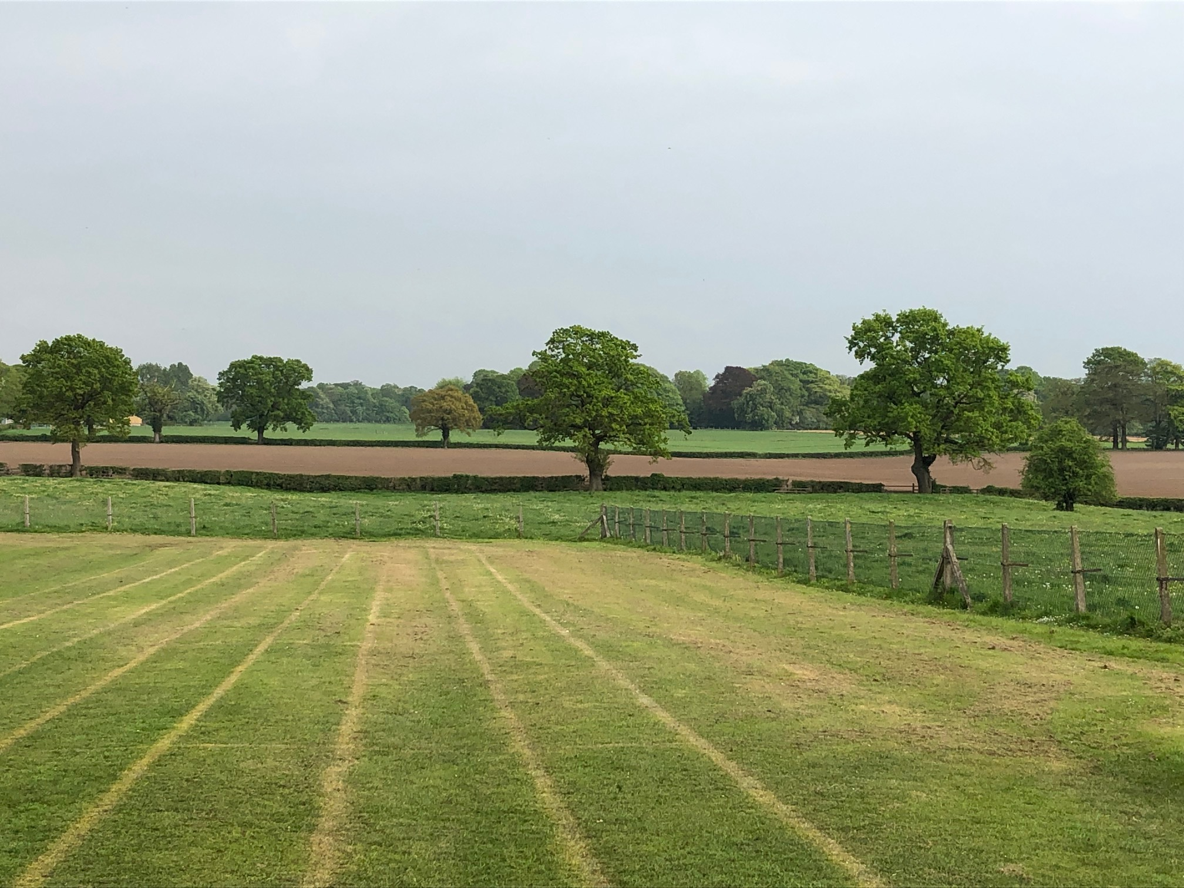



MOBBERLEY CHURCH OF ENGLAND PRIMARY SCHOOL

Church Lane, Mobberley, Cheshire, WA16 7RA

Headteacher: Mr D Stenson B.Ed NPQH

T: 01625 800 920 • E: [admin@mobberley.cheshire.sch.uk](mailto:admin@mobberley.cheshire.sch.uk) • W: [www.mobberley.cheshire.sch.uk](http://www.mobberley.cheshire.sch.uk)

**“Ask and it will be given to you; seek and you will find; knock, and the door will be opened to you”**

**Matthew 7:7**

**KS2 Teaching Vacancy**

**(1 Year Temporary Contract in the first instance)**

|  |  |
| --- | --- |
| **School:** | Mobberley C of E Primary School |
| **Headteacher:** | Mr Damien Stenson |
| **Address:** | Church Lane, Mobberley, WA16 7RA |
| **Telephone Number:** | 01625 800 920 |
|  |  |
| **School Email Address:** | admin@mobberley.cheshire.sch.uk |
| **School Website:** | http://www.mobberley.cheshire.sch.uk |
| **Position Advertised:** | KS2 Teacher  Full Time - 5 Days Per Week, starting Sept 25. One year contract in the first instance.  ECTs and experienced teachers may apply. |
| **Salary:** | MPS |
| **Closing Date:** | Friday 13th June 2025 (12 Noon) |
| **Shortlisting:**  **Interviews:**  **Applications to be obtained from:** | Friday 13th June 2025 (PM)  Thursday 19th June  School website / DfE Gov.uk Teaching Vacancies website |
| **Applications to be returned to:** | head@mobberley.cheshire.sch.uk |
| Mobberley C of E Primary School is a vibrant and progressive learning community. Our caring village school is a place where a love of learning is fostered, friendships are valued and achievements are celebrated.  The Head Teacher and Governors are seeking to appoint a committed, enthusiastic and creative teacher to join our team. The position would be for one year, starting September 2025, in the first instance. Applications are welcomed from experienced teachers and ECTs. The successful candidate will be a strong KS2 classroom practitioner with a focus on improving pupil outcomes. It is essential that they are sensitive to the needs and abilities of our pupils while ensuring that each pupil is appropriately challenged to achieve their potential. We are looking for someone knowledgeable and passionate about Primary Teaching with a personal drive to enable high quality classroom experiences and strong outcomes.  In return, Mobberley School can provide friendly children, a welcoming team of strong professionals, a stimulating working environment, supportive parents and a strong CPD offer.  Mobberley C of E Primary School is committed to the safeguarding and welfare of children within our care. Suitable candidates will be subject to stringent enhanced checks as part of the selection process.  If you would like to visit, please contact the school office on 01625 800 920 or email admin@mobberley.cheshire.sch.uk.  Application packs, including Person Specification and Job Description, can be obtained from the school website or the DfE Teaching Vacancies website.  Completed applications must be emailed to [head@mobberley.cheshire.sch.uk](mailto:head@mobberley.cheshire.sch.uk) by midday on Friday 13th June 2025. | |