 | Essential | Method of Assessment
Qualifications | - UK Qualified Teacher status (QTS)  - Evidence of professional development/teacher training course  - DBS | Application Form, Certificates
Experience | - Recent teaching experience in a school  - Evidence of participation in professional development or study  - Knowledge of relevant Key Stages and National Curriculum requirements | Application Form, References
Knowledge and understanding | - What constitutes quality and high standards in learning and teaching  - Inclusion and strategies for engaging all learners  - Effective organisational skills  - Understanding of safeguarding procedures and child protection methods and responsibilities | Application Form, References, Interview
Skills and Abilities | - Ability to plan creative lessons to effectively meet the needs of all children in a class  - Demonstrate a child centred approach, with a passionate commitment to making every child’s school experience as rich, balanced and positive as possible  - Must possess a thorough knowledge of the features of good/ outstanding lessons and the importance of Assessment for Learning  - Use positive behaviour management strategies | Application Form, References, Interview
Personal Qualities | - An individual with strong integrity and personal resilience, whose values are supports the Christian ethos of the school  - A strong sense of personal responsibility for the welfare of the school and its pupils, underpinned by a diligent and committed approach to all aspects of the role  - A team oriented individual who is both visible and welcomingly approachable to all members of the school community  - The ability to successfully engage parents in order to encourage their close involvement in the education of their children | Application Form, References, Interview
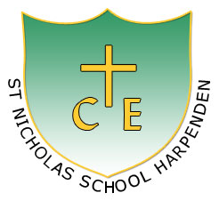
St Nicholas Primary School
Person Specification for Class teacher

