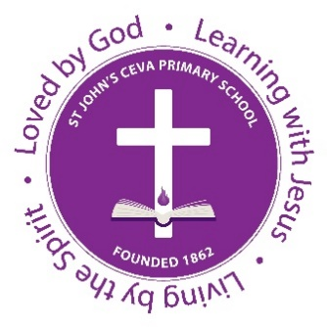
Key Stage 2 Teacher

St John’s CEVA Primary School
Victory Road
Ipswich
Suffolk
IP4 4LE
Tel: 01473 727554

Salary: MPR 4 £31,778 – UPR 1 £38,690
Contract type: Full Time
Contract term: Start date to be agreed from 01/09/2021.
Initial Fixed Term for 1 year pending permanent appointment.

At St. John's CEVA Primary School we are educated for life with the love of God and Christian values at the heart of our school.
We are looking for an exemplary primary practitioner.
You should:
- Have a clear commitment to the school's strong Christian values
- Be an outstanding teacher with a positive attitude and the highest expectations of pupils' attainment and behaviour
- Have a commitment to high standards of teaching and learning
- Display an ability to promote and develop the inclusion of all learners
- Be able to demonstrate excellent interpersonal skills with staff, parents, governors and the community
We will offer you:
- A welcoming school which has a strong vision, Christian ethos and a relentless determination to provide the very best for ALL
- enthusiastic, happy and confident children who are proud of their school
- a highly motivated staff team who are committed to continuing to build on the many strengths of the school
- a supportive and proactive Governing Body
- Opportunities for continuous professional development
Visits are warmly welcomed and recommended. Please contact Mrs. Frost, our school administrator, on 01473 727554 or via email office@st-johns.suffolk.sch.uk for an appointment.
St John’s is committed to safeguarding and promoting the welfare of children and young people and expects all staff and volunteers to share this commitment. The successful applicant will be required to undertake an DBS
Application Close Date: Friday 18th^{th} June 2021
Interview Date: Tuesday 29th June 2021
For more information and to apply online: www.teachingjobsdirect.org

