Primary, Secondary & Sixth Form

“A SCHOOL FOR EVERYONE…” Ofsted 2020
KS2 Teacher
Primary Phase

An Introduction to Washwood Heath Academy and the Primary Phase

In March 2019, Washwood Primary pupils and staff moved into the purpose built Primary building on the Washwood Heath Academy campus. It is a beautiful building with excellent teaching and learning facilities for children and staff. The Primary building is separate from the Secondary buildings, with its own playgrounds, but with access to Secondary facilities including music rooms, Science Labs, PE facilities, Drama studio, Art rooms and outside space. We plan and develop our ‘All Through’ activities to enable us to work together at opportunities throughout the year, including during Sports Days, Workshops, Library Events, Awards Ceremonies, Assemblies, Concerts and other events and celebrations.
Within the primary phase at Washwood Heath Academy, we believe in creating and sustaining a positive and uplifting culture for our children and each other. We are a caring and nurturing environment, which aims to develop all of our core HEARTS values: Happiness, Excellence, Achievement, Respect, Resilience, Tolerance and Self-Belief. We go above and beyond to ensure that everybody within our school community feels respected, challenged, supported and safe. We believe in being: Ready, Respectful and Safe and we expect all visitors to our school to uphold our three rules. We aim to provide our children with an excellent curriculum providing high-quality teaching and learning which equips our pupils with the right tools for them to achieve and to provide them with the most effective environment that ignites curiosity and wonder. We support our families in ensuring that they too, can provide the right environment for our children to learn effectively and to grow securely academically, emotionally and mentally. Together as one school, Washwood Heath Academy provides a safe and caring environment for our pupils led by highly-effective staff whose main aim is to ensure a continuing ethos of a love for for learning, quality education, resilience and respect whilst receiving excellent teaching and learning.
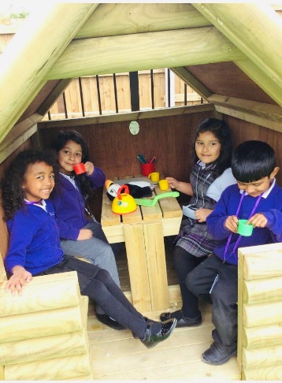
Washwood Heath Academy is a large All Through Academy with almost 1700 learners across the key stages. The Primary phase is a 1 form entry school which ensures we can care and cater for the needs of all in a caring and family orientated way. Every year, our 30 Year 6 pupils transition into Washwood Heath Year 7 and join a further 250 children from other local primary schools. In addition to teaching staff and teaching assistants, the Primary phase currently has a Pastoral Manager, SENCO, Assistant Head and Head of Primary Phase. The Primary phase works closely with the secondary phase and enjoys a special relationship, which positively benefits all.
In March 2020, Washwood Heath Academy experienced its first Ofsted inspection as an All-through Academy and was graded ‘Good’ in all categories. Ofsted reported that ‘Leaders have a clear and ambitious view of what pupils should learn. They have reviewed the curriculum, and made changes in short and longer term’. In September 2019, Washwood Heath Academy embarked on its journey to develop and implement a knowledge-rich curriculum across all phases of the Academy. To date, we have embedded a knowledge-rich curriculum into Key Stage 3 and Key 4 subject areas and is continuing to develop well in the Primary phase. In addition, we have embedded Direct Instruction into Key Stage 3 and Key Stage 2, which successfully supports the catch up and learning of children within these phases. We are looking for a Key Stage 2 teacher to work alongside Primary and Secondary colleagues to further enhance the teaching and learning of pupils and the further enhancement of the curriculum. Staff at Washwood Heath Academy use research to help improve teaching and learning, curriculum and pastoral care.
Due to the Pandemic, we do not have a set of results for Year 2 or Year 6 SATs so far. Nevertheless, our Primary pupils make good progress and our Year 1 pupils have achieved impressive phonics results. In March 2020, Ofsted praised the ‘sharp focus on the teaching of early reading, and children learn phonics from the start’.
Finally, Washwood Heath Academy really is ‘a school for everyone’ and a significant number of staff have remained at Washwood for many years because they enjoy being part of a family and working in a caring and supportive community that wants the best for all of its young people and staff.

JOB DESCRIPTION

JOB TITLE | Key Stage 2 Teacher
GRADE | Mainscale/UPS
REPORTS TO | Head of Primary Phase
LIAISON WITH | Teachers, Support staff, Creditors, Debtors, Site Team, Pupils and Parents.
Job Purpose | - To implement and deliver an appropriately broad, balanced, relevant and knowledge-rich curriculum for students and to support the Primary curriculum area as required.  - To monitor and support the overall progress and development of students as a teacher.  - To facilitate and encourage a learning experience which provides students with the opportunity to achieve their individual potential, regardless of the starting points.  - To contribute to raising standards of achievement and maximising student attainment.  - To share and support the school’s responsibility to provide and monitor opportunities for personal and academic growth  - To be committed to the safeguarding of children.
Reporting to | Head of Primary Phase
Liaising with | Head teacher/Head of Primary Phase/Senior Leadership Team, teaching and support staff, Multi Academy colleagues, external agencies and parents.
Main Duties
Teaching | - To provide a broad, balanced and relevant curriculum that engages all students.  - To provide excellent teaching and learning that meets the needs of all children, despite their starting points and is reflective of our community whilst providing cultural capital.  - To ensure the physical and emotional well-being of all students in our school.  - To use teaching strategies which will stimulate learning appropriate to student needs and demands of the curriculum.  - To mark, grade and give written and verbal and diagnostic feedback to students of individual work and group work they have undertaken.  - To assess, record and report on the attendance, progress, development and attainment of students and to keep such records as required.  - To work within the National Standards designated to the role of Classroom Teacher.  - To prepare and update subject and class materials ready for delivery of the lesson or series of lessons.  - To uphold and maintain the school’s philosophy and vision for the education of our students; behaviour and respect for others; to promote understanding of the school’s rules and values; to encourage good practice with regard to punctuality, behaviour, standards of work and homework.  - To safeguard, follow health and safety, and to develop relationships with and between students conducive to optimum learning.  - To undertake assessment of students as requested by external examination bodies, phase and school procedures.
Operational/ Strategic Planning | - To plan and prepare courses, schemes of work and individual lessons, appropriate to the needs, interests, experience and existing knowledge of students.  - To assist in the development of appropriate curriculum programmes, resources, schemes of work, marking policies and teaching strategies within the Primary phase.  - To contribute to the Primary phase Improvement Plan and its implementation.  - To contribute to the whole school’s planning activities  - To contribute to the department process of self-review and evaluation and Improvement Plan activities.  - To contribute to department and whole school enrichment and cultural capital opportunities.  - To contribute to department intervention and after school clubs.
Curriculum Provision and Development: | - To assist the Head of Primary and Key Stage Lead to ensure that the curriculum area provides a range of teaching which complements the school’s strategic objectives.  - To assist in the process of curriculum development and make necessary change to ensure the continued relevance to the needs of students, exams and the school’s Strategic Commitment, Purpose and Intent.  - To lead a subject area, following the school requirements and ensuring quality planning, provision, monitoring and improvement.
Staffing  Staff Development:  Recruitment/ Deployment of Staff | - To take part in the school’s staff development programme by participating in arrangements for further training and professional development.  - To continue personal development in the relevant areas including subject knowledge and teaching methods.  - To engage actively in the Performance Appraisal Review process.  - To ensure the effective/efficient deployment of classroom support.  - To work as a team member and to contribute positively to effective working relations within the school.
Quality Assurance: | - To adhere to and to help to implement school quality procedures.  - To contribute to the process of monitoring and evaluation of the Primary phase in line with school procedures, including evaluation against quality standards and performance criteria. To implement modifications and improvement where required.  - To review methods of teaching and programmes of work.  - To take part, as may be required, in the review, development and management of activities relating to the curriculum, organisation and pastoral functions of the school.
Management Information | - To maintain appropriate records and to provide relevant accurate and up-to-date information for the school’s management information system.  - To complete the relevant documentation to assist in the tracking of students.  - To track the progress of students and use this information to inform your teaching and learning.
Communication: | - To communicate effectively with the parents of students as appropriate  - Where appropriate, to communicate and co-operate with persons or bodies outside the school  - To follow agreed policies for communications in the school  - Attend meetings according to the school’s Directed Time Policy  - To take part in liaison activities such as Open Evenings, Parents’ Evenings and liaison events with other schools in the Multi Academy Trust  - To contribute to the development of effective subject links with external agencies/schools
Other duties / General | - To adhere to the ethos of and contribute to the overall purpose of WHMAT, as set out in its strategic plan.  - To adhere to WHMAT’s values as set out in its strategic plan  - To play a full part in the life of the school community, to support its Strategic Commitment, Purpose and Intent and to encourage staff and students to follow this example.  - To actively promote the school’s policies.  - To continue personal, professional development / growth.  - To actively engage in the school’s self-review and evaluation processes.  - To actively engage in the school’s Appraisal of Performance processes.  - To comply with the school’s Health and Safety Policy and undertake risk assessments as appropriate.  - To attend meetings as determined in the meetings policy and as directed by the Head of Academy.  - To undertake any other duty as specified by School Teachers’ Pay and Conditions Document, not mentioned in the above.  - To comply with the school’s procedures concerning safeguarding and to ensure that training is accessed, including protection, health and safety, security, confidentiality and data protection, adhering to GDPR.  This job description is not a comprehensive definition of the post. Discussions will take place on a regular basis to clarify individual responsibilities within the general framework and character of the post as identified below. The conditions of employment of teachers in the School Teachers’ Pay and Conditions of Service Document apply to this post, whose holder is expected to carry out any other professional duties of a teacher as other circumstances may require, under the reasonable direction of the Head of Primary / Academy.

JOB TITLE | KS2 Teacher
PERSON SPECIFICATION
 | Essential | Desirable | Method of Assessment
Knowledge/Qualifications
Degree in Primary Education or PGCE |  |  | Application
Qualified Teacher Status |  |  | Application
A willingness to undertake further relevant training and to pass those skills on to other members of staff as appropriate |  |  | Interview
Sound knowledge of the developments in the Primary curriculum |  |  | Application/Interview
Sound pedagogical knowledge on teaching and learning, especially Rosenshine’s Principles |  |  | Application / Interview
Good ICT skills |  |  | Application/Interview
Experience
Enthusiasm and passion for teaching |  |  | Application/Interview
Excellence as a classroom practitioner |  |  | Application/Interview
Experience of teaching in KS2
Experience of KS1 / EYFS |  |  | Application/Interview
Imagination and creativity in the classroom |  |  | Application/Interview
Experience in developing schemes of learning |  |  | Application/Interview
A commitment to the extra-curricular life of the school |  |  | Application/Interview
A commitment to safeguarding and promoting the welfare of children and young people |  |  | Application/Interview
A commitment to obtaining the highest standards of pupil achievement and a belief that enjoyable learning is the most effective learning |  |  | Application/Interview
A commitment to the school’s Strategic Purpose, Commitment and Intent |  |  | Application/Interview
Experience in leading a curriculum subject
Personal Skills
An effective team member |  |  | Application/Interview
Ability to work under pressure |  |  | Application/Interview
Excellent communication skills |  |  | Application/Interview
Able to motivate and inspire students |  |  | Application/Interview
An excellent teacher with enthusiasm and a commitment to education and developing young people |  |  | Application/Interview
Able to develop good personal relationships with students and adults |  |  | Application/Interview
Approachable and willing to help students both in and outside of lessons |  |  | Application/Interview
Ability to initiate ideas
Ability to set own targets and meet own and other  people’s deadlines |  |  | Application/Interview
Equal Opportunities
Must have an understanding of and commitment to the Trust’s equal opportunities policies and procedures |  |  | Application/Interview
To be able to demonstrate a commitment to celebrating diversity and promoting community cohesion in a multi-cultural setting |  |  | Application/Interview

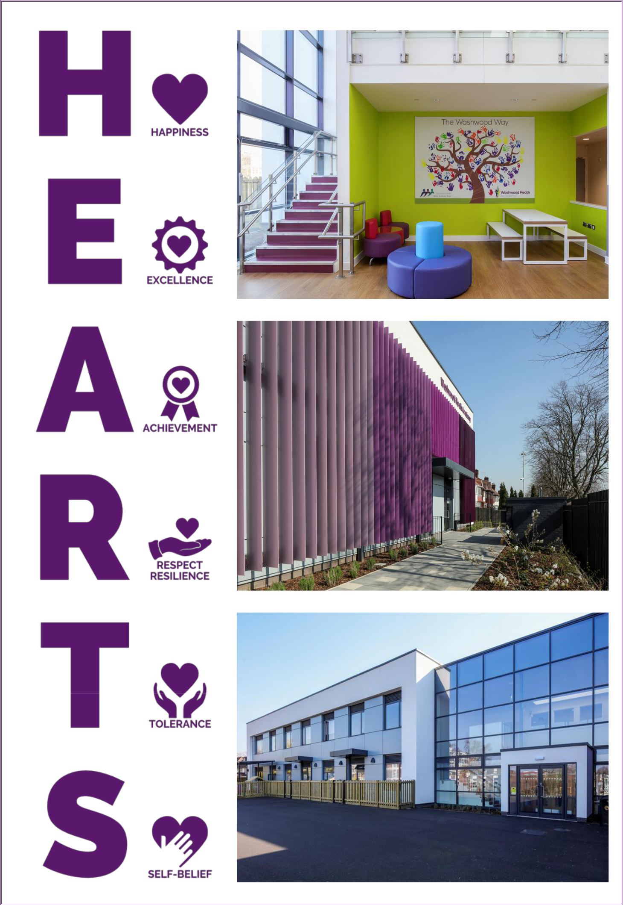
Primary, Secondary & Sixth Form

