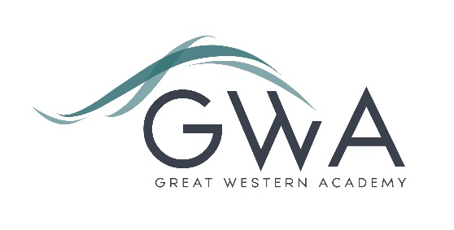

Information for Applicants

Key Stage 3 Specialist Teacher
Full-time or Part-time, Main/Upper Pay Scale
Great Western Academy opened in September 2018 and now accommodates over 950 students in years 7 to 11 and the Sixth Form. The school is heavily oversubscribed in years 7 to 11 and the Sixth Form is flourishing. Our first GCSE results in summer 2023 showed that the progress made by the large majority of our first cohort of year 11 students has been excellent, particularly in English and Maths. The results of our first three A-level cohorts in summer 2021, 2022 and 2023 were excellent and enabled 98% of university applicants to take up their offers, including three to Oxford and Cambridge: students have also secured prestigious apprenticeships with companies such as Airbus and Rolls Royce. We believe firmly that strong outcomes follow from high expectations, high quality teaching, and strong support in terms of behaviour structures and targeted academic and pastoral interventions.
This role will provide the successful applicant with the chance to teach across Key Stage 3, focusing on subjects where you have expertise or experience. This could include any subject, though the ability to provide lessons in one or more of English, Maths or Humanities would be an asset. We are particularly interested in staff who are passionate about ensuring that the transition from primary to secondary school is as effective as possible, and experience in teaching Key Stage 2 or working with primary age students would support your application. There is scope for the role to develop further in coming years, whether leading aspects of our whole school work at Key Stage 3, or widening your own practice into Key Stage 4 lessons or post-16 teaching in our Sixth Form.
Our priority is very much to recruit the best classroom practitioners who can ensure our students arrive at the Academy excited about the day ahead and leave each day talking about the excellent learning they have experienced. To this end the staff have the freedom and creativity to develop lessons within GWA’s framework of Teaching and Learning and faculty expectations. Staff are not prescribed to deliver identically structured lessons. Whether you are an ECT or an experienced teacher your input will be valued and integral to all the department does.
Application process

Please complete the application form and equalities form supplied and enclose a supporting letter, either in the space provided on the application form or as a separate document. The application form should be completed in full in black ink or type. A CV is not required and should not be submitted as part of the application. Please state clearly in your covering letter which subject(s) you wish to offer and whether you are seeking a full or part-time role.

Your supporting letter should be no more than 2 sides of A4 (with a font size no smaller than 11) and should enhance your application by providing further information, matched to the person specification, about your suitability for the post. This should include evidence of the impact on student outcomes you have made in your career to date.

Applications should be submitted electronically to recruitment@gwacademy.co.uk by 9am on Monday 15th April 2024. Interviews will take place as soon as possible after this date. Please note we may interview before the closing date (and close the advert early) depending on the suitability, and number of, applicants.
Great Western Academy is committed to safeguarding and promoting the welfare of children, young people and vulnerable adults and we expect all staff to share this commitment and undergo appropriate checks. All posts within the Trust are therefore subject to an Enhanced DBS and barred list check.

References: References will be taken up prior to interview.

