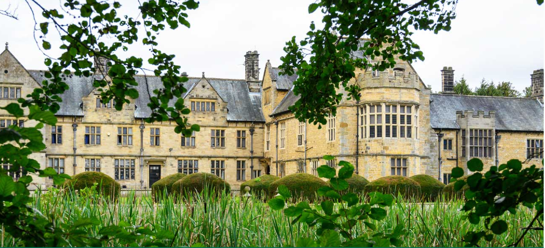


Welburn Hall School
Teachers
Recruitment Information Pack



CONTENTS

About us 3
Our Vision and Values 4
Our pupils and staff 5
Application Process 6
Job Description and Person Specification 7
Application guidance 11




OUR VISION & VALUES
Welburn Hall school will continue to be locally and nationally recognised as a specialist provision for autism and complex needs. We remain committed to being a centre of excellence. We will continue to provide high quality support, teaching and outcomes for our pupils, families and local schools.

ABOUT US

Welburn Hall is a special school/college for children and young people aged 8 to 19 years with a wide range of special educational needs.

Set in over 20 acres of stunning countryside, Welburn Hall School is situated in the market town of Kirkbymoorside; nestled on the edge of the North York Moors National Park. With dedicated staff, fantastic facilities and beautiful buildings, we create a calm and inspiring place to learn, live and work.

We are a Nurturing School and a National Autistic Society accredited specialist setting. Welburn Hall also boasts a vibrant and successful 6th Form College.

Our aim is to ensure all pupils and students have the opportunities they need to reach their full potential for academic achievement, independence and personal development. We pride ourselves in being a warm and friendly school; our staff are our greatest resource and are highly valued for the contribution and difference they make to the lives of our pupils. Our ethos and core values of respect, perseverance and excellence support this model and are lived out in the daily work of the school.

WELBURN HALL SCHOOL
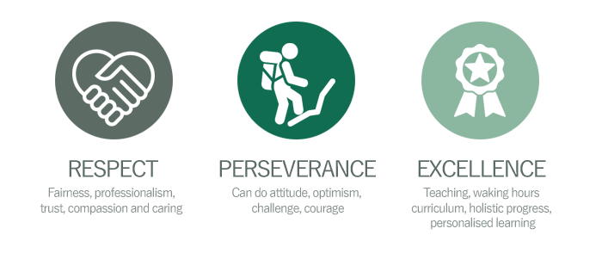


OUR PUPILS

Our curriculum has been developed to ensure it meets the needs of all our pupils and offers a blend of formal and informal learning. We want to enable successful learners, who enjoy learning, make progress and achieve their aspirational goals. We operate different pathways of: preformal, semi-formal, formal, Nurture, bridging. We have ‘communication’ classrooms where appropriate and the whole setting is a neuro-affirmative environment.

As pupils progress and transition into adulthood, we want to develop confident individuals who can live safe, healthy and fulfilling lives as independently as possible and are responsible citizens, who can make a positive contribution to society and their communities.

“Thank you doesn't even cover what I can say to you all; it's about 1% of what you all deserve but I don't know how to say the other 99%, just know I would if I could find the words.”

A Welburn Hall School parent
“Welburn Hall School is a warm and caring school. All staff want the very best for the
pupils who attend. As such, ambitions are high.”
Ofsted 2022

“Staff, both teaching and non-teaching, know their pupils well. Strong bonds have been forged between staff and pupils. Relationships are at the heart of the school…Staff expect pupils to achieve, which they do. Not least, this is because pupils are understood, treated and respected as individuals”

Ofsted 2022

OUR STAFF

The work we do here and the development of our school would be impossible without our staff, who are an amazing team of dedicated and highly skilled people.
We are very proud of what we’ve achieved so far on our journey and we are supported by an incredibly able and involved governing body.

Further information on our Governors can be found here.

APPLICATION PROCESS

The closing date for all applications is 11th July 2025
Interviews will be held week commencing 14th July

Please apply online via the NYC Jobs Page.
Please contact us should you require an application in a different format.
An email will be sent to candidates with details of the shortlisting outcome.

Queries
Please contact Chloe Bullen on 01609 536 964 or via chloe.bullen@northyorks.gov.uk
Chloe has been engaged to support us with recruiting to this exciting opportunity.
We actively welcome you to contact us to chat through the role and talk informally about the school/post and how working here will make a real difference to the children and young people in the area.
When applying please take into account the following:
Employment History
In line with KCSIE requirements, please complete your full employment history to ensure any gaps in your education and career history are accounted for.

Suitable References
When completing your application, please provide two employment referees. Generally, this should be your current and most recent Headteacher or line manager. Please note if your former Headteacher or line manager has since left, please use an alternative current senior staff member as they need to be in post at your former location to be able to confirm your details in full. Unfortunately, we cannot accept personal references or personal email addresses. Please get in touch for any queries if you are unsure.

Supporting Information
The supporting information section of your application should clearly evidence your ability to meet the requirements we have outlined in the job description & person specification. This will be used to shortlist applicants for this role and therefore it is imperative that you provide evidence as requested.

We are committed to meeting the needs of our diverse community and aim to have a workforce reflecting this diversity. We are also committed to safeguarding and promoting the welfare of children, young people and adults. We have a robust child protection policy and all staff will receive training relevant to their role at induction and throughout employment at the school. We expect all staff and volunteers to share this commitment.
Please note this post is in regulated activity and exempt from the rehabilitation of Offenders Act 1974 and subject to satisfactory references and an enhanced DBS criminal records and barred list check for work with children. An online search may be undertaken as part of the recruitment process on information available in the public domain. Candidates should disclose anything that may be relevant in line with Keeping Children Safe in Education.

JOB DESCRIPTION
Class Teacher at Welburn Hall School

GRADE: Depending on experience

RESPONSIBLE TO: Deputy Headteacher

RESPONSIBLE FOR: Planning, leadership, management and support of staff in leading a class group.
Leadership, management and support of staff in the development and delivery of responsibility areas to be agreed.

JOB PURPOSE: To secure and account for effective learning, appropriate achievement and educational social and personal progress of all pupils in the tutor group and in the assigned area of responsibility, consistent with the aims of the school and the unique needs of each individual learner.

KEY RESPONSIBILITIES:

- Support at all times the school’s moral purpose, aims, ethos and values.

- Uphold a culture that promotes excellence, equality and high expectations.

- Leading, planning, teaching, managing a tutor group and being responsible for the good progress of students within that group.

- Establish and lead the strategic development of the responsibility areas consistent with the agreed aims and policies of the school.

- Secure and sustain effective learning for pupils through leading the well-planned and effectively organised teaching within the responsibility areas, including the professional development of staff.

- Lead, manage and support staff and pupils within the responsibility area to sustain motivation and commitment to high standards of learning and care.

- Plan and be accountable for the effective deployment of allocated resources to secure high quality learning experiences.

- Advise the Deputy Headteacher and governors of suitable developments for the effective teaching in or management of the responsibility areas.

- Report to the Deputy Headteacher in accordance with school procedures.

- Participate in and provide advice on appropriate development activities for staff in areas of responsibility.

To fulfil all of the requirements and duties set out in the current Pay and Conditions Documents relating to the conditions of employment of teachers

To meet the National Standards for Subject Leaders

To achieve any performance criteria or targets related to the management post arising from the School’s Performance Management arrangements

This job description will be reviewed annually.

Whilst this job outline provides a summary of the post, it is not a comprehensive list or description and the job will evolve to meet changing circumstances. Such changes could be commensurate with the grading and conditions of service of the post and would be subject to discussion and consultation. All staff are required to comply with the school’s policies, procedures and ethos.

In relation to Data Protection, Information Security and Confidentiality, all staff are required to comply with the school’s policies and supporting documents in respect of these issues.
Equal Opportunities
North Yorkshire Council supports the principle of equality of opportunity in employment and has a clearly stated policy for Equalities and a copy can be downloaded from www.northyorks.gov.uk The school has its own policy adapted from this.



PERSON SPECIFICATION

Essential Upon Appointment. | Desirable on Appointment
Proven ability to cater for the different learning styles of pupils with a range of learning difficulties.  Successful teaching experience - a very good classroom practitioner who consistently makes learning memorable, impacting on all students to make good progress | Experience of teaching pupils with SEND  Experience of teaching, in both a mainstream and Special School.  Appreciation of the different learning styles of students with a range of learning difficulties.
Qualified Teacher Status | Evidence of continuing professional development.
Ability to lead by example and provide clear direction.  To be able to co-ordinate and lead on a curriculum area  Ability to work in partnership with the class team, organising, planning for (and with) and directing teaching assistants | Ability to formulate, monitor, evaluate and review teaching plans.
A proven track record of securing good progress for students.  Understand the role of assessment in pupils’ learning and the ability to contribute to the collection, analysis and use of  data on students’ progress and performance to raise standards.  The ability to help to promote a culture of learning throughout the college. | An understanding of the principles of effective learning for children with MLD, SLD, PMLD and ASD.
Have very good classroom organisation and management skills including positive behaviour management
Be committed to inclusion and the right of every student to be the best that they can be.  To have a strong philosophy of education that is student centred and a good understanding of AFL and personalised learning | To keep up to date with regard to educational priorities and developments locally and nationally particularly in the area of SEND
Be able to accurately assess where students are at and precisely plan the next steps for learning and personal development | To have knowledge of KS4 accreditation
Make a significant contribution to the Annual Review and reporting process
Have the ability to maintain appropriate relationships and personal boundaries with students.
Have emotional resilience in working with students with challenging behaviours.
To be responsible for a tutor group, maintaining very good and positive relationships with students, parents, staff and governors as well as other multi-disciplinary organisations involved with the pupils | To be aware of the 24 hour curriculum and liaise with key workers and Head of Care. To co-operate in the development of individual risk assessments and educational plans

You should use this information to make the best of your application by identifying some specific pieces of work you may have undertaken in any of these areas. You will be tested in some or all of the skill specific areas over the course of the selection process.



APPLYING FOR A JOB WITH NORTH YORKSHIRE COUNCIL

IMPORTANT ADVICE ON COMPLETING THIS APPLICATION

Your application form plays an important part in your selection. Please ensure you address all the essential requirements listed in the specifications. The following advice should help you to complete the application form as effectively as possible.
Data Protection
The information that you state on this application form will be used by the school and the Council to consider you for a job vacancy. To find out about how we use your personal data for the purposes of recruitment please see our Privacy Notice at www.northyorks.gov.uk/working-us.

Rehabilitation of Offenders
The post you are applying for requires you to have an enhanced Disclosure and Barring Service criminal records check for work with children, with a barred list check if you work in regulated activity. This check for disclosure of criminal history will include spent convictions, pending prosecutions / current court proceeding and police enquiries.

Should you be shortlisted, you will be asked to disclose full details of your criminal history prior to your interview. This includes any information deemed relevant as part of Keeping Children Safe in Education which may arise in an online search undertaken on shortlisted candidates. This information may be discussed with you at your interview in order to assess job related risks, but we emphasise that your application will be considered on merit and ability and you will not be discriminated against unfairly. Failure to disclose this information will result in any offer of employment being withdrawn.

Please also see the policy statement on the Recruitment of Ex-offenders below.

Information in Support of your Application
Every post advertised is supported by a full person specification. The specification lists all the essential skills, experience and qualifications which are necessary for the job and the criteria against which you will be assessed, both through your application form and at interview.

As part of the application process, you may have been asked to demonstrate within this application form how you meet some or all of the criteria or key competencies outlined in the person specification. Rather than simply repeating your career history, look at the skills and experience required by the job and provide evidence that you possess them by giving specific and detailed examples which include a focus on outcomes and on your own contribution to the scenario. Try to use different and varied examples wherever possible.

When completing these sections, do not forget the skills and experience you have gained outside full-time work. Outlining your previous work experience or other responsibilities may help you to uncover skills which you have taken for granted and which are clear signs of your ability to do the job.

Canvassing
You must not try to influence an elected Council Member, any council employee or a member of the school governing body, to act in your favour, as this will disqualify you. If you are related to a Councillor, a Council employee or a governor you must indicate this in the relevant section of the application form.

POLICY STATEMENT ON THE RECRUITMENT OF EX-OFFENDORS

1. As an organisation assessing applicants’ suitability for positions which are included in the Rehabilitation of Offenders Act 1974 (Exceptions) Order using criminal record checks processed through the Disclosure and Barring Service (DBS), this school complies fully with the DBS code of practice and undertakes to treat all applicants for positions fairly.

2. This school undertakes not to discriminate unfairly against any subject of a criminal record check on the basis of a conviction or other information revealed.

3. This school can only ask an individual to provide details of convictions and cautions that it is legally entitled to know about. Where a DBS certificate can legally be requested (where the position is one that is included in the Rehabilitation of Offenders Act 1974 (Exceptions) order 1975 as amended, and where appropriate Policy Act Regulations as amended) this school can only ask an individual about convictions and cautions that are not protected.

4. This school is committed to the fair treatment of its staff and potential staff, regardless of race, gender, religion, sexual orientation, responsibilities for dependents, age, physical/mental disability or offending background.

5. This school has this written policy on the recruitment of ex-offenders, which is made available to all DBS applicants at the start of the recruitment process.

6. This school actively promotes equality of opportunity for all with the right mix of talent, skills and potential and welcome applications from a wide range of candidates, including those with criminal records. Candidates are selected for interview based on their skills, qualifications and experience and criminal record information is only requested from short-listed candidates.

7. A disclosure is only requested from the DBS after a thorough risk assessment has indicated that one is both proportionate and relevant to the position concerned. For those positions where a criminal record check is identified as necessary, all application forms, job adverts and recruitment briefs will contain a statement that a DBS certificate will be requested in the event of the individual being offered the position.

8. This school ensures that all those who are involved in the recruitment process have been suitably trained to identify and assess the relevance and circumstances of offences.

9. This school also ensures that they have received appropriate guidance and training in the relevant legislation relating to the employment of ex-offenders, e.g. the Rehabilitation of Offenders Act 1974.

10. At interview, or in a separate discussion, this school ensures that an open and measured discussion takes place on the subject of any offences or other matter that might be relevant to the position. Failure to reveal information that is directly relevant to the position sought could lead to withdrawal of an offer of employment.

11. This school makes every subject of a criminal record check submitted to DBS aware of the existence of the code of practice and makes a copy available on request.

This school undertakes to discuss any matter revealed on a DBS certificate with the individual seeking the position before withdrawing a conditional offer of employment

