Keighley St Andrew’s CE Primary School
Lustre Street, Keighley, West Yorkshire, BD21 2ND

KEY STAGE TWO CLASS TEACHER (YEAR 4)
MATERNITY COVER
To commence as soon as possible

Teacher Main Pay Scale 1-6

APPLICANT PACK
SEPTEMBER 2021

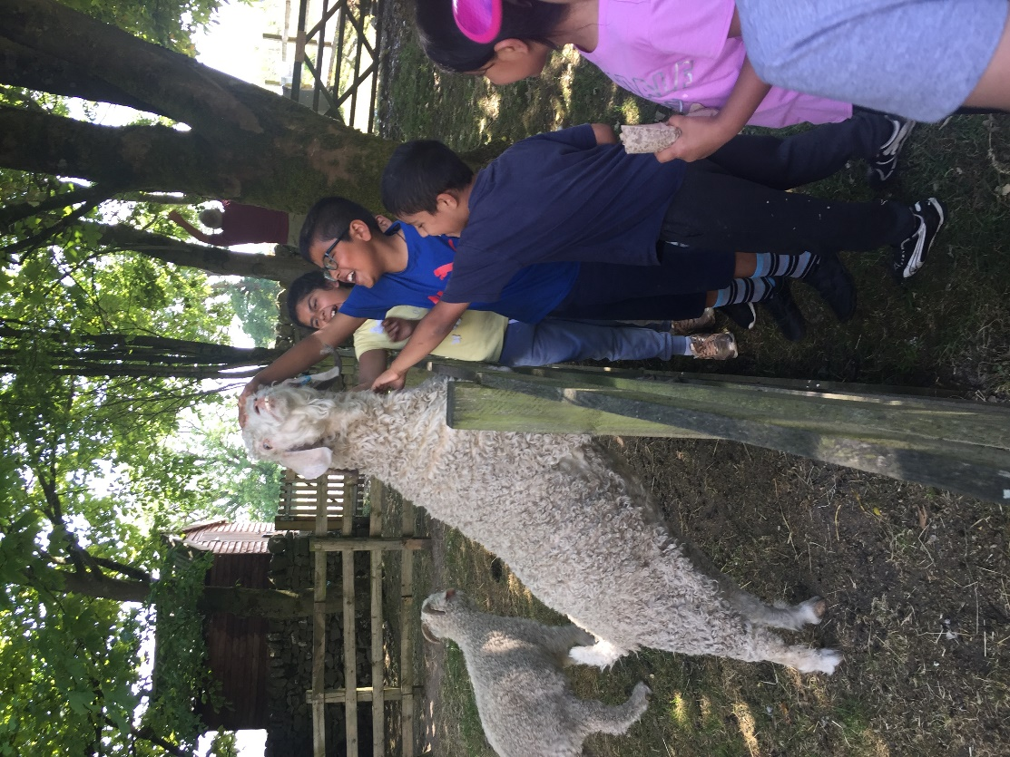

Contents
Head’s introduction
What’s it like to teach and develop at Keighley St. Andrew’s
Our School
Our Curriculum
Recruitment / Application Details
Job Description and Personal Specification

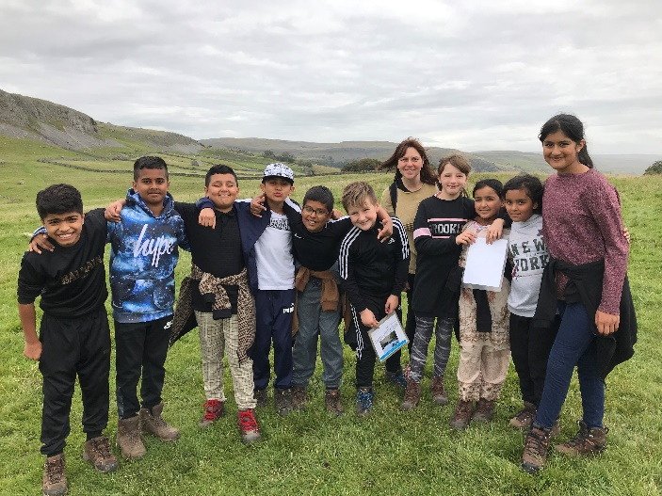
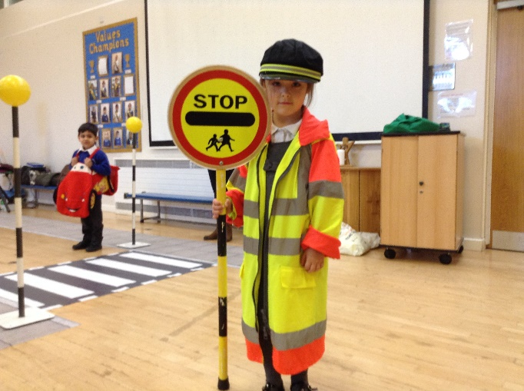

Introduction from the Headteacher
Thank you for showing interest in the role of Key Stage Two Class Teacher (Maternity Cover).
I am incredibly proud of our school community- Our children, staff (including governors) and parents. Together, we strive hard to create a wonderful place to learn and flourish. Our vision is rooted in our Christian ethos and shared school values of: Thankfulness, Peace, Community, Trust, Courage and Compassion.
Our School Vision: Guided by God, we will create a community of learners who will flourish and be filled with hope.
As a school community, we are committed to providing all learners with the skills, knowledge and experiences, which will enable them to flourish academically and personally. We value parent partnership and the contribution that parents can make to their child’s education.
Every day is a learning opportunity – whether child, parent or member of staff. We offer regular opportunities to develop home/school partnerships through a varied programme of events and courses to support learning and well-being (for both children and adults). Our staff also receive ongoing training and development so that they are also equipped with the skills to provide your children with the very best education and experiences.
We strongly encourage and recommend all prospective applicants to make an appointment to visit school (in line with our Covid risk assessment). Please phone Mrs. Reynard / Miss Hanif in our school office to arrange an appointment to visit or speak with a member of the Senior Leadership Team to find out more about the role and school.
Email: recruitment@standrews-primary.co.uk
Phone: 01535 604656
Website: www.standrews-primary.co.uk

Mrs Rachel Whitham
Headteacher

What’s it like to Teach and Develop at Keighley St. Andrew’s?
Don’t take it from me… Here’s what our teachers and aspiring leaders say:

Keighley St Andrew’s has consistently and proactively supported me in my professional development. I began my teaching career here as a Teach First participant. I received amazing support throughout my unqualified and NQT years, invited to attend a wide range of training courses and actively encouraged to trial the techniques I learnt on them and share these with my colleagues, delivering my first staff meeting in my first year as a teacher – scary but immensely valuable for my confidence and professional development. This professional development is something that has continued throughout my time at KSA. Once qualified, I was fully supported to pursue a two-year Masters degree, and given the encouragement and flexibility I needed to complete this to my full potential. Taking into account my desire to move into middle leadership, I was encouraged by leaders to apply for a middle leadership programme, which I have been completing during this academic year. The support and engagement I have felt from my colleagues and leaders while on this programme has been incredibly encouraging and motivating, and has really made a difference to an area of our school curriculum. As part of this course, I was offered the opportunity to attend a 9-day residential at the STEM learning centre, an opportunity that has significantly contributed to my development as a subject leader. This year, I was also given the opportunity to transition from year 5 to Early Years, and although initially nervous about this significant change, the support I received has made the experience a really positive one. Overall, the support, encouragement and opportunities I have received at KSA have helped me develop both personally and professionally. I look forward to the future opportunities that working in this school holds for me.

I immediately felt a valued and respected member of staff within a strong team. The leadership team at KSA are highly motivated and work closely with staff to move school in the right direction; they embrace positive change and provide endless opportunities for staff to develop both personally and professionally.
In my short time at KSA I have already been given the opportunity to lead staff meetings to develop reading across EYFS and KS1, I am also working to develop history as a subject area across the whole school as well as form part of a newly developed curriculum development team. I have also thoroughly enjoyed mentoring a SCITT student during a planned placement as well as supporting a member of staff through her HLTA course.
There are many exciting opportunities to be part of at KSA and I feel the continued professional development of staff is both nurtured and encouraged.

The wealth of opportunities during my time at Keighley St Andrews has enabled me to flourish in my teaching career and on a personal level. The encouragement and motivation from the leadership team has given me the confidence and knowledge to take on new roles within school. As an RQT, I was enrolled onto an Implementing and Leading Lesson Study course at Sheffield Hallam University. Keighley St Andrew’s were one of the first schools in the country to work towards this qualification and I was thrilled to be a part of it. The training made me realise just how important ongoing research is to develop teaching and learning and this inspired me to continue to improve my practice.

After attending a range of courses over the period of a year, I became the oracy lead for our school. I worked alongside Parkwood Primary to gain knowledge and experience of a dialogic classroom, which has led me to deliver staff training and effectively disseminate these strategies to teachers and HLTAs across school. This development opportunity has also led me towards the role of developing vocabulary through dialogic strategies.
My recent CPD training with Noctua and Literacy Trust has provided me with further knowledge to support our school’s aim to improve vocabulary across the curriculum and I have thoroughly enjoyed sharing activities and strategies with my colleagues.
Over the past term, I have also worked alongside leaders from Primary and Secondary schools across Keighley. We have been working together to create a bespoke activity passport, tailored to the needs of Keighley children. I am looking forward to rolling this out into our school to provide our children with a variety of skills and life experiences that they will cherish forever.
I think it is fantastic that our school is enthusiastic about the continuous professional development of staff. We value the learning of both pupils and staff in school and I am grateful for the continuous support I have received during my time here.

Our School
Keighley St. Andrew’s Church of England Primary School sits just outside the centre of Keighley.
- 2 form entry with a 30-hour Nursery
- Class sizes between 24 and 30 pupils
- School is well resourced with Support Staff (teaching assistants) to support the learning and independence of our children with additional need
- Well stocked School Library
- ICT suite
- I-Pads and Net Books for pupils and staff
- Staff laptop
- Each class has a visualiser to support feedback and teacher demonstration
- School minibus
- Active partnership and access to training (Northern Lights, Noctua and Bradford Birth to 19 Teaching School, English Hub, The Literacy Trust, Bradford Teaching Schools)
- Strong partnership with Initial Teacher Training Providers – Leeds Beckett University, Bradford Birth to 19
- Pupil School Council and Pupil Workforce
- Experiences such as: Visits to farms, outdoor learning, Residential Visits to the Yorkshire Dales (Ingleborough Hall and Halton Gill) – Pony Trekking, Caving, Gorge Scrambling
- Mental Health First Aider (to support adults with wellbeing and mental health)
- Mental Health Champion (to support children)

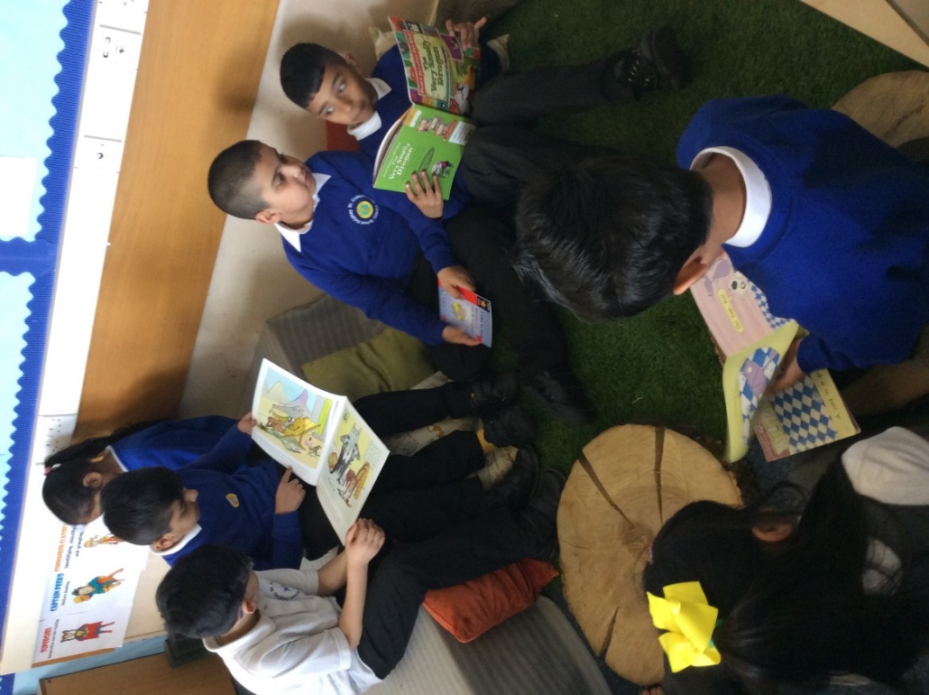

Our Curriculum
We know that it is essential that our children develop fluency and confidence in Mathematics and English so that they have the foundations to deepen their knowledge and learn across all subjects.
Vocabulary Development and Reading
It is crucial that children can develop a love of reading and wide vocabulary throughout their time at Keighley St. Andrew’s. School enjoys working with the Burley English Hub, National Literacy Trust and teaching schools across Keighley, Bradford and Leeds (Northern Lights, Bradford Birth to 19 and Noctua) to ensure that our training and development for both new and more experienced teachers is the best it can possibly be. We are committed to developing teachers and aspiring leaders so that training and development can take place both within and outside of school.
School uses the ‘Read, Write, Inc’ programme for the teaching of Early reading and phonics. Our phonics lead provides regularly coaching and mentoring to all staff who teach phonics.
In Key Stage 2 we use ‘Bug Club’ reading as a springboard for the development of comprehension skills and vocabulary. We have devised our own teaching sequence which ensures that the development and revision of new vocabulary and fluency are integral.
Daily story time using quality texts is a much-loved part of our curriculum and a chance for all to develop a love of reading and vocabulary through a broad diet of authors and genres throughout school.
Since 2016 our results have shown year on year improvement. In 2019, a third of our children left KS2 attaining the Higher Standard in reading.
Mathematics at Keighley St. Andrew’s
We use the White Rose Maths medium-term plans as a basis for our daily planning. The ‘Concrete, Pictorial, Abstract’ approach is one which really benefits our learners. That is also underpinned by a consistent diet of practising of number facts on a daily basis so that our learners have the fluency and confidence to work with larger numbers and multiple operations. Our maths lead and several members of staff have been developed by White Rose and the National Centre for Excellence in the Teaching of Mathematics (NCETM) so they are well placed to work alongside new and more experienced teachers to provide coaching, mentoring and be there as a source of advice and guidance.
Since 2016 standards in Mathematics have risen year on year. We believe that is due to our commitment to staff development and consistency of delivery which enable all our pupils to feel confident in grappling with new learning in maths.
Curriculum Intent and Development
We recognise that English and Maths help unlock potential in other subjects but also understand and value the role that other subjects play. We balance the acquisition of knowledge with opportunities for our children to develop their oracy skills, creativity and learn through experience.
Visitors, events and educational visits are important to us as they help our pupils make sense of the knowledge and also help them develop co-operation, empathy and resilience.
We are keen to develop our pupils’ creativity in the arts and have developed our Art Curriculum so that our children can build skills and knowledge relating to techniques, art forms and artists both traditional and contemporary. During our art lessons, our children develop vocabulary too, with enquiry relating to artists and art appreciation and practising the skills which our chosen artists use/d.
We use the Charanga program to teach music and our Year 4 and 5 pupils have weekly Ukelele lessons.
Religious Education is taught using the Understanding Christianity resource and schemes from the Diocese and allows children plentiful opportunities to ask, explore and answer ‘Big Questions.’ Our children love RE lessons as they are engaged in lots of discussion and reflection.
Computing is taught using the Purple Mash scheme as a starting point. We also have i-pads, net books and a designated computer suite to support computing and learning using ICT. Staff receive training to support their computing knowledge.
Sustainable Development Goals / Environmental Awareness
We have developed our own curriculum units of work based around the United Nations Sustainable Development Goals. We understand that the knowledge which our children acquire will equip them with the skills and knowledge to make changes for a better world.
Pupils experience: designing and making reusable shopping bags from recycled t-shirts and showing these off in a fashion show; visiting supermarkets to investigate where our produce comes from and waste. Growing vegetables in an aeroponic tower garden; designing, publishing and handing out leaflets about food waste in our shopping centre. Running a Pay as You Feel stall at school and in the town centre and using supermarket waste produce in our Cooking Club and a local food kitchen.
During the pandemic we have still worked hard to provide our learners with experiences. In 2020 – 21 – these included:
- A visit from Zoolab where our EYFS pupils handled and observed exotic insects and reptiles such as snakes, tarantulas and giant millipedes;
- A virtual visit / online demonstration of birds of prey;
- A live question and answer session with UK Parliament;
- A virtual reality headset experience (Earth and Space) themed;
- A Stone Age Explorer workshop
- Pony Trekking

Other things which make ‘Keighley St. Andrew’s:
- Values Champions – children and staff ‘spot’ when our values of ‘Thankfulness, Compassion, Trust, Courage, Community and Peace’ are put in to action by others. A weekly champion is chosen and celebrated.
- Year 6 Workforce: Our Year 6 pupils experience the World of Work by applying for in school jobs such as Play Leader, Eco-Crew, Reading Buddy. If successful they receive a special ‘CREW’ gilet and weekly pay tokens.
- Young Leaders – Our Year 5 children experience leadership at a school and local level; fund raise and complete tasks in the community both individually and in teams. Last year they worked with local churches and the council on community clear-ups, coffee mornings for parishioners. They also learn about influential leaders through history and research charities so that they can make informed decisions about fundraising.
- Collective Worship: Daily collective worship is planned by teachers, classes and pupils. Our pupils love being part of Worship Council where they plan and lead acts of collective worship.
- School Council: These are nominated and lead on fund raising and social projects in schools; they have: visited the London and the Houses of Parliament; represented school at a Gala Dinner in Leeds
- Outdoor Learning – Activities and experiences include: Archery, Nature Sculpture, Canal Visits, Den Building, Problem solving/team building and orienteering
- Inter Schools Sports Competitions: Football, triathlon, athletics and multi-skills
- Linking School Project: Year 3 students have partnered with Y3 students from a church School in Bradford to develop and understanding of the wider locality; and build values/ attitudes such as empathy and tolerance
- Residential Visits to Ingleborough Hall and Halton Gill where children pony trek, go fishing, caving, gorge scrambling, orienteering, hill walking and much more.

How to Apply
Interested candidates are requested to apply online for either of these posts. Via https://prospectsonline.co.uk/
or the DfE teacher Vacancies website:
https://teaching-vacancies.service.gov.uk/
Please ensure you read the application details and check you meet the criteria before completing an application form.
Closing Date: Monday 20th September@ 9am
Interviews / Recruitment tasks including observation of teaching
Thursday 23rd / Friday 24th September 2021
Safeguarding Statement
The school is committed to safeguarding and promoting the welfare of children and young people and expects all staff to share this commitment. The post is subject to an enhanced DBS check and satisfactory references.

Class teacher Job Description and Person Specification

Post: Class Teacher

Salary Scale: Main Pay Range

The following information is provided to assist staff joining Keighley St.Andrew’s C of E Primary School to understand and appreciate the work content of their post and the role they are to play in the organisation. The following points should be noted:

1. Whilst every endeavour has been made to outline the main duties and responsibilities of the post, a document such as this does not permit every item to be specified in detail. Broad headings, therefore, may have been used below, in which case all the usual associated routines are naturally included in the job profile.

2. Employees should not refuse to undertake work which is not specified on this form, but they should record any additional duties they are required to perform and these will be taken into account when the post is reviewed.

3. Keighley St.Andrew’s C of E Primary is an Equal Opportunities Employer and requires its employees to comply with all current equality policies in terms of equal opportunity for employment.

4. We are committed, where possible, to making any necessary reasonable adjustments to the job role and the working environment that would enable access to employment opportunities for disabled job applicants or continued employment for any employee who develops a disabling condition.

Line of Responsibility

The Class Teacher is directly responsible to the Headteacher.

Prime Objectives of the Post

As a primary school teacher you will be a strong classroom practitioner who consistently demonstrates the highest standards of planning, provision and delivery. You should be fully committed to raising and maintaining high levels of achievement across the whole school and across all subjects that you are required to teach. You will be acutely aware of the strategies required to achieve the highest standards across the curriculum.

You may from time to time be required to undertake other duties commensurate with the grade and level of responsibility defined in this job description. As a classroom teacher you will, at all times, be mindful of, and adhere to, the Professional Standards for Teachers and the Career Stage Expectations negotiated and adopted by the school at any time.

Purpose of Job

Teaching

- Contributing to the preparation and development of sequences of work, teaching materials and programmes, methods of teaching and assessment and pastoral arrangements throughout the school, including school trips, special assemblies, performances and special events;
- Planning, preparing and teaching lessons according to the individual needs of pupils, having high expectations of all pupils regardless or ability or background and setting challenging targets so as they achieve well;
- Promote the inclusion and acceptance of all children from a range of different backgrounds within the classroom ensuring equal access to lessons and their content;
- Providing feedback to pupils in line with the Keighley St.Andrew’s C of E Feedback Policy;
- To maintain strong behaviour among pupils throughout the school, in line with the Behaviour Policy;
- Keeping up to date assessments on the development, progress and attainment of pupils and recording and reporting these assessments in line with the school assessment procedures;
- Administering assessment tasks and tests in line with school policy;
- To arrange for the display of pupils’ work in central areas as requested by the Headteacher.

Management

- To plan, organise and manage the work of support staff assigned to the class, in order to have a positive impact on pupil progress and well-being;
- To liaise with the Inclusion Leader/SENDCo to contribute to the planning and organising of the work of support staff in order to have a positive impact on pupil progress and well-being;
- To ensure that the support staff of the class meets all of the responsibilities as set out in their job description in a timely and effective manner.

Training and Development

- Participate in CPD activities in school or with other providers in order to improve professional skills and knowledge;
- To contribute to and participate in staff meetings which relate to the curriculum, administration or organisation of the school, including pastoral arrangements;
- To participate to and contribute towards appraisal reviews in line with school policy;
- To keep up to date with current trends and research and to debate as appropriate.

Other Activities

- To promote the positive Church ethos and Values based culture of the school to other staff, governors, parents, children and members of the wider community;
- Comply with, support and promote all school policies and procedures, particularly those relating to child protection, equal opportunities, equality, health, safety and security, confidentiality, behaviour and data protection, reporting concerns to the Headteacher;
- To provide advice and guidance to pupils and parents on educational, emotional, behavioural and social matters in line with school policies and in consultation with the Headteacher;
- Keep records and make reports on the personal and social needs of pupils through CPOMs;
- Communicate and co-operate with other agencies to support the educational development and well-being of individual pupils and to participate in meetings arranged for any purposes described above;
- To act upon and inform the Safeguarding Team immediately of any concerns regarding pupil welfare;
- To communicate and consult with parents and provide an accurate written annual report for parents;
- To safeguard every pupil’s health, safety and well being in line with school policies;
- To lead on school assemblies and to attend assemblies at all times;
- To supervise pupils throughout the school during playtimes and other times requested by the Headteacher.

To carry out any other duties reasonably requested by the Headteacher or Deputy Headteacher and line manager. The duties may be varied to meet changed circumstances in a manner compatible with the post held, at the reasonable direction of the Headteacher. This job description does not form part of the contract of employment. It describes the way in which the teacher is expected and required to perform and complete the particular duties as set out above.

Environmental Demands / Working Conditions

- Will have long periods of sitting or standing;
- Available to work during school hours (directed time) during term time and a willingness to be flexible as may be required to attend staff meetings/training sessions outside of usual hours;
- Will have contact with members of the public/other professionals e.g. teaching staff, governors, parents/carers, community groups, local authority, external providers etc;
- The post holder may occasionally be subjected to antisocial behaviour from stakeholders;
- This post may include a degree of manual lifting and handling. You are expected to be aware of health and safety policies and procedures and frequently assess your ability to carry out the lifting tasks required of you;
- Report all concerns to an appropriate person.

Fluency Duty

In line with the Immigration Act 2016; the Government has created a duty to ensure that all Public Authority staff working in customer facing roles can speak fluent English to an appropriate standard.

For this role the post holder is required to meet the Advanced Threshold Level.

Advanced Threshold Level

The post holder should demonstrate the can:

- Express themselves fluently and spontaneously at length effortlessly;
- Explain difficult concepts simply without hindering the natural smooth flow of language;
- Take responsibility for promoting high standards of Literacy, articulacy and the correct use of Standards English in school.

In line with the Immigration Act (2016); you should be able to demonstrate fluency of the English language at the required threshold level.

Special Conditions Of Service

- No contra-indications in personal background or criminal record indicating unsuitability to work with children/young people/vulnerable clients/finance (an enhanced DBS check is required).

Other Considerations

- To be aware of and comply with policies and procedures relating to child protection; being vigilant for signs that children may be being abused and to report any such suspicions to the school’s nominated Designated Safeguarding Lead;
- To act in accordance with the Data Protection Act and maintain confidentiality at all times e.g. access to staff/student/parent and carers files;
- Accept and commit to the principles underlying the Schools Equal Rights policies and practices;
- Be able to perform all duties and tasks with reasonable adjustment, where appropriate, in accordance with the Equality Act;
- Must be legally entitled to work in the UK.

Conditions of employment

The postholder is required to support and encourage the school’s ethos and its objectives, policies and procedures as agreed by the Governing Body. The postholder is to be aware of and comply with policies and procedures relating to child protection; being vigilant for signs that children may be being abused and to report any such suspicions to the school’s nominated Designated Safeguarding Lead or Deputy Designated Safeguarding Lead.

Be aware of, and comply with, policies and procedures relating to child protection, health, safety and security, confidentiality and data protection, reporting all concerns to an appropriate person.

The postholder may be required to perform any other reasonable tasks after consultation, and under the direction of the Headteacher.

This job description allocates duties and responsibilities but does not direct the particular amount of time to be spent on carrying them out and no part of it may be constructed. The duties may be varied to meet changed circumstances in a manner compatible with the post held, at the reasonable direction of the Headteacher. This job description does not form part of the contract of employment. It describes the way in which the teacher is expected and required to perform and complete the particular duties as set out above.

All staff participate in the school’s appraisal scheme.

Please see next page for Personal Specification

Personal Specification
Essential | Desirable
Professional Qualifications and Training
- Qualified Primary Teacher status  - Recent relevant CPD | - Recent experience of teaching across the Primary age range (4 – 11);
Experience
- A record of outstanding classroom practice  - Successful implementation of quality assessment techniques to inform teaching and learning  - Successful experience working with children with a variety of learning needs and EAL children  - Experience of planning to meet the needs of children with special educational needs (including those with EHCPs and social and emotional need) | - Successful teaching experience in more than one setting  - Experience of effective involvement of parents in their children’s education  - Effective curriculum leadership and management
Knowledge, skills and abilities
- Excellent interpersonal and communication skills at all levels  - Ability to model and secure high standards of pupil achievement and behaviour  - The ability to demonstrate a positive attitude and to develop and maintain positive and supportive professional relationships with children, staff, parents and governors  - Ability to work as part of an effective team  - Ability to provide a broad, balanced, relevant and creative curriculum  - Ability to inspire, lead and motivate children  - Confident user of ICT  - Excellent organisational and time management skills and an ability to prioritise effectively | - Evidence of parental involvement to improve quality of children’s learning  - An awareness / knowledge of statutory assessment  - A thorough knowledge and understanding of how children learn (pedagogy)  - A thorough grasp of current educational issues  - Evidence of the use of data to record and track attainment and progress  - Knowledge of the national curriculum/ Early Years framework and its assessment, recording and reporting requirements
Personal Qualities
- An outstanding passion and drive for raising standards and implementing an innovative curriculum  - A willingness to embrace and seek feedback as a tool for personal progress  - A willingness to support a church school ethos  - Commitment to equal opportunities  - Positive, enthusiastic and resilient, thrives on challenge  - Commitment to personal and professional development  - Commitment to whole school improvement | - Evidence of continual professional and personal development

