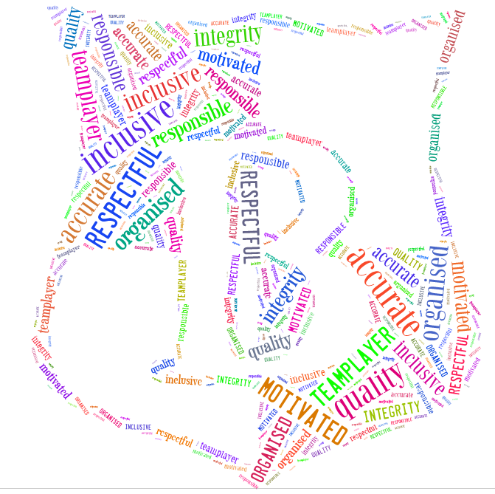
Berkswich CE Primary School
POSITION | KS2 Class Teacher
REPORTS TO | Headteacher
GRADE | Teachers Pay & Conditions M1 – M6  TLR may be available

General role and responsibilities
To be an effective class teacher as set out in the School Teachers’ Pay and Conditions Document in accordance with the Teachers’ Standards.
To work with the staff and the governing board, to determine and fulfil the school values and mission statement. To inspire high expectations for learning which uphold the school ethos:
‘We believe, we achieve, we care’, reflects the strong commitment to the Christian principles which are at the heart of the school.’ Ofsted (2017)

To share in the whole school responsibility for promoting and safeguarding the welfare of pupils at the school.
To be a highly effective professional who:
- has high expectations which directly impact on all pupil attainment and progress
- can teach and assess effectively
- works within the Christian values and ethos of the school
- embraces diversity and inclusivity
- demonstrates thorough curriculum knowledge
- takes responsibility for Professional Development
- embraces opportunities to learn and demonstrate leadership at different levels

At Berkswich CE, we continuously offer creative, inventive and rich learning opportunities for both children and staff. We relish opportunities to gain wider professional experiences as part of our inspirational, outward-looking team.
Specific Role and Responsibilities
Responsibilities include:

Teaching and learning

- having a good up-to-date working knowledge and understanding of a range of teaching, learning and behaviour management strategies and know how to use and adapt them, including how to personalise learning to provide opportunities for all learners to achieve their potential.
- establishing and maintaining fair, respectful, trusting, supportive and constructive relationships with all pupils.
- holding positive, Christian values and attitudes and adopting high standards of behaviour in their professional role.
- communicating effectively with children, colleagues, parents and carers, conveying timely and relevant information about attainment, objectives, progress and well-being.
- having a commitment to collaboration and co-operative working where appropriate.
- being prepared to adapt their practice where benefits and improvements are identified.
- acting upon advice and feedback and be open to coaching and mentoring.

Assessment and monitoring

- knowing the assessment requirements and arrangements for the subjects/curriculum areas they teach, including those relating to public examinations and qualifications.
- knowing a range of approaches to assessment, including the importance of formative assessment.
- monitoring the progress of those they teach and to raise levels of attainment.
- knowing how to use reports and other sources of external information related to assessment in order to provide learners with accurate and constructive feedback on their strengths, weaknesses, attainment, progress and areas for development, including action plans for improvement.

Subjects and curriculum

- having a secure knowledge and understanding of curriculum areas and related pedagogy including the contribution that their subjects / curriculum areas can make to cross curricular learning and recent relevant developments.
- knowing and understand the relevant statutory and non-statutory curriculum and frameworks, other relevant initiatives across the age and ability range they teach.
- understanding that the curriculum allows children to explore their faith, beliefs and spirituality.

Pupils’ personal development and well-being
- demonstrating unwavering commitment to every child having a safe and happy upbringing in order to develop in character and reach their God-given potential. Anyone who works at Berkswich CE Primary will be expected to share this commitment and should any concerns arise, be proactive in following procedures in accordance with statutory and school policies.
- collaborating with parents and carers and across multiple agencies for the well-being of all children.
- being responsible for high levels of behaviour from all pupils.
- liaising with all aspects of special/additional educational needs provision.
- enacting of Health and Safety requirements and initiatives as directed.

Key Organisational Objectives
The post holder will contribute to the school’s objectives in service delivery by:
- fully supporting the Christian Ethos of the school and adhere to the Church of England Primary School Handbook
- ensuring compliance with Data Protection legislation and all school policies.
- commitment and contribution to improving standards for pupils as appropriate.
- contributing to the maintenance of a caring and stimulating environment for pupils.

Personal and Professional Conduct

All teachers are expected to demonstrate consistently high standards of personal and professional conduct, upholding public trust in the profession and maintaining high standards of ethics and behaviour. Teachers must have an understanding of and always act within the statutory frameworks which set out professional duties and responsibilities. They will:

- treat all people fairly and equitably and with dignity and respect to create and maintain a positive school environment, observing proper boundaries appropriate to a teacher’s professional position.
- remain vigilant and have regard for the need to safeguard students’ wellbeing, in accordance with statutory provision and school policies.
- demonstrate tolerance of and respect for the rights of others and not undermining fundamental British values including democracy, the rule of law, individual liberty and mutual respect and tolerance of those with different faiths and beliefs.
- ensure that personal beliefs are not expressed in ways that exploit vulnerability or might lead them to break the law.
- develop and maintain a culture of high expectations of self and others.
- regularly review practice and feedback from others, set personal targets and take responsibility for professional self-development.

Equal Opportunity
The post holder will be expected to carry out all duties in the context of, and in compliance, with the Council’s Equal Opportunities Policies.

