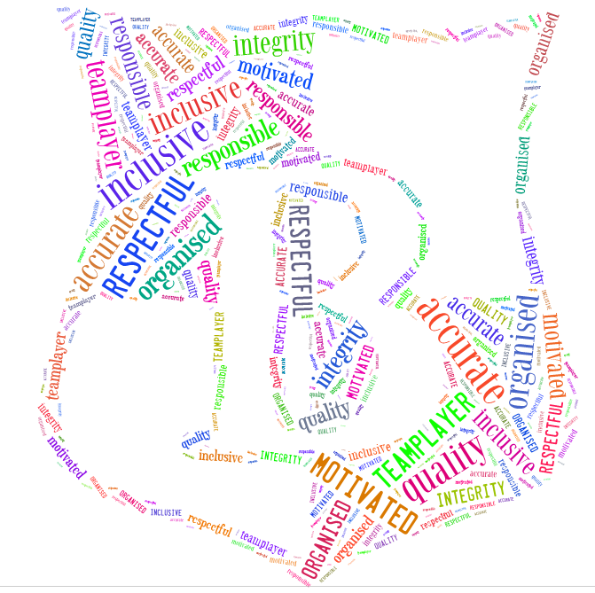
Person Specification

Key Stage Two Teacher

Factors | Essential | Desirable | Measured by
Qualification and Skills  - Qualified Teacher status  - Relevant and regular record of continuing professional development  - Evidence of further study, research or self-learning | Yes  Yes | Yes | AF
Special knowledge, abilities and/or experience  - Recent and successful teaching in Key Stage Two  - An understanding of what it means to be a part of a Church of England School community  - Excellent classroom practitioner with high expectations of learning and behaviour  - An up-to-date knowledge of the curriculum  - Raise standards and set challenging targets for all pupils through the use of assessment  - Experience of using assessment data to track and analyse pupil progress and set targets for improvement  - Experience of initiating/implementing strategies to work in partnership with colleagues, parents and the community | Yes  Yes  Yes  Yes  Yes  Yes  Yes |  | AF/I
Practical skills  - Outstanding primary practitioner with the ability to raise and maintain high standards  - Have the ability to maintain attention to detail  - Excellent interpersonal skills and the ability to lead by example  - Have a calm approach to behaviour management, able to promote and model strategies for developing grit and courageous learning  - Ability to set clear targets and to monitor, evaluate and assess specific aspects of school life  - Ability to prioritise effectively and maintain a sense of humour and a calm approach when working under pressure | Yes  Yes  Yes  Yes  Yes  Yes
Personal Qualities  - Upholding and modelling our school values and the Christian ethos of the school  - Enthusiasm  - Commitment  - Confidentiality  - Resilience  - Inclusivity  - Driven  - Loyalty and dedication with high expectations of self and others  - The ability to be flexible, stay positive and maintain focus and perspective  - A belief in a child-centred approach and of life-long learning for all  - Ability to lead and develop others | Yes  Yes  Yes  Yes  Yes  Yes  Yes  Yes  Yes  Yes |  | I
Interest and motivation in the job  - Have a unwavering drive to enable all unique and valued individuals to flourish  - Ambitious in furthering professional skills and knowledge with a strong desire to progress within Church of England Primary Schools  - Willing to undertake further training as and when required  - Commitment to own professional /personal development  - Team-player  - Self-motivated  - Keen to develop leadership skills at different levels  - Passion for subject/phase development | Yes  Yes  Yes  Yes  Yes  Yes  Yes |  | I

