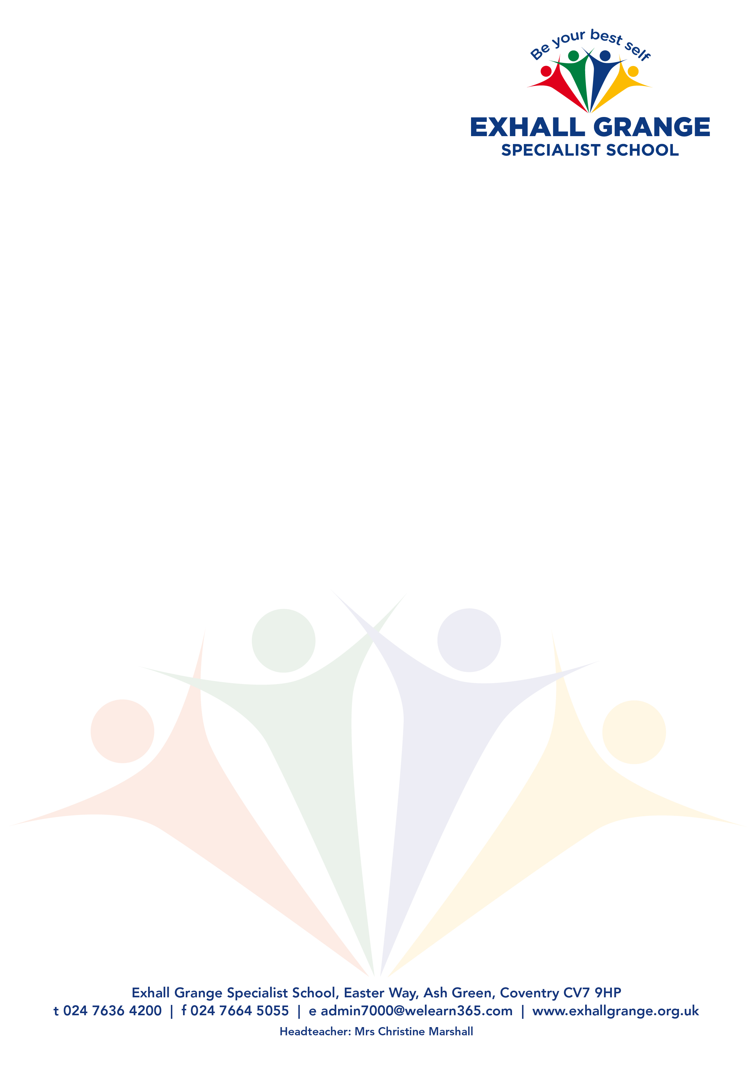

CM/pk

8 October 2021

**Re: Post of Key Worker (SEND)**

Thank you for your interest in the above vacancy at Exhall Grange Specialist School. I hope that the following information is of interest and that you decide to apply. The closing date for applications is 9.00 am on **Monday 18 October 2021 and interviews will be held on Friday 22 October 2021.**

Exhall Grange Specialist School is a county-wide specialist provision for pupils aged between 4 and 19. The school meets the needs of pupils who are unable to access the curriculum in a mainstream school owing to their sensory impairment or physical disabilities or the impact of long-term illness or social communication difficulties including autism.

We offer a mainstream curriculum and endeavour to break down barriers to learning. Through high quality teaching and personalised support, we aim to unlock the potential of every pupil so that they leave our school as well-rounded citizens, ready to embrace the next step of their journey.

This is an exciting opportunity to work within the Exhall Grange Learning POD, an innovative development within Warwickshire’s Vulnerable Learner’s Strategy. The post is to support the work of a team of specialist staff who are creating a small learning environment for key stage 4/5 pupils.

The pupils, from mainstream settings, have acute mental health needs arising from their complex communication and interaction presentation. The successful candidate must have direct and recent experience of working with pupils with autism/complex communication and interaction needs.

Exhall Grange Specialist School is committed to Safeguarding Children in line with the Keeping Children safe in Education Policy, and the post holder will be subject to all of the relevant pre-employment screening checks including an Enhanced DBS with barred list check.

**Successful candidates will be contacted via email where possible and references will be sought prior to interview.**

We look forward to receiving your application.

Yours sincerely,

Christine Marshall

Christine Marshall

Headteacher