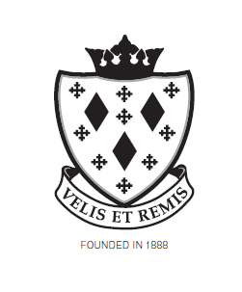
Stockport School

Kitchen – General Assistant

Job Description

Post reports to:

Cook in charge

Main Duties and Responsibilities

- To assist with the preparation of food.

- To assist with serving meals and collecting used crockery and cutlery at the end of the lunch period.

- To assist with the daily preparation of the dining room and counter.

- To undertake cleaning duties in the kitchen and dining areas, including the washing of kitchen utensils, crockery, cutlery etc.

- To store goods delivered.

- To assist with the operation of cash tills where appropriate

- To assist with the preparation of buffets and working lunches

- To maintain, operate, fill and clean vending machines where appropriate.

- To be able to provide cover for the trolley service.

- To undertake such other duties related to the work of the department, appropriate to the post, as may be assigned.

- The post-holder will have opportunity to assist with the preparation of food for special functions as required.

- The post-holder will be allotted a timescale in which these duties must be performed.

Health and Safety

- Co-operate with the employer on all issues to do with Health, Safety & Welfare.

Continuing Professional Development

- In conjunction with the line manager, take responsibility for personal professional development as required

This job description will be reviewed annually and may be subject to amendment or modification at any time after consultation with the post holder. It is not a comprehensive statement of procedures and tasks, but sets out the main expectations of the School in relation to the post holder’s professional responsibilities and duties.

Elements of this job description and changes to it may be negotiated at the request of either the Headteacher or the incumbent of the post.

