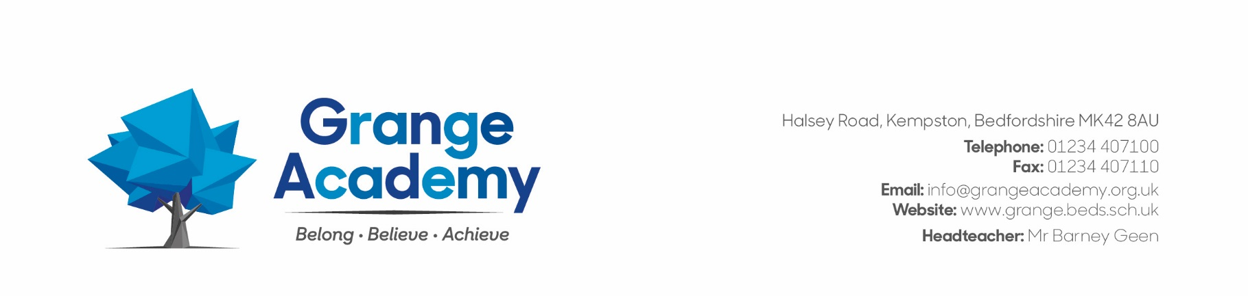Dear Candidate

Thank you for your interest in the post for Bedford Inclusive Learning & Training Trust (BILTT), visits are welcomed.

To give your application the best chance of success, please read through the application guidelines, job description and person specification before completing the application form as fully as possible. In section G, explain how you meet each of the requirements of the job, referring to the person specification. It will help the short-listing process if you address each area of the person specification separately, preferably using sub-headings. Provide examples to illustrate your knowledge, skills, and experience, use additional sheets if necessary.

Ensure that your referees know that you are nominating them and check their contact details with them, especially email addresses. Ask them to respond promptly to the reference request, to aid your application, it could delay your start date if you were offered the post.

BILTT is a lovely environment to work in for students, staff and visitors. I wish you every success with your application. Please telephone Mrs Russell on 01234 407100 if you have any questions or would like to arrange a visit.

BILTT is committed to safeguarding, Prevent, the welfare of pupils and ensuring equality of opportunity for all pupils, staff, parents and carers; irrespective of age, disability, gender reassignment, marriage & civil partnership, pregnancy & maternity, race, belief, sex or sexual orientation and expects staff to share that commitment.

All posts are subject to satisfactory references, Enhanced DBS Clearance, Health Clearance and a 6-month probationary period.

Kindest regards



Bernice Russell

HR Manager BILTT