




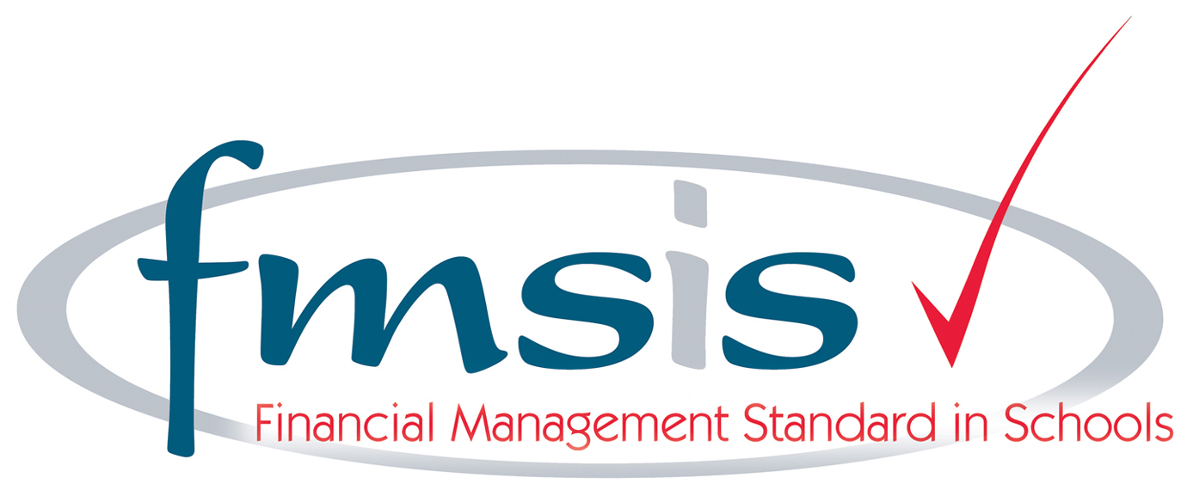
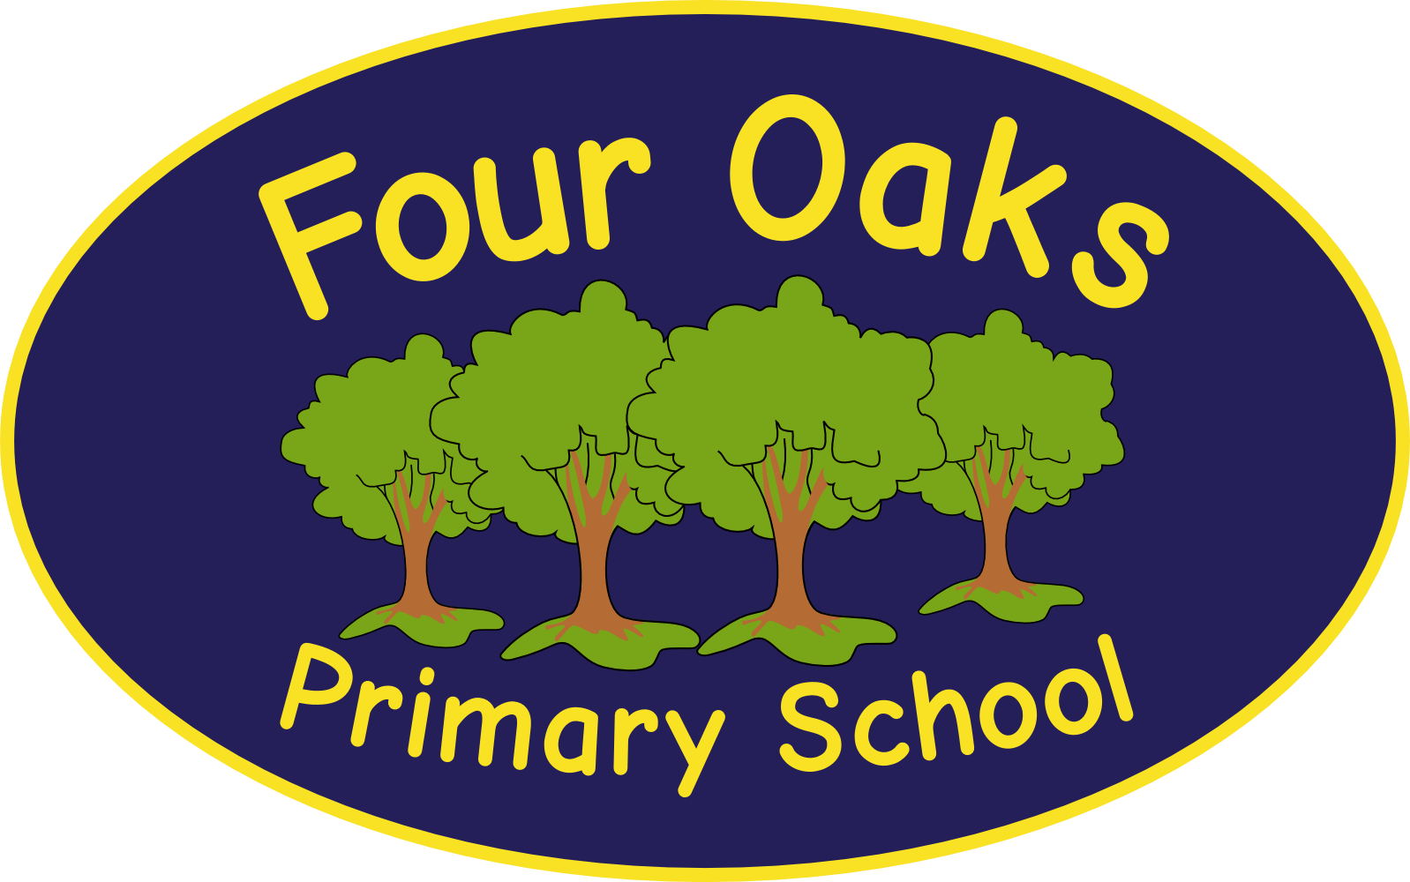

Headteacher: Mrs S Robinson B.A.(Ed) M.Ed. NPQH

39 Davy Street
Liverpool L5 1XP
Telephone: (0151) 263 4038
Fax: (0151) 260 7257
Email: office@fouroaksprimary.com
Website: www.fouroaksprimary.co.uk


22nd May 2025
Teachers
Full-time, KS2 teacher.
01.09.2025 to 31.08.2026
M1 – UPS3

The contracts are fixed term in the first instance to cover a maternity leave and a fixed term contract with a strong possibility of both being extended or made permanent to meet the growing needs of the school. A permanent contract may be available for suitably experienced and expert candidate.

The Governors wish to appoint teachers to join our team. You must have consistently excellent feedback on your teaching. You will be joining a Key Stage Two Phase team who work well together and who are dedicated to providing the very best education to our children. We recently achieved Academy status with Northern Schools Trust. We were developing a strong and positive relationship for over a year before officially joining with them on 1st December 2023.

Four Oaks is an inclusive primary school, with high aspirations for all. We have happy, extremely well-behaved children and supportive, dedicated staff and governors, catering for pupils from 2 to 11 years old. We pride ourselves on our welcoming and supportive teaching teams who work well together. We provide a comprehensive and bespoke CPD programme for our colleagues.

Our school has received a prestigious SCALA architects’ award. It is a modern build with beautiful, well-equipped classrooms and state of the art facilities including an interactive 4D classroom. It is surrounded by landscaped grounds with many facilities for the children. Visitors to our school always comment on the happy, enthusiastic children who demonstrate impeccable behaviour and on the calm and friendly atmosphere that permeates the school.

Visits to the school are warmly welcomed by appointment through the school office.
Please use the link below to apply and do not hesitate to contact the school office if you require any further information or support with your application.

https://ce0218li.webitrent.com/ce0218li_webrecruitment/wrd/run/ETREC179GF.open?WVID=223506RT2Y&VACANCY_ID=241218eOnc

As we have multiple posts available, we are extending the deadline. If you have recently applied for the fixed term or maternity leave posts with a closing date of 23.5.2025, your application will be automatically included in this round so there is no need to reapply.

We look forward to hearing from you!

Closing date: Friday 6th June 2025

Four Oaks Primary School is committed to safeguarding the welfare of young people and expects all staff and volunteers to share this commitment. All appointments are subject to enhanced DBS checks and excellent references.

