



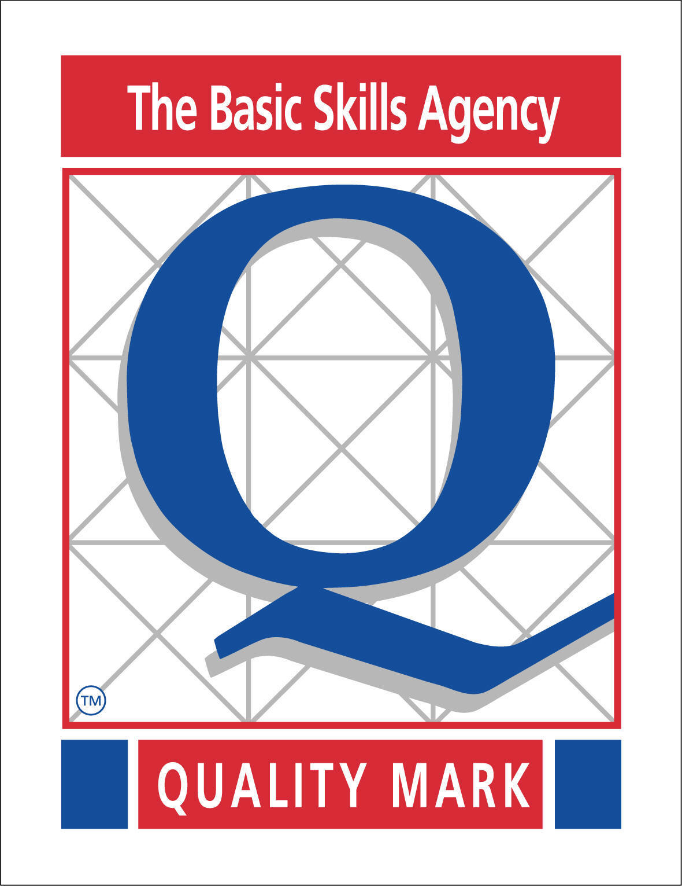
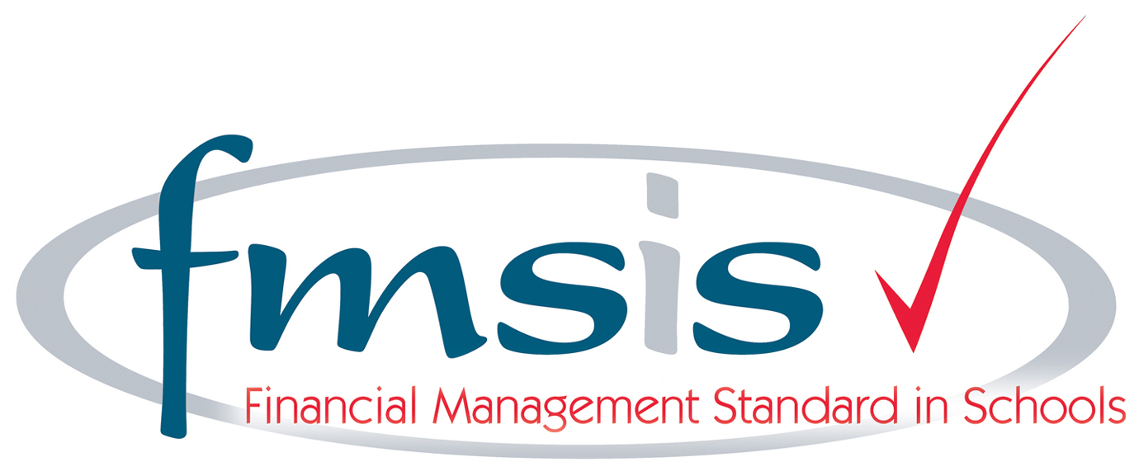
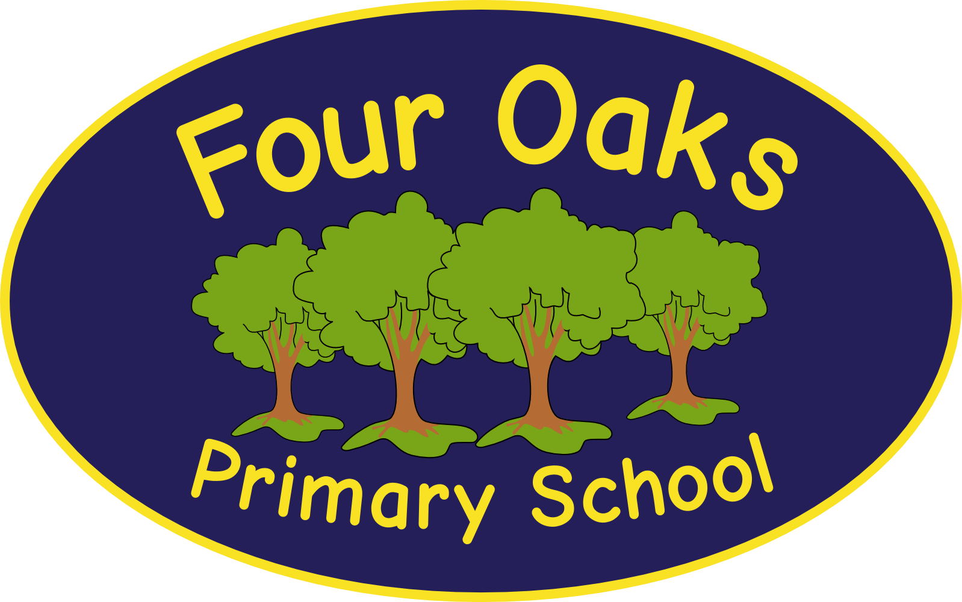

Headteacher: Mrs S Robinson B.A.(Ed) M.Ed. NPQH

39 Davy Street
Liverpool L5 1XP
Telephone: (0151) 263 4038
Fax: (0151) 260 7257
Email: office@fouroaksprimary.com
Website: www.fouroaksprimary.co.uk
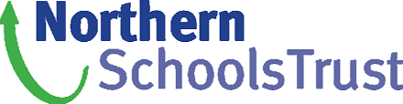

5th May 2025
Teacher

Full-time, KS2 teacher.
Fixed Term – 12 Months
M1 – UPS3

The contract is fixed term. Staffing requirements will be reviewed at the end of this period and there may be a possibility to extend the duration of the fixed term contract or for it to become permanent, in line with the needs of the school.

The Governors wish to appoint teachers to join our team. You must have consistently excellent feedback on your teaching. You will be joining a Key Stage Two Phase team who work well together and who are dedicated to providing the very best education to our children. We recently achieved Academy status with Northern Schools Trust. We were developing a strong and positive relationship for over a year before officially joining with them on 1st December 2023, therefore the successful candidate will also be involved in our recent and exciting conversion to academy status.

Four Oaks is an inclusive primary school, with high aspirations for all. We have happy, extremely well-behaved children and supportive, dedicated staff and governors, catering for pupils from 2 to 11 years old. We pride ourselves on our welcoming and supportive teaching teams who work well together. We provide a comprehensive and bespoke CPD programme for our colleagues.

Our school has received a prestigious SCALA architects’ award. It is a modern build with beautiful, well-equipped classrooms and state of the art facilities including an interactive 4D classroom. It is surrounded by landscaped grounds with many facilities for the children. Visitors to our school always comment on the happy, enthusiastic children who demonstrate impeccable behaviour.

Visits to the school are warmly welcomed by appointment through the school office.
Please use the link below to apply.

NST KS2 Teacher Fixed Term

Closing date: 11:59pm Friday 23rd May 2025.

Four Oaks Primary School is committed to safeguarding the welfare of young people and expects all staff and volunteers to share this commitment. All appointments are subject to enhanced DBS checks and excellent references.

