Celtic Cross Education
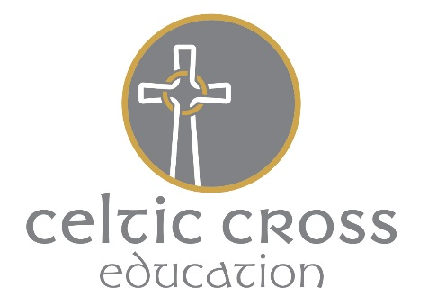

Equal Opportunities Monitoring Sheet

Celtic Cross Education takes it duty to promote equality and to celebrate diversity in our community very seriously. We are keen to gather and use information about job applicants and the workforce in order to continually improve our employment policies and to remove barriers to and within employment.
If you require help to fill in this form please do not hesitate to contact us.

Role applied for
Grade or Hourly Rate |  | Full Time Post / Part Time Post  Please select

If you do not wish to answer any questions, please leave them blank

Age – What age are you? Please select
16 or under | 17 – 24 | 25 – 35 | 36 – 45 | 46 – 55 | 56 – 65 | 66 & over

Gender – What is your gender? Please select
Female |  | Male

Ethnicity – What is your ethnic group?
Please read through carefully before selecting the ethnic group that you feel most closely reflects your background. Note that the list is in alphabetical order.
Asian: Bangladeshi |  |  | Asian: Cornish
Asian: Indian |  |  | Asian: Pakistani
Asian: Other
Black: African |  |  | Black: Caribbean
Black: Cornish |  |  | Black: Other
Chinese |  |  | Chinese: Other
White & Asian |  |  | White & Black African
White & Black Caribbean |  |  | Other Mixed
Gypsy/Romany |  |  | Traveller or Irish Heritage
White: British |  |  | White & Black Caribbean
White: Irish |  |  | Other

Disability
Do you consider you qualify for protection under the Equality Act 2010? | Yes / No  Please select
If the answer is Yes, it would help us to know any barriers you have faced when dealing with us. Please also use this space to make suggestions on how we can improve….

I do not wish to disclose this information

