September 2021

Dear Applicant

Role: KS1 Class Teacher – Fixed term to cover a maternity leave until 31st August 2022
Start: ASAP

Thank you for your interest in the above post. Please find enclosed information about our school, the personnel specification and job description.

The deadline for applications is Friday 8th October at 12.00pm. We will be inviting candidates for interview week beginning 11th October.

You are very welcome to look around the school prior to making your application. Please contact the school office to arrange a visit.

We look forward to receiving your application.

Yours sincerely
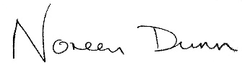

Noreen Dunn
Executive Headteacher

