

Weavers Federation
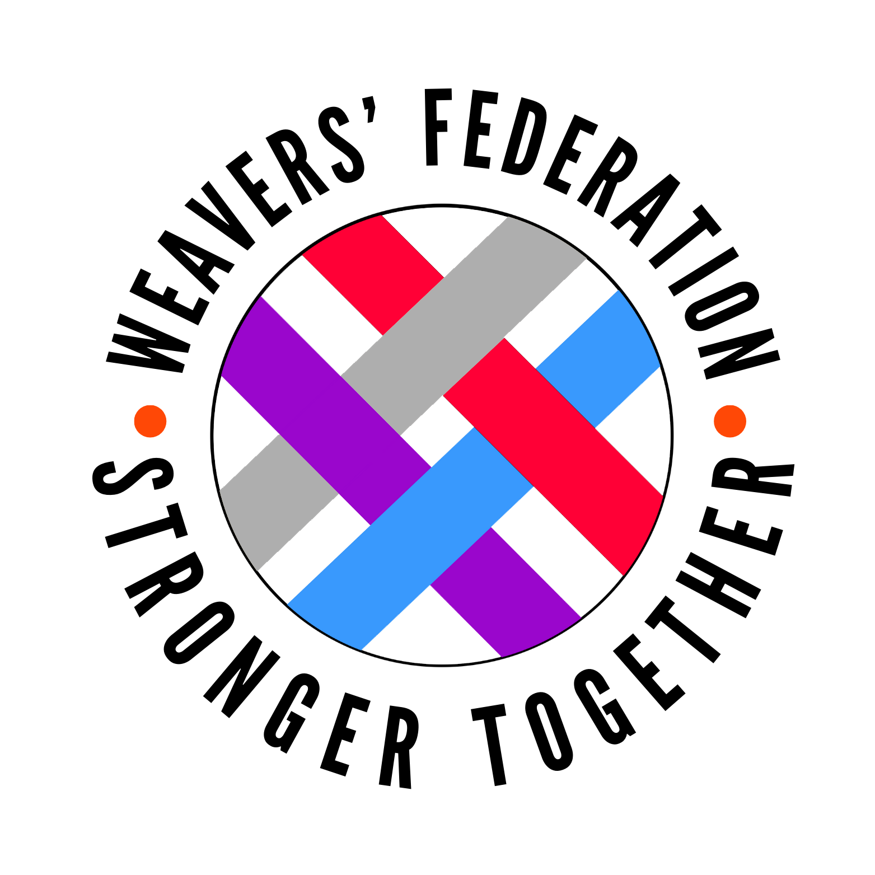
31 Brady Street
London, E1 5DJ
Tel: 0207 375-3267
Fax: 0207 375-3567
Website:https://www.shhfederation.org/

Email: admin@hague.towerhamlets.sch.uk

Job Description
Weavers Federation Class Teacher Main Scale - Primary (EYFS / KS1 experience preferred)

Primary Class Teacher (EYFS/KS1 Experience Preferred)
Location: Federation employees may be asked to work at either Hague or Stewart Headlam Primary Schools.
Contract: Full-time, Permanent
Start Date: To be negotiated with successful applicant
The Weaver’s Federation is seeking two passionate and dedicated Primary Class Teachers. We welcome candidates with experience in Early Years Foundation Stage (EYFS) and Key Stage 1 (KS1), including Early Career Teachers (ECTs), who are eager to develop their skills within a supportive and forward-thinking environment.
What We Offer:
- Collaborative and inclusive school culture committed to high ambition and broad horizons for all pupils
- Opportunities for professional development
- Comprehensive induction and mentoring programme for ECTs.
Role Responsibilities:
- Deliver high-quality teaching and learning experiences enabling all pupils to make and exceed expected progress.
- Create an inclusive classroom environment supporting pupils with SEND and EAL needs.
- Manage and direct teaching assistants effectively to maximise pupil outcomes.
- Promote positive attitudes to learning, resilience, and pride in achievement.
Safeguarding and Safer Recruitment:
Weaver’s Federation is committed to safeguarding and promoting the welfare of children. The successful candidate will be subject to enhanced DBS and other pre-employment checks as per Keeping Children Safe in Education (KCSIE) 2025. All appointments are conditional upon satisfactory completion of these checks.
How to Apply:
Submit your application form and supporting statement by Friday 6th February to admin@hague.towerhamlets.sch.uk.

