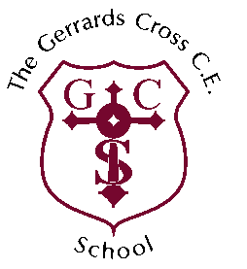**THE GERRARDS CROSS CE SCHOOL**

**CLASS TEACHER – Job Description**

|  |  |
| --- | --- |
| **Key information:** | |
| Post Title  Salary  Responsible to | Class teacher  MPS / UPS + fringe  The Headteacher of The Gerrards Cross CE School |
| **Description of role:** | |
| **Class Responsibilities**  To take overall responsibility for a class or groups of children as designated by the Headteacher. This overall responsibility will include:   * The provision of a stimulating, effective and attractive working environment. * Planning, teaching, evaluating and developing agreed programmes of work to promote high educational achievement. * Assessing, recording and reporting pupil progress in accordance with agreed school policy. * Ensuring that the special educational needs of children are acknowledged and met as far as is possible, and that individual children’s dignity and self-esteem are respected and enhanced. * The management of children to ensure that they are aware of, and freely conform to, a framework of clear and sensible rules. * Liaison with teaching and non-teaching staff, parents, governors, educational support services and other relevant agencies. * To uphold a culture of safeguarding at all times, caring for and nurturing each individual child, and alerting the Designated Safeguarding Lead with any concerns. * Welcoming and supporting parents as partners in the learning process of children. * Responsibility for registration and other general administrative matters relating to the class. * Upholding the school’s Christian ethos.   **Team Responsibilities**   * Awareness of the aims and objectives of the school and working towards their fulfilment. * Participation in staff consultations and professional meetings. * Providing professional support and advice to colleagues. | |