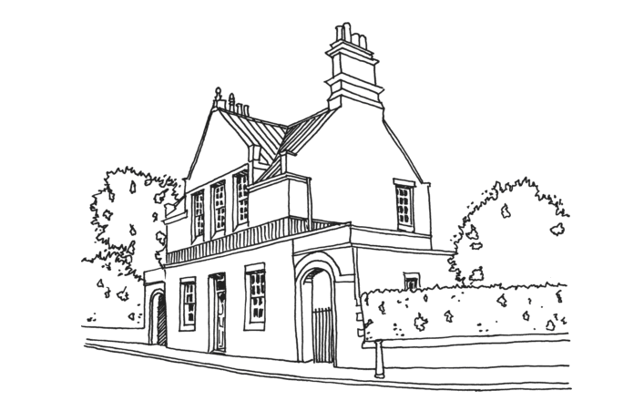
Bishop Road Primary School
Bishop Road
Bishopston
Bristol, BS7 8LS

Job Reference CTP3 – 2023
KS1 & KS2 Class Teacher Permanent
(Please quote this number on your application form)

Pay Scale: MPS - £28,000 – £38,810

Application Closing Date: Tuesday 4th April 2023 @ 8.00am

Interview Date/s: Monday 17th April & Tuesday 18th April 2023

Starting Date: 1st September 2023

We are looking for:

- Teachers who would thrive working with quality children’s literature and a story based curriculum
- Teachers who wish to contribute to a clear vision with space for personal expression and interests
- Teachers who have high expectations and professional standards

We offer

- Children who enjoy learning
- Opportinities for exciting and creative teaching and CPD
- An excellent team of caring and supportive staff

If you feel we are what you are looking to start or progress your teaching career and are a someone who truly cares about providing the very best learning for children, we would like to hear from you.

In your application please indicate clearly why you are applying for this post and the curriculum area/s to
which you wish to contribute.

Applications from ECT’s are very welcome

Please apply online. Applications must be on the BCC application form – CVs will not be considered.
Please ensure applications are sent with the correct postage as we will not be able to collect any
incorrectly stamped applications which are held back by the post office. Please quote Job Ref on the
Application Form and not the Eteach Id No.

Bishop Road Primary School is committed to safeguarding and promoting the welfare of children
and expects all staff and volunteers to share this commitment. All appointments are subject to
relevant checks including satisfactory completion of Enhanced DBS disclosure.

