




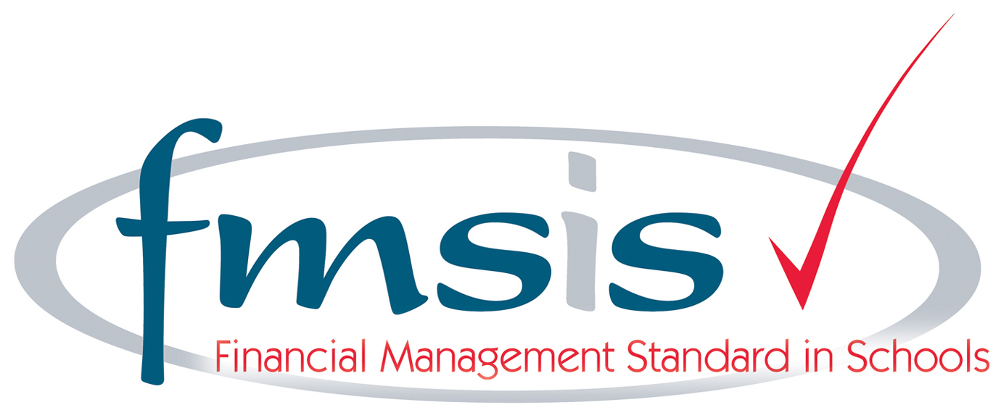
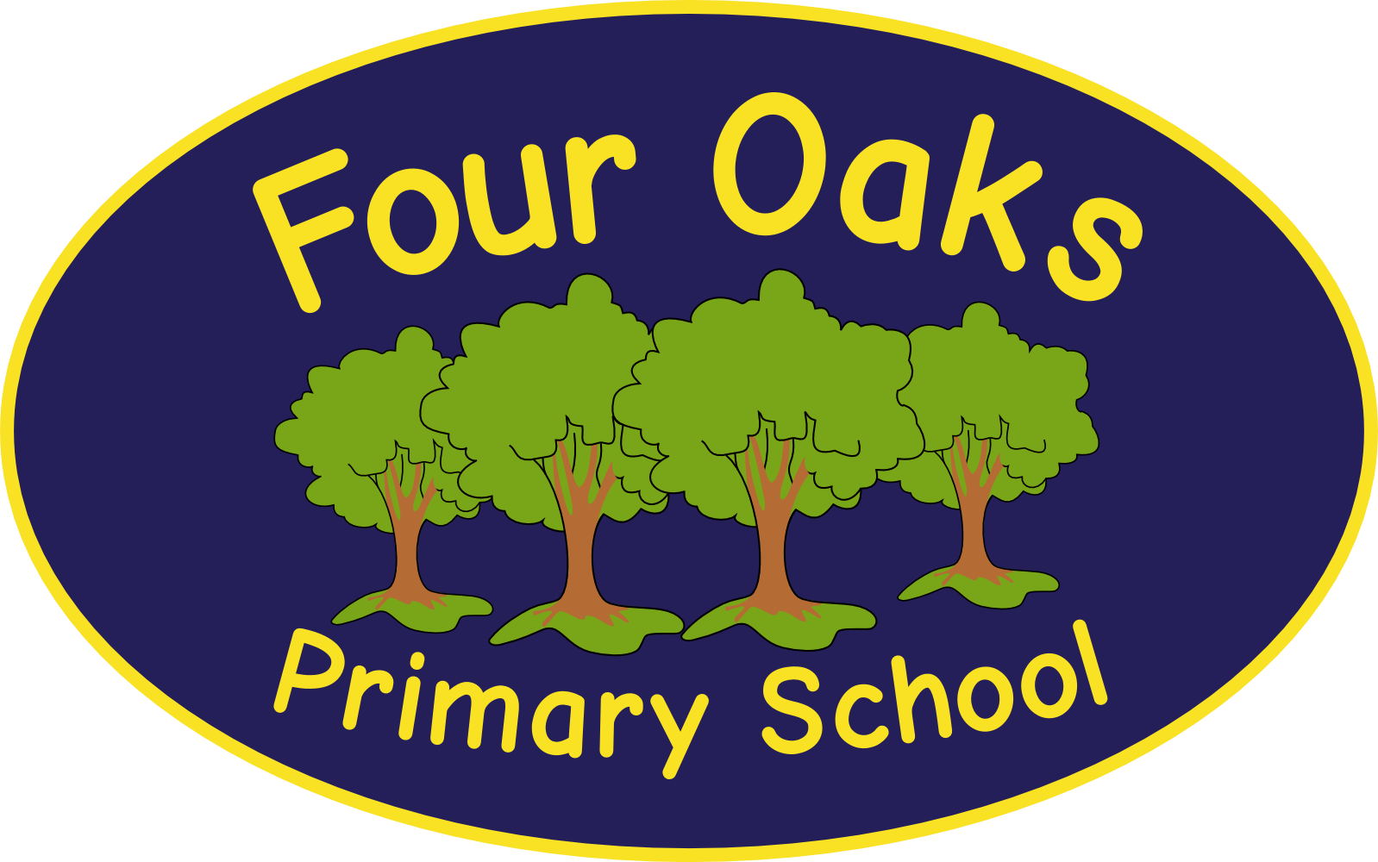

Headteacher: Mrs S Robinson B.A.(Ed) M.Ed. NPQH

39 Davy Street
Liverpool L5 1XP
Telephone: (0151) 263 4038
Fax: (0151) 260 7257
Email: office@fouroaksprimary.com
Website: www.fouroaksprimary.co.uk

Teacher

Full-time, fixed term.

The post will be fixed term from 1st September 2021 until 31st August 2022

Four Oaks is an inclusive primary school, with high aspirations for all. We have happy, extremely well behaved children and supportive, dedicated staff and governors, catering for pupils from 1 to 11 years old.

Our recently built £9million school has received a prestigious SCALA architects’ award. It is a modern build with beautiful, well equipped classrooms and state of the art facilities including an interactive 4D classroom. It is surrounded by landscaped grounds with many facilities for the children. Visitors to our school always comment on the happy, enthusiastic children who demonstrate outstanding behaviour.

The Governors wish to appoint a teacher to join our team. We have flexibility regarding which year group you join. You should make it clear on your application form which Key Stage(s) or year group(s) you prefer. You must have consistently Good or Outstanding feedback on your teaching. You will be joining a strong Phase team who work well together and who are dedicated to providing the very best education to our children. The posts are temporary in the first instance to cover a maternity leave and to support the delivery of our Recovery Curriculum with a strong likelihood of the post being extended.

Closing date: Friday 23rd April

Four Oaks Primary School is committed to safeguarding the welfare of young people and expects all staff and volunteers to share this commitment. All appointments are subject to enhanced DBS checks and excellent references.

