





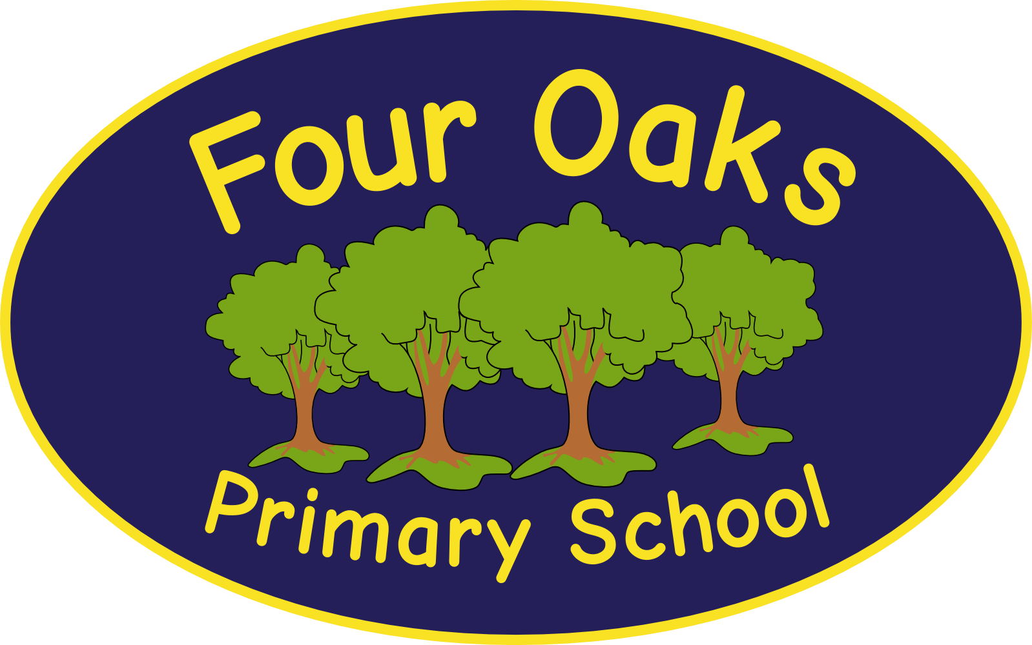

Headteacher: Mrs S Robinson B.A.(Ed) M.Ed. NPQH

39 Davy Street
Liverpool L5 1XP
Telephone: (0151) 263 4038
Fax: (0151) 260 7257
Email: office@fouroaksprimary.com
Website: www.fouroaksprimary.co.uk

POST: Class Teacher

SCHOOL: Four Oaks Primary School

CONTRACT: Full time teacher from 1st September 2021 to 31st August 2022. This is temporary in the first instance to cover a Maternity Leave and support our Recovery Curriculum with a strong likelihood of the post being extended.

PRIMARY PURPOSE OF THE JOB:

To fulfil the requirements set out in the latest Teachers' Pay and Conditions Document.

To teach and care for the pupils assigned to you as a class teacher, compliant with the requirements of the National Curriculum, school aims, policies of the governing body and in pursuit of high standards of pupil achievement.

To maintaining the positive ethos and core values of the school, both inside and outside the classroom.

To share in the corporate responsibility for the well-being and positive behaviour of all pupils.

DIRECTLY RESPONSIBLE TO:

The Headteacher or her representative

DIRECTLY RESPONSIBLE FOR:
Teaching Assistants and pupils in your class and any work experience students or volunteers. Responsible for quality communication with paretns and carers of pupils in your class.

MAIN RESPONSIBILITIES:
In addition to the professional duties of a class teacher as set out in the current Teachers’ Pay and Conditions Document you will adhere to all school policies.

KEY AREAS OF RESPONSIBILITY

As a practitioner;
- to plan and prepare work which reflects the pupil's age and ability within the class;
- to regularly mark, record, assess and report on the attainment and progress of pupils;
- to consult with the parents of children in the class;
- to ensure the good order and discipline of pupils in the class;
- to communicate and co-operate with outside agencies;
- to create an interesting and stimulating learning environment;
- to organise materials and to display children's work, reflecting current themes and topics.
- to undertake any professional duties which may be delegated from time to time by the Headteacher

As a member of the staff team;
- to participate in a Performance Management Interview conducted by the Headteacher or team leader following guidelines set down in the Performance Management Policy.
- to follow a whole school approach to the delivery of the curriculum;
- to create a climate conducive to the development of all pupils and staff.

As a creator of good and effective relationships;
- create good and effective relationships with pupils, teaching and non-teaching staff, parents and the wider community;
- to participate in the extra-curricular life of the school;
- to continue professional development after consultation with the Headteacher, taking into account the wider development plans for the school as a whole;
- ensure equal opportunities for all pupils.

CONDITIONS OF EMPLOYMENT

The post holder may be required to perform any other reasonable tasks commensurate with the role.

This job description may be amended at any time after discussion between the teacher and the Headteacher but will be reviewed annually at the Performance Management Interview.

Four Oaks Primary School is committed to safeguarding the welfare of young people and expects all staff and volunteers to share this commitment. All appointments are subject to enhanced DBS checks and excellent references

