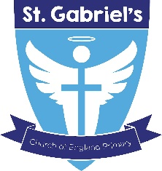

Job Advert

We have a vacancy for a KS1 / KS2 teacher at St Gabriel’s Church of England Primary School to commence 1st September 2022.
The vacancy is for 12 months in the first instance.

The leaders of the trust are seeking to appoint an excellent practitioner who teaches to the highest standards, believes that each and every child can and will achieve, and is dedicated to improving the life chances of all children and their families.
Please email your completed application form along with a letter of interest to vacancies@remat.org.uk by 24th May 12pm.
Shortlisting will take place on the 24th May.
Lesson observations for shortlisted candidates will take place on 25th/26th May
Interviews 26th May

Rainbow Education Multi-Academy Trust is committed to safeguarding children and promoting children's welfare. This post is subject to all the relevant pre-employment checks set out in 'Keeping Children Safe in Education’, including an enhanced DBS certificate with a barred - list check.

Visits to the school welcomed and can be arranged via the school office:
stgabrielsoffice@remat.org.uk 0151 477 8250

