Sharrow School
Sitwell Road,
Sheffield, S7 1BE
Tel: 0114 2551704
Email: info@sharrow.sheffield.sch.uk
Position: KS1 / KS2 TEACHER
Salary: M1 to M3
Hours: Full-time
Start Date: September 2024
Contract Term: 1 year contract initially

An exciting opportunity has arisen at Sharrow School for a creative and inspiring KS1 / KS2 teacher to join our committed and friendly staff team.

Sharrow School is an inclusive primary school at the heart of a vibrant, multicultural community. Our beautiful, purpose-built school is located just off London Road, looking out across Mount Pleasant Park. With a nature-reserve on the roof, an allotment and orchard, a performing-arts space and a Children’s Centre on site, we cater for children from 3 months to 11 years, as well as providing learning opportunities for older children and adults out of school hours. Our building has been designed to provide flexible teaching spaces where staff can learn from and support each other, with good access to outdoor space for all year groups. The excellent facilities help to ensure we are able to meet the needs of the children and their families by delivering a creative and exciting curriculum.

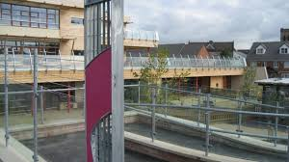 |  | 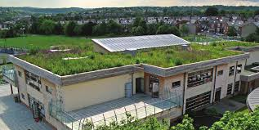
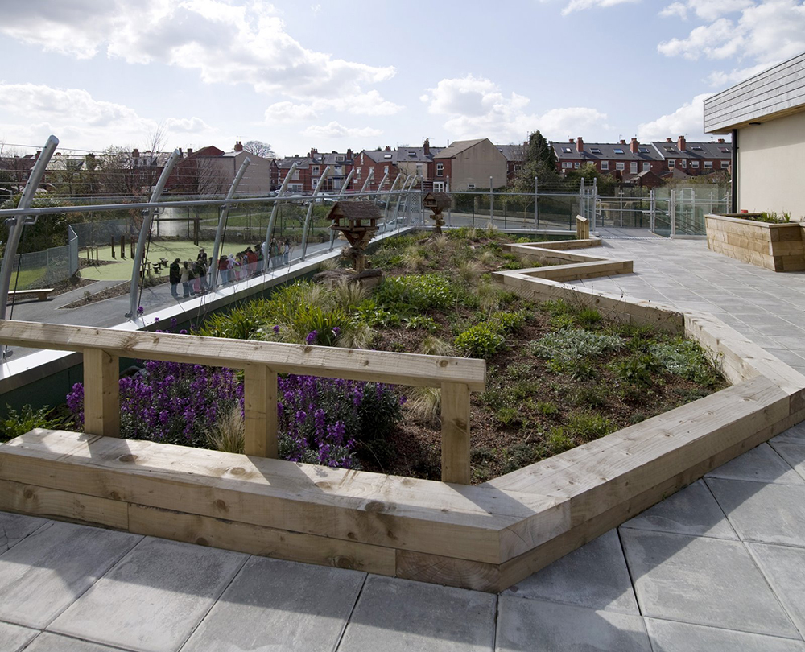 | 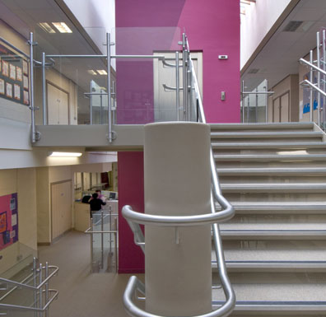 |  | 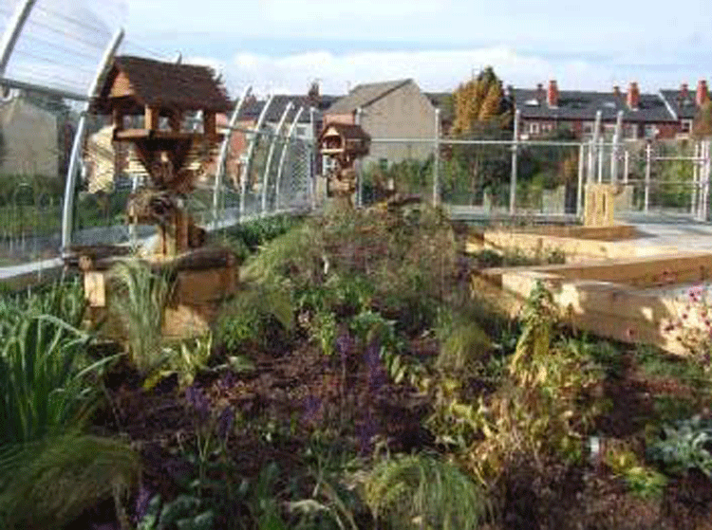

Our hard-working staff team are passionate about ensuring that all children enjoy their time at Sharrow and make good progress. We attach significant importance to developing children’s literacy and numeracy skills as well as their creative and expressive skills. We also encourage children to develop their sporting abilities and have PE specialists as part of the staff team. We teach in a variety of styles to best match the needs of the children and provide the most effective learning experiences.

A walk along the London Road will give you a flavour of the cultural and racial diversity of the community. The school serves an economically diverse area - with housing ranging from large stone fronted Victorian properties to privately-rented accommodation and Council flats. The school has a commitment to equality of opportunity for all learners and operates a vigorous inclusion policy. As a whole school we are committed to providing the children with a range of experiences beyond the school gate, and supporting the families in our community.

The successful candidate will be provided with support and challenge to develop their skills further through coaching, mentoring and succession planning. We actively encourage quality CPD and there are opportunities to work with a range of outstanding staff and outside consultants. Applications from NQT’s are welcome.

Further information and an application form are available on the DfE Teaching Vacancies website or from the school website. Completed applications should be returned to the Headteacher:-

Headteacher
Sharrow School
Sitwell Road
Sheffield, S7 1BE
Tel: 0114 255 1704

Deadline for application: Friday 7th June 2024 @ midday
Interviews: Thursday 20th June 2024
Internal applications welcomed

We are an equal opportunities employer and welcome applications regardless of age, gender, ethnicity, religion or disability. International candidates who are able to meet the person specification are welcome to apply. The school is committed to safeguarding and promoting the welfare of children and young people/vulnerable people and expect all staff and volunteers to share this commitment. This position is subject to an Enhanced Disclosure check in line with the Rehabilitation of Offenders Act 1974.

