SCHOOL DETAILS

Our address is: Abbey Lane Primary School, Abbey Lane, Sheffield S8 0BN
Tel: 0114 2745054 Fax: 0114 2746708
Our e-mail is: enquiries@abbeylane.sheffield.sch.uk
Our web site is: www.abbeylaneprimaryschool.co.uk

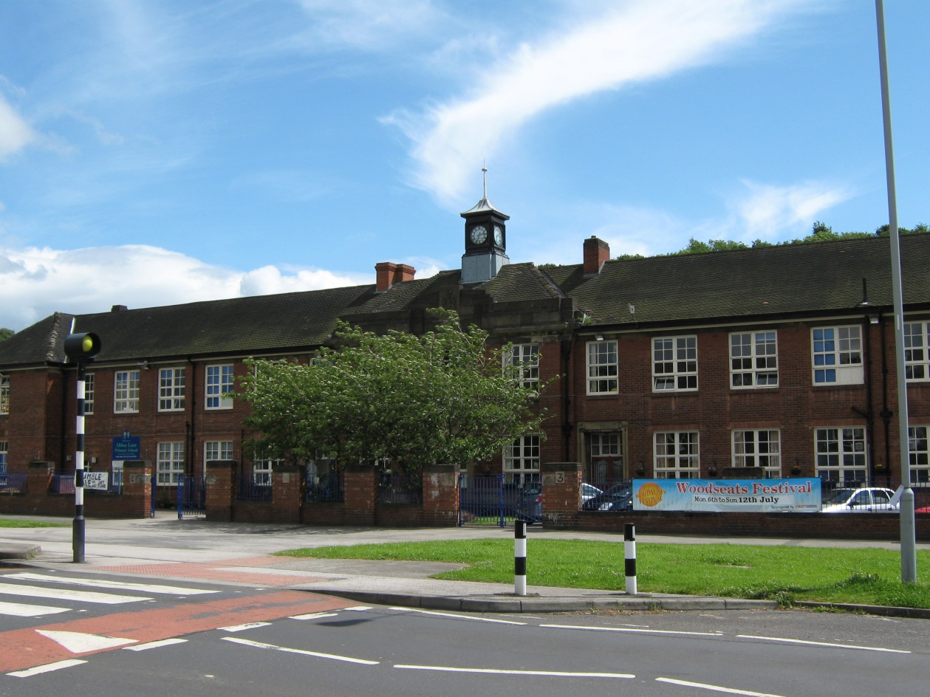

This year there are approximately 550 pupils on roll, aged from 4+ to 11. Children must begin school in the academic year before their 5th birthday, either in September, January, or Easter and leave at the end of the year during which they have become 11. Children enter the school in Reception Class, and move up each September, finishing in Year 6 when they are 11.

We have no provision for Nursery children.

Prospective parents/carers are invited to visit our school at any time by arrangement with the school. We will be pleased to show you round and answer your questions. Please see the separate section in this book headed “Starting School” for further details of Reception admission.

The School Day

The morning session is from 8.45 until 11.30 for Foundation Stage (Reception), Key Stage 1 (Year 1 and Year 2) and until 12.30 for Key Stage 2 (Years 3, 4, 5 & 6). All children will have a break of 15 minutes during the morning session. Afternoon school is from 12.30 (Foundation Stage and Key Stage 1) and 1.30 (Key Stage 2) until 3.15 with a break during the afternoon for Reception, Year 1 and Year 2, where the children are encouraged to improve their skills with play equipment including bats and balls, skipping ropes and throwing and catching.

The teaching time per week (minus registration, assemblies and break time) is as follows;

Reception – Year 2 = 22 hours 15 minutes

Year 3 – Year 6 = 23 hours 20 minutes

All children are allowed into school with parents at 8.35 am and a bell sounds to indicate the beginning of the day at 8.45 am.

No child should arrive at school before 8.35 am. Though, in bad weather, they may be admitted to the building. While we cannot guarantee their safety and supervision before that time there is usually a member of staff on duty in the yard from 8.40 am.

Children should leave the premises promptly at the end of the day, unless taking part in an organised after-school activity.

