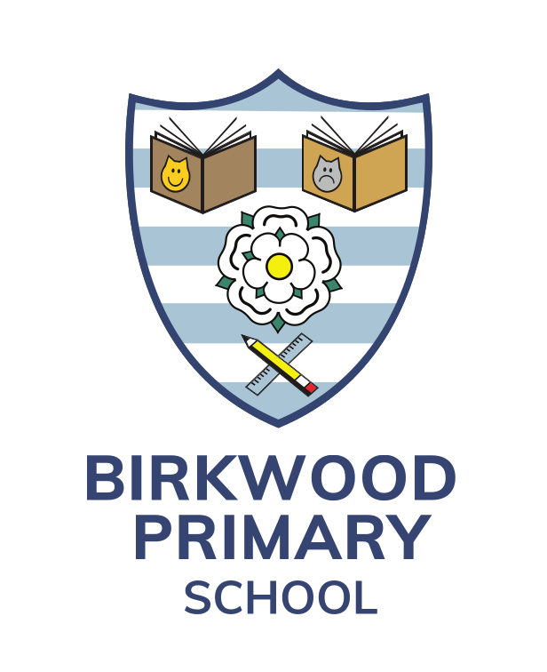 | Birkwood Primary School  Darfield Road  Cudworth  Barnsley  S72 8HG  Telephone: Barnsley (01226) 710447  Email: r.cocking@birkwood.org.uk  www.birkwood.org.uk  twitter.com/BirkwoodPrimary
KS1 Teacher

Permanent Contract

From September 2024, we are seeking a highly committed and hardworking teacher to join Birkwood Primary School.

We are looking for someone who can actively support our vision and ethos – ‘The Birkwood Way’ where children will
- Do the Right Thing
- Acquire a depth of knowledge
- Experience Leadership, Collaboration and develop independence

The role offers an exciting opportunity for a passionate and motivated practitioner. The successful candidate will be creative, enthusiastic, able to work as part of a team and use their initiative.
This would present a great opportunity for an ECT.

We are looking for a candidate who:
- is enthusiastic, positive and hard working
- is a well-organised, team player with excellent inter-personal skills
- is highly motivated with high expectations
- wants the very best for our children

We can offer:
- A happy caring school where you will be supported and valued
- A dedicated and supportive staff team and Governors
- A strong, nurturing community ethos
- A high-quality learning environment

Please see our school’s website – www.birkwood.org.uk

Visits to school with the Headteacher are warmly welcomed.

All Applications to be completed via the BMBC Online Recruitment Page.
Closing date for receipt of applications is 12 noon on Monday 6th May 2024. Interview date to be confirmed.

Birkwood Primary School is committed to safeguarding and promoting the welfare of children and expects all staff and volunteers to share this commitment. This post involves working with children and therefore if successful you will be required to apply for a disclosure of criminal records at an enhanced level. Birkwood Primary School is an equal opportunities employer.

