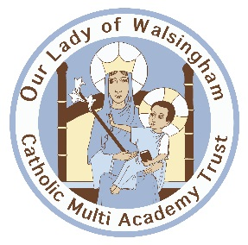
St Felix Roman Catholic Primary School
Person Specification
Mainscale Class Teacher
 | Essential | Desirable
Education and Training | Qualified Teacher Status.  Degree or Equivalent. | Catholic Certificate in Religious  Studies.  A commitment to further professional development.
Experience | Experience / teacher placement at primary school level.  Evidence of being an excellent classroom practitioner. | Experience of working in a  Catholic School.
Knowledge and  Experience | The class teacher should have knowledge and understanding of:  Current practices and strategic developments in primary education.  A working knowledge of the National Curriculum (2014).  Strategies to promote effective Learning and Teaching.  Understand AFL and use assessment and record keeping as a means of developing  Teaching and Learning.  The statutory requirements of legislation concerning Equal opportunities, Health and  Safety, Special Educational Needs and Safeguarding requirements. | A working knowledge and understanding of Catholic Religious Education programmes, for example the Diocesan RE Curriculum.  A broad range of interests and a commitment to providing a rich curriculum experience for the children.
Skills and Abilities | The class teacher will:  Have high expectations of attainment and behaviour.  Be an excellent communicator with good organisational and interpersonal skills.  Be confident in the use of IT to support learning.  Exemplary communication skills and the ability to work as part of a team.  The ability to lead a curriculum  area throughout the school.
Personal Attributes | The successful candidate will:  Be supportive of the Catholic  Ethos of our School.  Be willing to share ideas, energy and initiative.  Be enthusiastic and excited about teaching children.  Be committed to school improvement and raising pupil achievement.  Be committed to an inclusive education.  Be a team player, keen to engage in all aspects of the life of our school.  Be committed to working with parents and the wider community.  Be committed to ongoing  professional development

