STEVENAGE ST NICHOLAS CHURCH OF ENGLAND
PRIMARY SCHOOL AND NURSERY


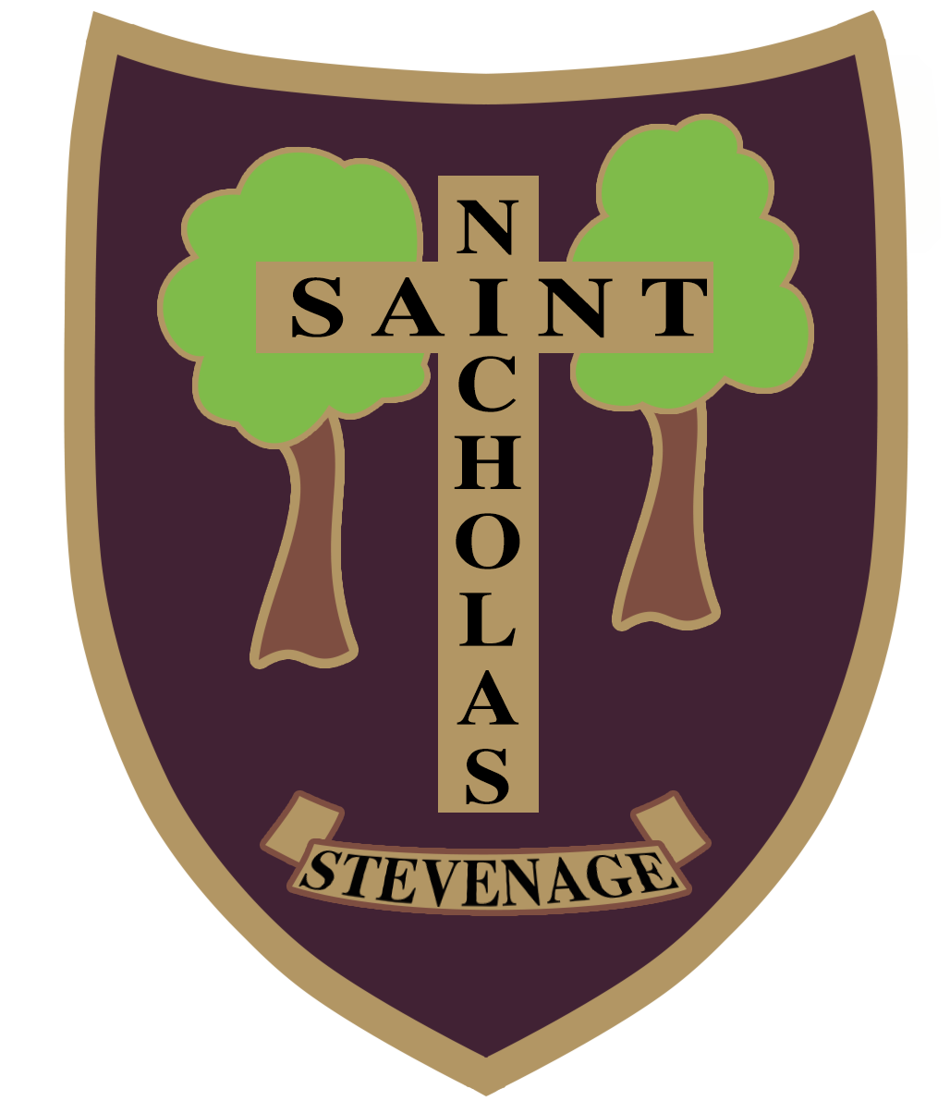

Six Hills Way, Stevenage, Herts, SG2 0PZ

Headteacher: Miss Adelaide Yarwood PGCE, BA (hons)
Learning, Loving, Living in God’s Family

Learning in God’s Family

Class Teacher Person Specification

Selection decisions will be based on the criteria outlined below. At each stage of the process, an assessment will be made by the appointment panel to determine the extent to which the criteria have been met.
When completing your application form and supporting statement, you should ensure that you address each of the selection criteria and provide supporting evidence of how you meet the criteria through reference to work or other relevant experience.

 | Essential | Method of Assessment
Qualifications | - UK Qualified Teacher status (QTS)  - Evidence of professional development  - DBS | Application form  Certificates
Experience | - Experience of teaching in KS2.  - Experience of teaching in KS1 desirable  - Recent teaching experience in a school, preferably in KS1 or Foundation Stage  - Evidence of participation in professional development or study | Application form  References
Professional knowledge and understanding | - Know what constitutes quality and high standards in learning and teaching  - Know and use a range of strategies for engaging all learners and meeting individual needs  - Effective organisational skills  - Know a range of approaches to assessment use assessment effectively to progress pupils’ learning  - Know how to use statistical information to evaluate the effectiveness of their teaching, to monitor the progress of those they teach and to raise levels of attainment.  - Understanding of safeguarding procedures and child protection methods and responsibilities | Application form  References  Interview  Lesson observation
Skills and abilities | - Creates a happy, challenging and effective learning environment  - Has high expectations for behaviour and learning  - Good behaviour management skills  - Able to communicate effectively with pupils, staff, colleagues and parents  - Able to create inspiring and creative learning experiences  - Works well within and contributes to team development  - Able to plan effectively to meet the needs of learners  - Uses ICT effectively to support teaching and learning  - Able to offer support for extra-curricular activities  - Supportive of the Christian ethos of the school  - Able to develop relationships with parents and good home school links | Application form  References  Interview  Lesson observation
Personal qualities | - Show a passion for teaching and learning  - Be adaptable  - Excellent attendance and punctuality  - Be proactive in personal professional development  - Commitment to achieving and sustaining high standards  - Commitment to promoting and safeguarding the welfare of pupils at the school  - Demonstrate the positive values, attitudes and behaviour they expect from children  - Have a commitment to collaboration and co-operative working. | Application form  Interview

