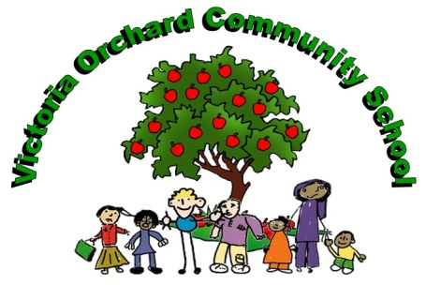

Victoria Community School, Victoria Road,
Burton upon Trent, Staffordshire. DE14 2LU
01283 247432
Victoria Orchard Site, Belvoir Road,
Burton upon Trent, Staffordshire. DE13 0RA
01283 247420

Head Teacher: Mrs Elizabeth Laughlin
E-mail: headteacher@victoria.staffs.sch.uk

Victoria Community School @VictoriaCommun1

April 2021

KS1 CLASS TEACHER (YEAR 2)
Permanent/Full time
MS1-MS6 £25,714 - £36,961 pa

Dear Colleague

Thank you for your interest in our permanent full time teaching post as a Year 2 Class Teacher which is available from September 2021. Please find enclosed a job description, application form and information about our school.

Our two-site two form entry school serves a majority minority ethnic community which is unique within Staffordshire, as we are the only school where over 91% of our pupils speak English as an additional language. More recently we have admitted a number of pupils with a variety of cultural and linguistic backgrounds including those from Eastern Europe.

It is important that you have a genuine interest and desire to learn in this area of education and share in the real challenges and rewards of raising the achievement of our pupils. As a school we can offer you:

- The support of an excellent team of colleagues.
- An experienced and dedicated team of support staff.
- Established curriculum plans and schemes of work and agreed planning formats.
- A well-resourced curriculum including an ICT suite and interactive whiteboards.
- An attractive, caring and supportive learning environment.
- Opportunity to work in a multi-disciplinary environment.
- Access to professional development and a comprehensive programme of staff training
- An active partnership with our parents and local community.

If you are keen to join a team committed to working together to raise the aspiration and attainment of all our pupils you are strongly encouraged to consider this vacancy. We welcome applications from colleagues whether very experienced or newly qualified. You are encouraged to outline in your application form-

- The skills, talents and experience you could bring to our school.
- Information concerning recent and relevant teaching experience.
- Strategies you have found successful in supporting all pupils to achieve high standards.

This School is committed to safeguarding and promoting the welfare of children and young people/vulnerable adults and expect all staff and volunteers to share this commitment.
This position is subject to a “disclosure” check under the “Rehabilitation of Offenders Act 1974”. Further details regarding this check and Staffordshire County Council’s employment policy will be found within the guidance notes.

Please note that completed applications should be returned to school no later than 9am on
Wednesday 19th May 2021. Interviews are planned for Wednesday 26th May 2021. Applications should be sent by email to office@victoria.staffs.sch.uk.

We look forward to hearing from you.

Yours sincerely

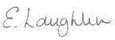

Mrs E Laughlin
Headteacher

