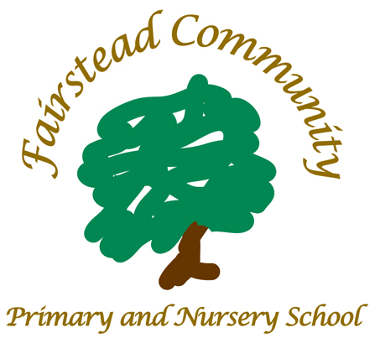
At Fairstead Community Primary and Nursery School, we nurture and invest in our relationships. We identify each individual’s potential and work as a team to create a safe environment for everyone to grow and succeed.

Fairstead Community Primary
and Nursery School
William Booth Road, King’s Lynn
Norfolk PE30 4RR
Telephone: 01553 774666
Email: office@fairstead.norfolk.sch.uk

Email: office@fairstead.norfolk.sch.uk

‘Unless someone like you cares a whole awful lot, nothing is going to get better. It’s not.’ – Dr. Seuss

Join our team as a Key Stage 2 class teacher in
September 2024

MPR/ UPR

We are seeking a highly effective teacher to join our friendly, ambitious and forward-thinking team.
You will have the enthusiasm and purpose to want to make a difference. We want to recruit people who are passionate about making a positive impact on our children’s lives and want to challenge themselves to keep on improving. Our working relationships are positive and supportive as we strive to keep our evidence based practice the best it can be.
We are looking to employ a Key Stage 2 Class Teacher who will work well as part of our successful school team, with supportive colleagues and governors who ensure that all pupils make outstanding progress from Nursery through to Year 6.

We offer an excellent caring environment in a bright, well-resourced school where you will have the opportunity to either start or advance your career within a supportive community school. We have enthusiastic and polite children who love to build positive relationships.

Cultural Fit

Our school is developing all the time. We have implemented a curriculum whose drivers are possibilities, community and independence. We are a school at the heart of our community, and we feel it is important for our children to have a developed sense of their locality and be proud to be part of it.

Together with our curriculum our pedagogic principles underpin the school culture.

- We believe that we can all improve as teachers
- We believe we can all improve, children learn from staff as well as from each other.
- We believe in the potential of all children to learn
- We engage in deep thought about challenge and quality
- We provide opportunities to practise skills that have been learnt until over time automaticity is achieved.
- We sequence all learning in to small steps with children’s starting points taken in to account
- We have an openness to feedback
- We develop worked models that communicate quality and success
- We take ratio in to account where over time learners take on more of the learning load
- We believe that children should be given feedback at all points of the learning journey
We focus single-mindedly upon providing the best teaching we possibly can for our children. If you want to become an even better teacher than you are now and want to work hard on your practice, then this will be the school for you.
Working in a school where you are not aligned with the culture can be a miserable experience. So…we both need to have alignment if you come to work here!
We can offer:

- An induction package to support successful integration
- A forward thinking school, which is committed to improvement through evidence based research
- Friendly and supportive staff
- More opportunities to grow your career with our focused CPD programmes
- Norfolk Rewards – staff discount programme
- ECT time with other ECT’s
- Leadership development – working with colleagues to improving outcomes across the learning community supported by NPQ or equivalent courses
- PPA time with parallel class teacher to share and reduce workload
- Part of the Viscount Nelson Education Network (VNET) incorporating a tailored package of bespoke in-school support as well as a wide range of CPD opportunities across Norfolk and beyond.
- An Emotional Literacy Support Assistant (ELSA)
- HLTA and TA support throughout school
- SSS Safeguarding suite training package ensuring that training for safeguarding is highly effective
- The opportunity to work part time may be available for an ideal candidate

The school supports ECT induction and welcomes applications from both recently qualified and experienced teachers.

Visits to the school are encouraged. If you would like to visit the school, you will be assured a warm welcome. Please contact Kerry Tucker, School Business Manager who will be more than happy to arrange your visit.

Fairstead Community Primary and Nursery School is committed to safeguarding the welfare of children and young people and expects all staff to share this commitment.

Enhanced DBS disclosure is required for appointment to this post. We are unable to accept CVs in place of application forms. Please download a job description and an application form from our school website:

https://www.fairsteadprimaryschool.co.uk/information/vacancies/

Completed application forms should be returned either by email to admin@fairstead.norfolk.sch.uk or by post to Kerry Tucker, Fairstead Community Primary and Nursery School, William Booth Road, Kings Lynn, Norfolk, PE30 4RR.

We are an equal opportunities employer. If you require any additional support to enable you to make an application please contact Kerry Tucker, School Business Manager: by email to admin@fairstead.norfolk.sch.uk or phone: 01553 774666.

Closing date: 12/06/2024

