Alderley Edge Community Primary School
Key Stage 2 Teacher Required (initially in upper KS2)
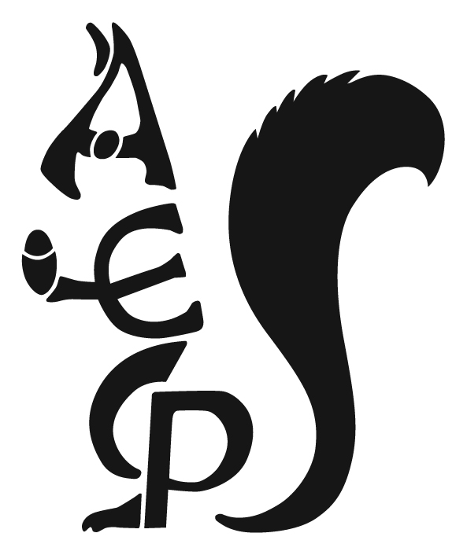
Want to teach great children in a fantastic primary school?
An outstanding teacher is required to teach in our school from September 2021. We are looking to appoint a bright, innovative, hardworking and highly competent teacher with a desire to learn and develop a career in teaching.
High quality teaching must be one of your key strengths, along with the ability to closely monitor the individual needs of each child so allowing them to maximise their potential. The ability to lead a foundation subject in the arts such as art and design, music or design technology would be an advantage.
You need to be someone who is determined to develop young children as valuable contributors to a more sharing and caring society of the future. You must have the very highest expectations of all children, both behaviourally and academically. The post offers unrivalled opportunities to join a very happy and dedicated team of people who work very well together to get the best outcomes for the children in our care. Opportunities for CPD are excellent.
Alderley Edge Community Primary School is committed to the protection and safety of its children therefore robust pre-employment checks will be completed.
NQTs and RQTs are welcome to apply.
Application forms can be downloaded from the school website or are available from the school office but must be returned to school electronically. A person specification will be sent to you by email on request (contact admin@aecps.org) or can be downloaded from the school website http://www.aecps.org/school-essentials/vacancies.
The Letter of Application must be written on no more than 2 sides of A4, font size 11.
Interested candidates are also strongly encouraged to visit school on Monday 10th May at 9.30am or Wednesday 12th May at 1.30pm. Due to COVID restrictions, these will be limited to five candidates per tour and accompanied by the head teacher. Candidates will only be able to view of external areas of the site but will have an opportunity to talk to the Head Teacher.
The closing date for applications is Thursday 13th May at 12 noon
Interviews will take place on Tuesday 18th May

