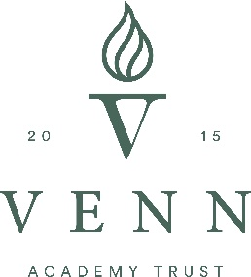
Maternity Cover
Marshland Primary Academy
Class Teacher 100%
(part-time may be considered for the right candidate)
MPS/UPS

Our Trust is a group of inspirational and aspirational mainstream and specialist schools, whose main objective is to ensure that all pupils make exceptional progress.
We aim to provide the best educational support and provision for young people in the Yorkshire and Humber region.

Marshland is a small primary in the heart of its community.

We are looking for an exceptional and inspirational teacher to join our team, initially based in Key Stage Two for two terms to cover maternity leave. This post is suitable for an experienced teacher or someone at the start of their career. ECTs are welcome to apply and lots of support will be given if this is the case.

At Venn Academy Trust, we believe in maximising the potential for all, including our employees. We offer a range of employee benefits including investment in CPD to assist us in our continued objective to deliver outstanding education to the community.

Visits to the setting are warmly welcome, please contact Sarah Hall, Executive Headteacher to make an appointment.

Closing date: Wednesday 20th October at 12:00noon

Venn Academy Trust is committed to achieving fairness and equality in employment and welcomes applications from all sections of the community.

Our Trust is fully committed to safeguarding and promoting the welfare of pupils and expects all staff to share this commitment.

An enhanced DBS check is required for all successful applicants.

