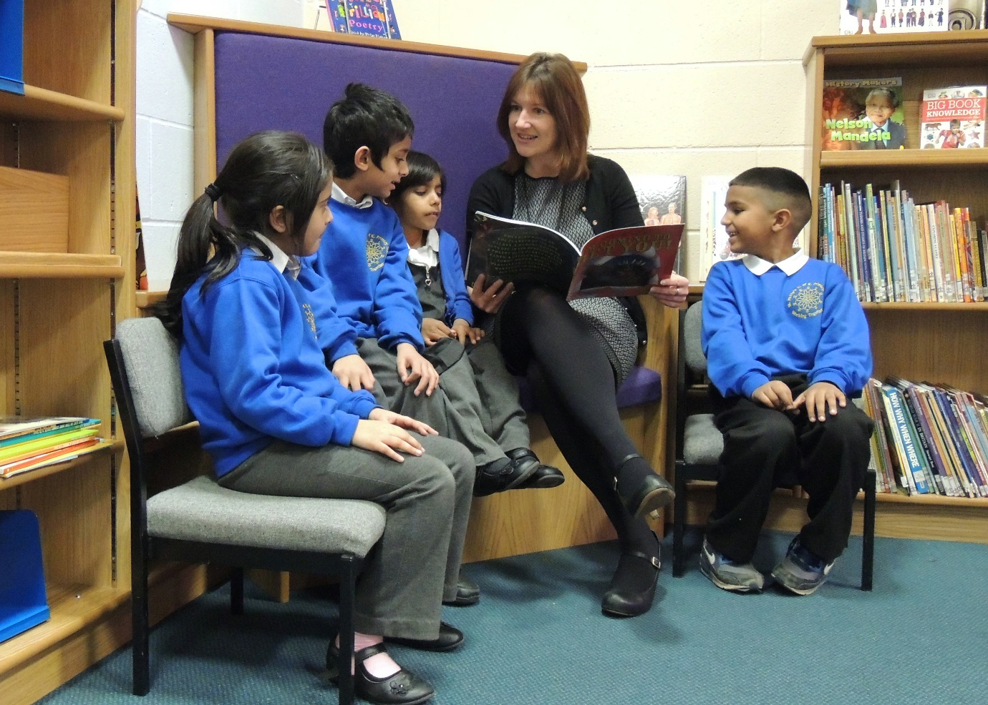

St Philip’s CE Primary Academy
Class Teacher
Application Pack
Candidate Information Pack, March 2021

Closing Date: 12.30pm Friday 16th April 2021
Short listing: Friday 16th April 2021
Observations conducted remotely/video lessons: 19th – 21st April 2021 – to be arranged individually
Interviews: Friday 23rd April 2021
Contents

- Letter from the Headteacher
- In and Around Bradford
- How to Find Us
- Advertisement
- Bradford Diocese Academies Trust
- Job Description and Person Specification
- The selection process
- Application Form
Additional documents – please access on the website www.stphilipsceacademy.co.uk
St Philip’s Primary Academy
Whitby Terrace, Girlington, Bradford BD8 9JL
Headteacher: Miss M Hargreaves
email:office@stphilips.bradford.sch.uk
Tel: (01274) 546496

22nd March 2021

Dear Candidate,

Thank you for your application. Within this pack you will find an application form, a job description and a job specification. Within the application form, there is space to submit a personal statement no longer than two sides of A4.

Over the time that I have spent here as Headteacher, the school and our outcomes have dramatically changed. We have been on a journey from Inadequate in January 2013 to Good in July 2017 – and our journey of improvement continues. During that time we converted to an academy, joining the Bradford Diocesan Academy Trust (BDAT) in 2014. Our MAT is becoming ever-stronger, and offers us a great deal of support from the central staff as well as through the network of Primary and Secondary Academies who have joined BDAT.

As a Church of England Primary Academy, we ensure that our pupils are given every opportunity to achieve their potential within an environment where they feel confident to express their faith – whether our pupils are Christian, Muslim, any other faith or follow no particular faith.

Here at St Philip’s we are passionate about ensuring that our pupils get every opportunity to do their best. To enable this to happen, we offer our staff a supportive network and great CPD opportunities. Whether you are an NQT or an established teacher, we will carefully look at your personal needs and support you in taking the next steps in your career.

Please look at our website to find out more about us – www.stphilipsceacademy.co.uk

We look forward to seeing you and hope to receive an application from you.

Yours sincerely,

Michelle Hargreaves
Headteacher

In and Around Bradford
Bradford truly is a diverse place to live and work, and has so much to offer. The city has great rail and road links to Leeds and Manchester as well as Ilkley, the Yorkshire Dales and even the Lake District. In case you are seeking warmer climates during the school holidays Leeds Bradford airport, home of the low cost airline Jet2, provides links to the rest of the world.
Closer to home, Bradford city centre is home to The Broadway, a brand new shopping centre where you’ll find all your favourite high street stores and much more. If you’re a fan of the theatre, the Alhambra Theatre, which is widely regarded as one of the North's premier touring venues, will be on your list of places to visit, along with the West Yorkshire Playhouse in Leeds. For football fans, a match day ticket will cost you just £15 and entry to the National Media Museum is absolutely free!
The social scene in Bradford is growing with the revival of North Parade and the Independent Quarter. This vibrant new leisure area is being led by the emergence of new high-end bars and eateries, key ingredients to a great night out.
For the music lovers amongst you, Bradford hosts the increasingly popular Bingley Music Live where bands such as Example, The Pet Shop Boys and Jess Glynne have played.
The city is full of history and culture. Home of the Bronte sisters, Haworth is just a short train journey away or visit Saltaire Village home to Salts Mill, Saltaire Brewery and the annual Saltaire Food Festival. Known as the curry capital of Britain, the city has plenty of award winning restaurants to tease your taste buds. The annual Mela, one of the largest celebrations of Asian Arts and Culture in Europe, is an event not to be missed.
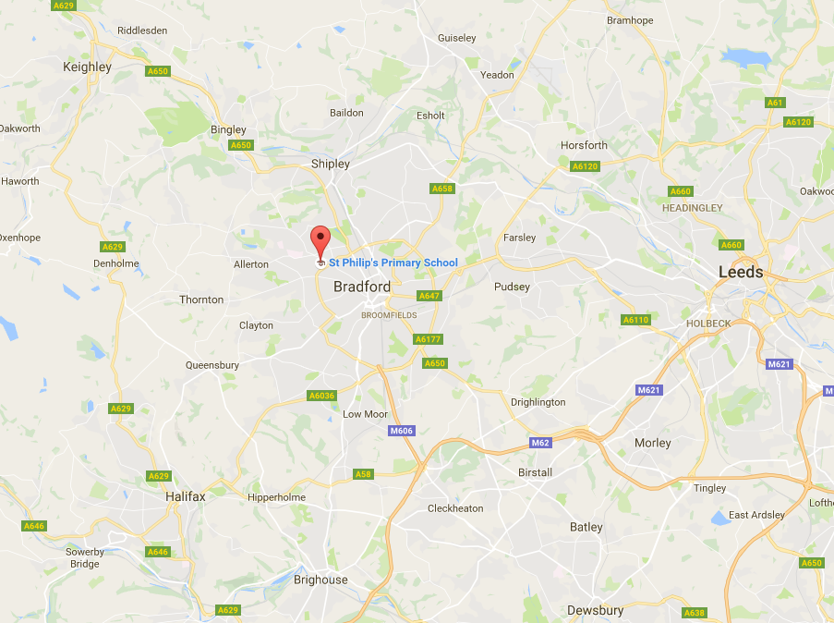
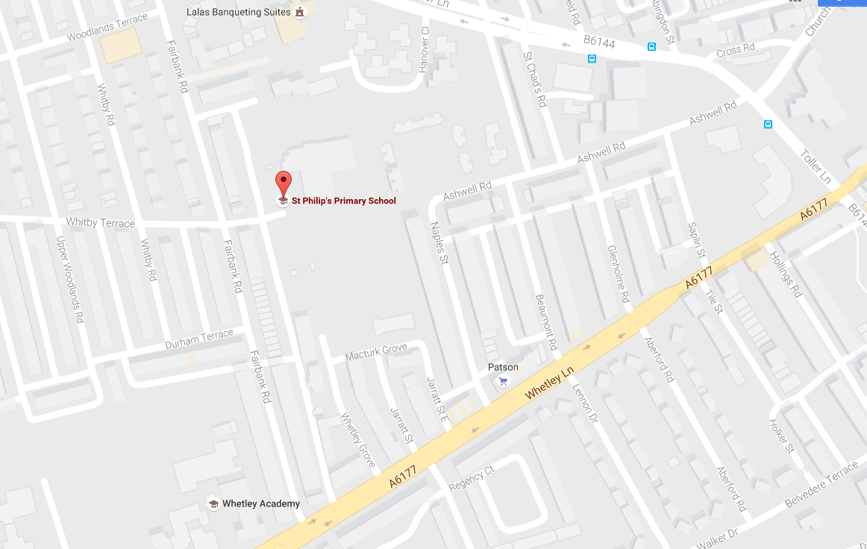
How to find us

St Philips CE Primary Academy
Whitby Terrace, Girlington, BD8 9JL
Tel: 01274 546496
www.stphilipsceacademy.co.uk
Class Teacher Posts

St Philip’s Church of England Primary Academy, a member of the Bradford Diocesan Academy Trust,is a one form entry school in the central-Bradford location of Girlington. We have a strong leadership and teaching team to support any new members of staff coupled with the additional support and network opportunities that we access through our membership of BDAT.
The Governors would like to invite applications from ambitious and talented teachers for the following posts to commence September 2021

1 x KS2 Class Teacher (Full time) Permanent
1 x Year 1 Class Teacher (Full Time) 2 Term Temporary Maternity Cover

Experienced teachers and NQTs are all welcome to apply

We are seeking people who:
- have high expectations of children’s achievement and a dedication to inspiring learners
- are practitioners striving towards excellence in all they do
- have evidence of good or outstanding teaching that is creative and innovative leading to the provision of exciting learning experiences
- are dedicated to school improvement and raising standards for all stakeholders
- have effective communication skills with children, parents, colleagues and the wider community.

We can offer you:
  - an induction programme for all new staff
  - a friendly and warm community with dedicated staff and governors
  - well behaved, enthusiastic learners
  - a commitment to raising standards for all our children
  - a highly motivated and supportive leadership team
  - a commitment to enhancing your professional development.

We take great care to ensure that our pupils are safeguarded against harm, therefore these posts are subject to an enhanced DBS check.
Although they may be conducted slightly differently than usual, visits to school are warmly welcomed and can be arranged by contacting the school office team on 01274 546496. Applicants are requested to apply online.

Closing Date: 12.30pm Friday 16th April 2021
Short listing: Friday 16th April 2021
Observations conducted remotely/video lessons: 19th – 21st April 2021 – to be arranged individually
Interviews: Friday 23rd April 2021

About BDAT

General Information and Background

Bradford Diocesan Academies Trust (BDAT) is a Multi- Academy Trust (MAT) supporting a number of primary and secondary schools in Bradford.

BDAT is the only Church of England MAT operating in Bradford, as part of the Diocese of Leeds.

BDAT operates as an Exempt Charity, and is governed by a board of trustees who are responsible for, and oversee, the management of the company. The Memorandum and Articles are available on the Trust’s website at www.bdat-academies.org.

The mission statement of BDAT

“The Trust’s mission is to provide an education of the highest quality within the context of Christian belief and practice.”

In practice, as a Trust, we seek to work with and alongside the schools in our Trust to provide a good quality of education to all children in our schools.

The Trust does this through operating a light touch support role for schools at times of challenge and by establishing collaborative structures and processes to enable our schools to work together and share good practices.

As our family of schools continues to grow, we are constantly looking at how we can continue to improve to establish effective and efficient ways of partnership working.

Trust development and growth

The MAT was established in 2012 to support both primary and secondary Church schools needing support within an Academy model.

Our Schools

BDAT is currently made up of seventeen academies operating across Bradford, providing education for over 8500 students and employing nearly 1500 staff.

We work with schools of all different contexts and backgrounds including good and outstanding schools and we support schools in special measures. We recognise that each of our schools is unique and value their differences and the communities they represent.

Our Primary Academies  - Christ Church Primary Academy  - Oxenhope CofE School  - St Oswald’s CofE School  - St Philip’s CofE Primary Academy  - Westminster CofE Primary Academy  - St John’s CofE Primary School  - The Academy at St James  - Shipley CofE Primary  - Clayton St John CofE Primary School  - Cullingworth Village Primary School  - East Morton CofE Primary School  - Woodlands CofE Primary School  - Wycliffe CofE Primary School | Our Secondary Academies  - Belle Vue Girl’s Academy  - Bradford Forster Academy  - Buttershaw Business and Enterprise College  - Immanuel College

Our Christian ethos

BDAT is a proud Christian organisation committed to providing high-quality education for all within an ethos which encourages academic, vocational, mental, physical, and spiritual opportunities and development for each member of its academies.

Whilst robust Christian principles underpin the work of the Academy, everyone is encouraged to explore their own spirituality and to recognise and understand that of others. It is for this reason that we choose to support and sponsor Non-Church of England Schools, as well as those within the faith.

For more information on BDAT visit www.bdat-academies.org or visit #wearebdat.

Job Description: Class Teacher

Job Title: Class Teacher

Scale: Main Pay Spine 1-6

Hours/week: Full-Time Equivalent

Job Purpose:
The Class Teacher will:
- teach a class of pupils, and ensure that planning, preparation, recording, assessment and reporting meet their varying learning and social needs;
- maintain the positive ethos and core values of the school, both inside and outside the classroom;
- contribute to constructive team-building amongst teaching and non-teaching staff, parents and governors;
- ensure that the current national conditions of employment for schoolteachers are met.

Duties:
The Class Teacher will:
- implement agreed school policies and guidelines;
- support initiatives decided by the Headteacher and staff;
- plan appropriately to meet the needs of all pupils, through differentiation of tasks;
- be able to set clear targets, based on prior attainment, for pupils’ learning;
- provide a stimulating classroom environment, where resources can be accessed appropriately by all pupils;
- keep appropriate and efficient records, integrating formative and summative assessment into weekly and termly planning;
- report to parents on the development, progress and attainment of pupils;
- maintain good order and discipline amongst pupils, in accordance with the school's behaviour policy;
- participate in meetings which relate to the school's management, curriculum, administration or organisation;
- communicate and co-operate with specialists from outside agencies;
- lead, organise and direct support staff within the classroom;
- participate in the performance management system for the appraisal of their own performance, or that of other teachers.

Person Specification: Class Teacher

 | Essential | Desirable
Qualifications | Qualified Teacher Status | Evidence of continuous INSET and commitment to further professional development.
Experience | The Class Teacher should have experience of:  teaching across the Primary age range; | In addition, the Class Teacher might have specific experience of:  Teaching Key Stage 1 or 2;  working in partnership with parents;  teaching within a Church of England setting.
Knowledge and understanding | The Class Teacher should have knowledge and understanding of:  the theory and practice of providing effectively for the individual needs of all children (e.g. classroom organisation and learning strategies);  statutory National Curriculum requirements at the appropriate key stage;  the monitoring, assessment, recording and reporting of pupils’ progress;  the statutory requirements of legislation concerning Equal Opportunities, Health & Safety, SEN and Child Protection;  the positive links necessary within school and with all its stakeholders, including that of the church;  effective teaching and learning styles. | In addition, the Class Teacher might also have knowledge and understanding of:  the preparation and administration of statutory National Curriculum tests;  the links between schools, especially partner schools.
Skills | The Class Teacher will be able to:  promote the school’s aims and Christian ethos positively, and use effective strategies to monitor, motivate and develop positive morale;  develop good personal relationships within a team;  establish and develop close relationships with parents, governors and the community;  communicate effectively (both orally and in writing) to a variety of audiences;  create a happy, challenging and effective learning environment. | In addition, the Class Teacher might also be able to:  develop strategies for creating community links.
Personal characteristics | Demonstrate the NOAH’S ARC values of St Philip’s CE Primary Academy:  Nurture, Optimism, Aspiration, Hope, Sincerity, Achievement, Respect, Confidence

Class Teacher Posts
Selection Process Guidance

Our aim is to ensure that we recruit the right person for the job. We will ensure that the selection process is fair and without discrimination for or against any candidate based on age, ethnicity, sex, marital status, or sexual orientation. The person specification sets out the criteria used to assess candidates through the selection process.
We are committed to safeguarding our pupils and will assess the candidate’s suitability for working with children as part of the selection process. We will check the accuracy of all information and investigate any perceived anomalies. We take up references prior to interview and use these to verify the information you have given us. Firm offers of employment are never made without satisfactory references. All potential employees are subject to an enhanced disclosure form the Disclosure and Barring Service.

Visits to the school
Visits to the school are warmly welcomed by prior arrangement, although they will look a little different due to social distancing and current risk assessment restrictions. Please contact the school office on 01274 546496 to arrange a mutual appointment. The visit will give you an opportunity to ask questions about the role and the school to assess if this is somewhere you would like to work.

Applications
Please ensure that all parts of the application are completed. We do not accept CVs as part of the selection process. Please ensure that you demonstrate how your experience and skills make you suitable for the position. We request at this time that all applications are made electronically, and sent to vacancies@stphilips.bradford.sch.uk.

Shortlisting
We assess all applications against the person specification criteria using the evidence you provide in your application. This is done by a panel of senior staff and governors. We carefully check all applications for anomalies.

Candidates who best meet the person specification will be invited to complete an observed lesson. If the lesson demonstrates good or better teacher, or the potential to achieve that, candidates will then be invited to interview. We will notify you by telephone with e-mail confirmation to follow. If you have not heard from us within 3 days of the shortlisting date, you have not been successful at this stage.

References
We request references for all candidates who are invited to interview. Requests will be made at the same time that candidates are invited to interview. Your first referee should be your current or last, employer.

Interview Day
The interview day will consist of an unseen task and a formal interview. These are designed to allow you to demonstrate your skills and abilities. You will be asked to bring proof of qualifications and identity on the day.

Final Selection
Following the task and formal interview, we will use the person specification as a guide to select the most suitable candidate for our school. We will then telephone each candidate to inform them of the outcome. We will give brief feedback during this telephone conversation.

Offer of Employment
We will make a verbal offer of employment by telephone on the day of the interview and this will be confirmed in writing. Any offer is made subject to:
- References satisfactory to us
- A satisfactory DBS check
- Provision of proof of identity and qualifications

St Philip’s CE Primary Academy is an academy within Bradford Diocesan Academies Trust (BDAT). The successful candidate will be employed by BDAT although their main place of work will be at St Philip’s CE Primary Academy.

Time line

Closing Date: 12.30pm Friday 16th April 2021
Short listing: Friday 16th April 2021
Observations conducted remotely/video lessons: 19th – 21st April 2021 – to be arranged individually
Interviews: Friday 23rd April 2021
All applications forms to vacancies@stphilips.bradford.sch.uk

All posts are subject to an Enhanced DBS check. We are committed to the safeguarding of children.

