Welcome to St John’s
Our Mission Statement
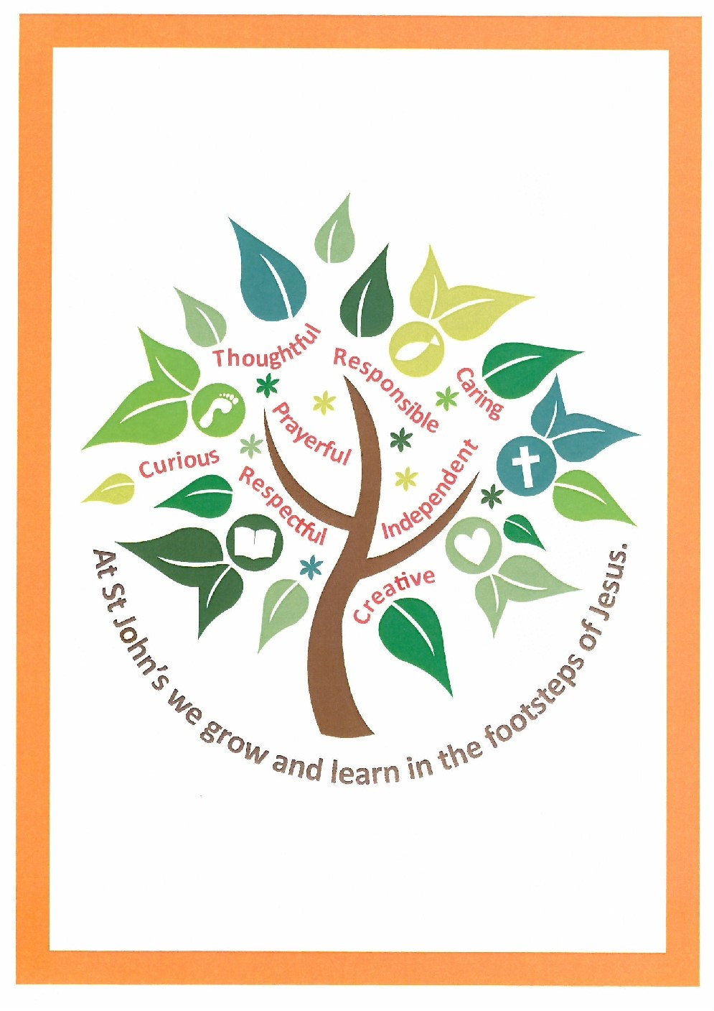

General Information
We live our Mission by:
• ensuring that our attitudes and values are transmitted through a curriculum that is consistent with the Catholic faith
• delivering a curriculum that is relevant, varied, interesting, stimulating, balanced and appropriate
• developing schemes of work and policies on teaching and learning, assessment and special needs which recognise that R.E. is an integral part of the curriculum
• developing sound teaching and effective classroom management strategies
• generating a positive attitude to learning where realistic expectations of pupils and high standards of work are expected
• using a variety of teaching approaches that reflect the needs of individual pupils
• participating in projects which focus on the needs of others including local and international charities.
The Sisters of St. John of God founded St John’s school in 1927. It began its life in an army hut in the presbytery gardens with eleven pupils. Permanent buildings were erected in the 1930’s.
In 1950 the formerly private school became state-aided. Its popularity meant that is soon became too large for the original site and so expanded to include buildings on Park Street, Innox Hall and the Pratten hut on the junior school site.
In 1968 the main junior classroom block was completed. After concerted efforts by the school and parish a new school hall was built on the junior school site and was completed in 1992.
In 2000 our long-term aim to amalgamate the infant and junior departments of the school was realised. The infants now have a purpose built block, which is directly joined to the junior department.
In 2003 we added a Reception playground and an additional Reception classroom to the school, bringing the total number of classes to eleven.
In 2005 we replaced the mobile classrooms with a new ultra modern block with enhanced facilities for art and practical work.
In 2012 a new Foundation stage classroom was built together with an outdoor learning area. Additionally a new chapel, library and music practice rooms were completed.
Although the sisters of St John’s left the parish in the summer of 2014, continuity with the 1927 Foundation continues to live on in the school.
Father Tom from St John’s parish church is our school chaplain. He regularly visits pupils in classes and assemblies. All classes hold a class liturgy which is well attended by parents. St John’s pupils and staff contribute to Sunday mass on a monthly basis, leading the music and choir and readings.
Many of the pupils naturally continue to St Augustine’s Catholic College, Trowbridge,
St John’s currently has 305 pupils who are split across 11 classes. The school is split into 4 phases, each of whom is led by a Phase Leader who is part of the school leadership team. Together with the Headteacher, Tracey Sessions, the Inclusion Lead and School Business Manager, they lead the school with support from the Governing Body.

Parents
We have very supportive parents who actively engage in supporting the school and parish community and the pupils. St John’s has an active School Association called the Friends of St John’s who regularly run social and fund raising events. These are not only enjoyable but also a very valuable aspect of our parish and local community life.

Catholic life, Religious Education, and the Wider Curriculum
We are a Catholic school, providing a broad, creative, supportive family environment centred on the Gospels, on the example and teachings of Jesus Christ. We highlight the unique nature of the individual, everyone’s right to be shown respect and everyone’s responsibility to give his or her best for the community. We are inclusive and aim to find areas of excellence in all our members (governors, pupils, staff, parents and volunteers) to help them grow as individuals and achieve their potential. All are fully supportive of our mission and give copiously of their time and expertise.

Collaboration with other schools
We are committed to working in collaboration with other schools including a range of support provided by both senior management and governors. We are a member of the Emmaus Schools Partnership and Trowbridge Collaborative Schools.

Further Information
The latest OFSTED and Section 48 reports, along with information on the governing body and much else, can be found on the school website www.st-johns-trowbridge.wilts.sch.uk and/or in the school prospectus.

