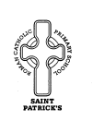
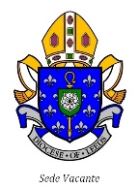
Diocese of Leeds & Children Leeds
St. Patrick's Catholic
Primary School

Torre Road, Leeds LS9 7QL
Head Teacher: Mrs Claire Grady
www.stpatricksleeds.org.uk
0113 2480380
NoR: 212

Email: office@stpatrickleeds.org.uk

Required for September 2022

Key Stage 2 Teacher

Permanent Contract

The Governors of St Patrick’s school wish to appoint
an outstanding teacher to join our happy school family.

We are looking to appoint someone who is committed, passionate and strives for excellence in all they do.

Applications will be warmly welcomed from practising
Catholics or those who are able to support fully the Catholic
ethos of the school.
Applications from experienced teachers are welcome as well
as those from ECT’s. Application packs and further details are

available on the school website or by contacting

the School office by phone or email.

Closing Date: 20th May 2022 (Midday)

Shortlisting: 20th May 2022 pm

Interviews: 25th May 2022

St Patrick’s is committed to safeguarding the welfare
of children and expect all staff to share this commitment.
An enhanced DBS and a Disclosure check will be required for the successful candidate and at least two professional references will be taken and followed up.

