Trewirgie Junior School

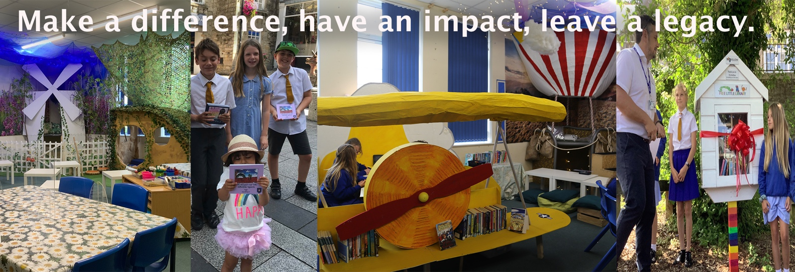

Salary Range: MPS, UPS (£25,714 - £41,604 FTE)

Class teacher with the potential for leadership responsibility for the right candidate

Contract: Full time, permanent

Closing date: 9am Friday 15th October 2021

Interviews will be held on Thursday 21st October 2021

Start date: January 2022. However, we will be flexible on this for the right candidate

We are looking for a talented and innovative practitioner to join our dynamic and vibrant school where we aim to ‘make a difference, have an impact, and leave a legacy. In the school’s recent Ofsted in June 2021 it stated, “There is enough evidence of improved performance to suggest that the school could be judged outstanding if we were to carry out Section 5 inspection now.”

The school’s curriculum is the driving force of the school. It is innovative, imaginative and creative and pushes the boundaries of children’s experiences and thinking. Our purposeful approach to learning ensures that children’s learning has real relevance to themselves and the wider world. It enables them to explore real life issues, develop a social conscience and through this contribute towards changing this.

We are looking for somebody to come and help us to shape the next stage of our journey. The successful candidate will have a proven track record of innovative teaching, that results in high quality learning outcomes. We welcome applications from teachers who share our school’s unique vision and values for children’s learning and wants to play a key part in the future shaping of this.

As a school we have a proven track record of supporting and developing teacher’s aspirations and careers. We welcome applications for experienced teachers who can bring their skillsets and passions to this role.

Visits to the school are warmly welcomed. Please contact Mrs Sadie Gumma, 01209 215238 or enquiries@tjschool.co.uk to arrange. If this is not possible then the headteacher is happy to set up a short zoom call with prospective candidates

Please email your completed application forms before the closing date of Friday 15th October 2021 to enquiries@tjschool.co.uk
We are committed to safeguarding and promoting the welfare of children and young people and expect all staff and volunteers to share this commitment. We operate DBS safeguarding procedures.

