Primary, Secondary & Sixth Form

“A SCHOOL FOR EVERYONE…” Ofsted 2020

KS2 Phase leader and Primary Maths Lead

An Introduction to Washwood Heath Academy and the Primary Phase

In March 2019, Washwood Primary pupils and staff moved into the purpose built Primary building on the Washwood Heath Academy campus. It is a beautiful building with excellent teaching and learning facilities for children and staff. The Primary building is separate from the Secondary buildings, with its own playgrounds, but with access to Secondary facilities including music rooms, Science Labs, PE facilities, Drama studio, Art rooms and outside space. We plan and develop our ‘All Through’ activities to enable us to work together at opportunities throughout the year, including during Sports Days, Workshops, Library Events, Awards Ceremonies, Assemblies, Concerts and other events and celebrations.
Within the primary phase at Washwood Heath Academy, we believe in high expectations, creating and sustaining a positive and uplifting culture for our children and each other. We are a caring and nurturing environment, which aims to develop all of our core HEARTS values: Happiness, Excellence, Achievement, Respect, Resilience, Tolerance and Self-Belief. We go above and beyond to ensure that everybody within our school community feels respected, challenged, supported and safe. We believe in being: Ready, Respectful and Safe and we expect all visitors to our school to uphold our three rules. We aim to provide our children with an excellent curriculum providing high-quality teaching and learning which equips our pupils with the right tools for them to achieve and to provide them with the most effective environment that ignites curiosity and wonder. We support our families in ensuring that they too, can provide the right environment for our children to learn effectively and to grow securely academically, emotionally and mentally. Together as one school, Washwood Heath Academy provides a safe and caring environment for our pupils led by highly-effective staff whose main aim is to ensure a continuing ethos of a love for learning, quality education, resilience and respect whilst receiving excellent teaching and learning.
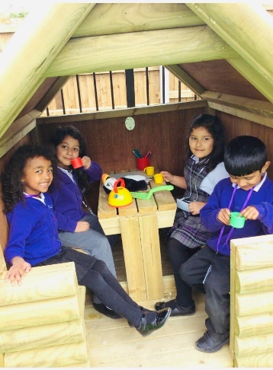
Washwood Heath Academy is a large All Through Academy with almost 1700 learners across the key stages. The Primary phase is a one-form entry school, which ensures we can care and cater for the needs of all in a caring and family orientated way. Every year, our 30 Year 6 pupils transition into Washwood Heath Year 7 and join a further 250 children from other local primary schools. In addition to teaching staff and teaching assistants, the Primary phase currently has a Pastoral Manager, SENCO and Head of Primary Phase. The Primary phase works closely with the secondary phase and enjoys a special relationship, which positively benefits all.
In March 2020, Washwood Heath Academy experienced its first Ofsted inspection as an All-through Academy and was graded ‘Good’ in all categories. Ofsted reported that ‘Leaders have a clear and ambitious view of what pupils should learn. They have reviewed the curriculum, and made changes in short and longer term’. In September 2019, Washwood Heath Academy embarked on its journey to develop and implement a knowledge-rich curriculum across all phases of the Academy. To date, we have embedded a knowledge-rich curriculum into Key Stage 3 and Key 4 subject areas and is continuing to develop well in the Primary phase. In addition, we have embedded Direct Instruction into Key Stage 3 and Key Stage 2, which successfully supports the catch up and learning of children within these phases. We are looking for an English or Maths Lead and Key Stage 2 Phase Leader to work alongside Primary and Secondary colleagues to further enhance the teaching and learning of pupils and the further enhancement of the curriculum. Staff at Washwood Heath Academy use research to help improve teaching and learning, curriculum and pastoral care.
In March 2020, Ofsted praised the ‘sharp focus on the teaching of early reading, and children learn phonics from the start’.
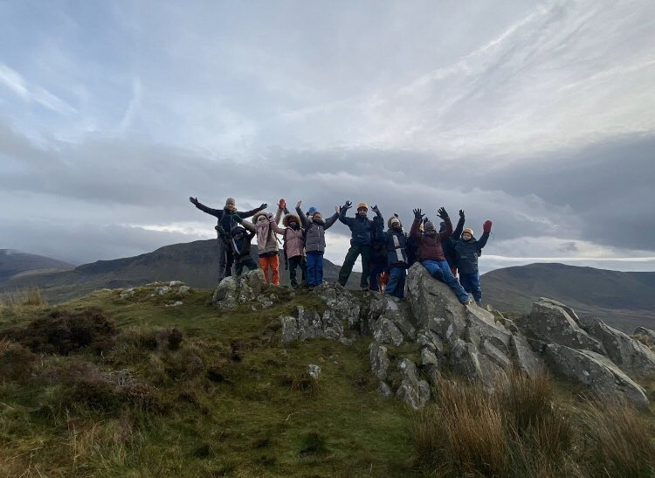
Washwood Heath Academy really is ‘a school for everyone’ and a significant number of staff have remained at Washwood for many years because they enjoy being part of a family and working in a caring and supportive community that wants the best for all of its young people and staff.

JOB DESCRIPTION

JOB TITLE | Key Stage 2 Phase Leader and Maths Lead
GRADE | M3-UPS + TLR 2B £4784
Job Purpose | - To work in partnership with the Headteacher and Head of Primary Phase as part of the Middle Leadership Team, in securing high quality Maths teaching and learning across the school. To lead Key Stage 2.  - Create an environment across the school where children are engaged with their writing and enjoy reading for pleasure.  - Monitor and evaluate the Maths curriculum, analysing data and moderation of assessments.  - Mentor and support colleagues through a solid understanding of the curriculum and good pedagogical practices.  - Contribute towards the vision for the school and its development plan as part of the MLT as a key stage leader.  - To contribute to raising standards of achievement and maximising student attainment.  - To share and support the school’s responsibility to provide and monitor opportunities for personal and academic growth  - To be committed to the safeguarding of children.
Reporting to | Head of Primary Phase
Liasing with | Head of Academy/Head of Primary Phase/Senior Leadership Team, teaching and support staff, Multi Academy colleagues, external agencies and parents.
Main Duties
Leadership | - Support the Leadership Team in determining and developing the long-term strategic development for the Key Stage 2 curriculum, including English, Maths and the wider Curriculum alongside whole school Maths and foundation curriculum subjects, where necessary;  - Support the Leadership Team in organising and implementing the English or Maths curriculum, other foundation subjects being lead, and the curriculum in KS2;  - Support the Leadership Team in establishing a learning environment that helps pupils develop learning skills in order that they become successful and independent learners for life;  - Support the Leadership Team in the regular monitoring of the quality of teaching and learning across the Key Stages for Maths and foundation subjects being led and the whole curriculum for KS2;  - Support the Leadership Team in the management of assessment in Maths and, foundation subjects being led for the whole school, and all KS2 curriculum areas. This will include collating assessment information, the analysis of performance data to determine students’ progress and assessing and evaluating performance in KS2, whole school Maths and the foundation subjects leading on, in relation to local and national results and the school’s own targets.  - Support the Leadership Team in the delivery of staff training and development meetings;  - Contributing to the school strategic plan and promote the learning priorities of the school.
Knowledge and understanding | - Demonstrating well-developed and up-to-date subject knowledge and pedagogical knowledge and keeping this relevant;  - Continually updating own pedagogy and being able to inform/train others on this;  - Attending relevant training sessions and network meetings to keep up-to-date-with any curriculum or assessment changes and to disseminate new information to colleagues accordingly;  - Monitor and evaluate Maths, foundation subjects leading on and the KS2 curriculum, in order to identify and act on areas for improvement;  - Using the classroom as a place to innovate and try new ideas, which can then be later shared with colleagues.
Development of subject, self and others | - Support staff and class teachers in matters relating to whole school Maths, the KS2 curriculum and foundation subjects being led, including demonstration lessons;  - Support and provide staff with opportunities to further improve their performance in teaching and robust assessment procedures  - Developing SoW and curriculum skills map across EYFS, KS1 and KS2 for Maths.  - Ensure production, review and revision of schemes of work relating to Maths, foundation subjects leading on and the KS2 curriculum, providing guidance and support as appropriate;  - To lead, motivate, support, challenge and develop all staff to secure continual improvement including his/her own continual professional development;  - Report to and provide advice and feedback to SLT on matters relating to whole school Maths, foundation subjects you lead and the KS2 curriculum;  - Encourage, develop and support curriculum links and routes for progression between all phases in school and KS3;  - Inspire trust and confidence in pupils, colleagues and parents;  - Build team commitment with colleagues and in the classroom.  - Liaising closely with the Head of English or Maths in Secondary;  - Working with teachers in the secondary phase regarding reading and English in Year 7.  - Developing Oracy in KS2 and throughout Primary in Maths.
Management | - Carry out lesson observations of teaching staff as requested by the Leadership Team;  - Demonstrating well-developed and up-to-date subject knowledge;  - To attend Middle Leadership Team meetings as and when requested by the Head of Primary / Academy;  - Take on specific tasks related to the day to day administration and organisation of Maths, foundation subject being led and the Key Stage as reasonably requested by the Leadership Team;  - Attending relevant training sessions and network meetings to keep up to-date-with any curriculum or assessment changes and to disseminate new information to colleagues accordingly;  - Ensure that improvements in Maths are priority targets for all pupils, with a particular focus on those in KS2;  - Take on specific tasks related to the day to day administration and organisation of Maths, foundation subject being led and the Key Stage as reasonably requested by the Leadership Team;  - Running workshops to inform parents of the Academy practice and development to enable them to support their child at home;  - Ensure self-evaluation and improvement processes related to Key Stage 2, whole school Maths and foundation subjects being led, are robust and regularly reviewed;  - Provide information and advice to the Board on matters relating to the KS2 curriculum, whole school Maths and whole school foundation subjects;  - Ensure communication between all parties is highly effective;  - Ensure the implementation of whole school policies which support the school’s values, aims and objectives  - Line-manage colleagues  - Ensure all necessary administration is completed and deadlines are met  - Lead meetings and professional days to disseminate information, solve problems and make decisions  - Contribute to meetings in school and outside to ensure appropriate views are represented  - To ensure accountability and be accountable.
General teaching | - Have responsibility for the teaching of a class, developing a stimulating and challenging learning environment which secures effective learning and provides high standards of achievement, behaviour and discipline and models good practice for other teachers;  - To provide an example of ‘excellence’ as a leading classroom practitioner, inspiring and motivating other staff, modelling good practice for all staff;  - Oversee whole school displays that promote the subject;  - To sustain high expectations and excellent practice in teaching and learning throughout the school;  - Using the classroom as a place to innovate and try new ideas, which can then be shared with colleagues.
Other duties / General | - Play a full part in the life of the school community;  - Support the school’s priorities, ethos and values and encourage staff and students to follow this example;  - To help develop an academy culture and ethos that is utterly committed to achievement;  - Be a role model to all staff in Academy;  - Act in a fully professional way at all times;  - Undertake personal professional development activities, as agreed with the Head of Primary / Academy;  - Attend all relevant parental consultation evenings, open evenings and celebration evenings as per the school calendar;  - Implement school policies and procedures;  - To actively promote the academy at all times;  - To support and work in collaboration with colleagues and other professionals in and beyond the Academy;  - Undertake any other responsibilities as reasonably requested by the Head of Primary / Academy.  This job description is not a comprehensive definition of the post. Discussions will take place on a regular basis to clarify individual responsibilities within the general framework and character of the post as identified below. The conditions of employment of teachers in the School Teachers’ Pay and Conditions of Service Document apply to this post, whose holder is expected to carry out any other professional duties of a teacher as other circumstances may require, under the reasonable direction of the Head of Primary / Academy.
PERSON SPECIFICATION

JOB TITLE | KS2 Phase Leader and Maths Lead

 | Essential | Desirable | Method of Assessment
Knowledge/Qualifications
Qualified Teacher Status |  |  | Application
Evidence of further study and/or qualifications |  |  | Application
A willingness to undertake further relevant training and to pass those skills on to other members of staff as appropriate |  |  | Interview
Sound knowledge of the developments in the Primary curriculum |  |  | Application/Interview
Sound pedagogical knowledge on teaching and learning, especially Rosenshine’s Principles |  |  | Application / Interview
Good ICT skills |  |  | Application/Interview
Experience
Enthusiasm and passion for teaching |  |  | Application/Interview
Evidence of a managing a subject |  |  | Application/Interview
Be familiar with Ofsted requirements |  |  | Application
Evidence of successful teaching across more than one primary Key Stage |  |  | Application
Evidence of leading Maths or a phase for whole school improvement |  |  | Application/Interview
Experience of administering Key Stage 2 SATs |  |  | Application
Experience of a range of school situations |  |  | Application/Interview
Experience of analysing pupil progress data and implementing appropriate improvement activities |  |  | Application/Interview
Experience of effective pupil progress meetings |  |  | Application/Interview
Experience and understanding of data analysis , school internal systems and external. |  |  | Application/Interview
Successful experience in more than one school. |  |  | Application
An understanding of how children across the primary phase learn |  |  | Application
Experience of phonics screening and key stage 1 SATs |  |  | Application
Experience of EYFS |  |  | Application
A commitment to the extra-curricular life of the school |  |  | Application/Interview
A commitment to safeguarding and promoting the welfare of children and young people |  |  | Application/Interview
Experience in leading a curriculum subject
Management Skills
Ability to work strategically as part of the middle leadership team. |  |  | Application/Interview
Experience of monitoring and evaluating classroom practice |  |  | Application/Interview
Have led and worked successfully with a team |  |  | Application/Interview
Be able to manage time effectively |  |  | Application/Interview
Have been involved in, and understand the importance of School Improvement and Development Planning |  |  | Application/Interview
Experience in staff development work |  |  | Application/Interview
Have had experience of staff development and appraisal |  |  | Application
Curriculum
Show a thorough understanding of the primary curriculum |  |  | Application/Interview
Able to support colleagues in the Maths curriculum planning process |  |  | Application/Interview
Have a thorough understanding of young children’s needs, and how they learn |  |  | Application/Interview
Be an outstanding, innovative and creative teacher |  |  | Application/Interview
Have held responsibility for more than one curriculum area |  |  | Application
Understand the importance of developing thinking skills |  |  | Application/Interview
Have experience leading whole school change. |  |  | Application/Interview
Skills
An effective team member and leader |  |  | Application/Interview
Ability to work under pressure |  |  | Application/Interview
Excellent and effective communicator with all school stakeholders |  |  | Interview
Able to identify and solve problems independently and creatively |  |  | Application/Interview
Ability to promote and foster a positive attitude |  |  | Application
Able to motivate and inspire students and colleagues |  |  | Application/Interview
An excellent teacher with enthusiasm and a commitment to education and developing young people |  |  | Application/Interview
Ability to develop and encourage positive partnerships with parents, governors, outside agencies etc. |  |  | Application/Interview
Approachable and willing to help students both in and outside of lessons |  |  | Application/Interview
Ability to initiate ideas |  |  | Application/Interview
Ability to set own and others targets and deadlines |  |  | Application/Interview
Ability to embrace change |  |  | Application/Interview
Flexibility |  |  | Application
Has successfully mentored or coached a colleague |  |  | Application/Interview
Personal Qualities
Be motivating and motivated |  |  | Interview
Have an awareness of the needs of others |  |  | Interview
Well-organised, professional, innovative and tactful |  |  | Interview
Have the ability to meet targets and objectives |  |  | Application/Interview
A reflective practitioner |  |  | Application/Interview
Have a sense of humour |  |  | Interview
Be passionate about wanting to make a difference to our children |  |  | Application/Interview
Have a desire to further your own learning and be ambitious for your career |  |  | Application
Have effective time management skills |  |  | Application/Interview
Equal Opportunities
Must have an understanding of and commitment to the Trust’s equal opportunities policies and procedures |  |  | Application/Interview
To be able to demonstrate a commitment to celebrating diversity and promoting community cohesion in a multi-cultural setting |  |  | Application/Interview

Primary, Secondary & Sixth Form

