0.6 fte Class Teacher for Key Stage 2

Application pack

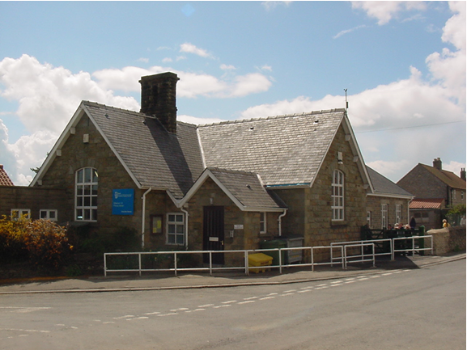

Our Vision

Our rural and community focused school aims to enable everyone in our community to flourish through a focus on nurturing first the blade, then the ear, then the full grain (Mark 4:28); from the youngest child to the oldest member of the village. Inspirational learning through curiosity and commitment will encourage aspiration and the desire to be the best they can, in their work and through the respect, care and love they have for each other. Enabling a life lived in all its fullness.

Our Values

Honesty, Love and Care, Respect

Main Street
Gillamoor
North Yorkshire
YO62 7HX
☏ 01751 431643
admin@gillamoor.n-yorks.sch.uk
School website: http://www.gillamoor.n-yorks.sch.uk/

Closing date for applications: 12 noon Wednesday 18 May 2022

Welcome to Gillamoor CE (VC) Primary School

Dear Applicant,

Thank you for your interest in the post of 0.6fte Class Teacher for Key Stage 2 commencing September 2022.
This application pack contains the following:

- Application form (separate document)
- Job description
- Person specification

We are looking for an enthusiastic teacher, who has experience of teaching Key Stage 2, to be a valued member of the school team.
We are looking for someone who:

- Is an excellent practitioner with experience of teaching at Key Stage 2
- Is warm, friendly and approachable.
- Engages children through high quality and creative teaching.
- Is prepared to contribute to the life of the whole school.
- Is highly motivated and able to motivate others with high expectations
- Has energy, determination and a sense of humour.
We can offer:
- Enthusiastic, happy, well-motivated children with supportive parents.
- A welcoming, caring, committed and professional staff team.
- A clear vision and values underpinned by Christian ethos
- A pleasant working environment.
- Opportunities and support for your own continued professional development.
- A committed and supportive governing body.

The closing date for application is Wednesday 18 May at 12 noon. Emails will be sent to acknowledge receipt.

If you have any further questions, or would like to visit the school, please contact Mrs Hugill, School Business Manager on 01751 431643 or by email at admin@gillamoor.n-yorks.sch.uk.

We are very proud of our school and I would be pleased to show you round.
Yours sincerely
Andrea Hayes
Headteacher

Our School
- Gillamoor CE (VC) Primary School is situated in the village of Gillamoor. An attractive village, nestled on the edge of the North York Moors, a predominantly farming community. Our school is based close to the historic market towns of Helmsley and Kirkbymoorside and is easily accessible by road, being only 5 minutes’ drive from the A170.
- We were inspected by Ofsted in July 2019 and judged to be a Good school.
- The children are organised into three classes; Foundation/Key Stage 1, Lower Key Stage 2 (Y3/4) and Upper Key Stage 2 (Y5/6).
- There are currently 50 children on role, a number which has been rising over the past few years.
- The school is a Nurture School with a very caring, supportive, family ethos and is an important part of the local community.
- The school has use of the community playing field, including a Multi User Games Area and uses the pool and sport facilities at The St Alban Sport Centre.

Application process

Please email completed application to admin@gillamoor.n-yorks.sch.uk
Or post to; Mrs A Hayes
Gillamoor CE Primary School
Main Street
Gillamoor
North Yorkshire
YO62 7HX
Telephone 01751 431643

Closing date noon Wednesday 18 May 2022
Interviews will take place on Monday 23 May 2022

Job Description KS2 Class Teacher
Job Title: Class Teacher. Part time 0.6 (3 days per week).
Fixed term starting September 2022 until Summer 2023 (with potential for extension).

Grade: Main Pay Scale 2 - 4
Responsible to: Headteacher
Responsible for: Deployment of support staff allocated. Subject leadership (subject to be dependent upon experience and discussed at interview).
Job Purpose: Promote effective learning, appropriate achievement and educational, social and personal progress of pupils in KS2, consistent with the aims of the school and the needs of each individual as in The Teacher Standards.
Key Responsibilities:
1. Develop and maintain an up-to-date knowledge and understanding of the areas of teaching and pupil support for which you are responsible.
2. Plan work to meet the learning needs of all pupils in a consistent and effective way.
3. Use appropriate teaching and classroom management strategies to motivate pupils and enable each to progress to their full potential.
4. Monitor and evaluate the progress of pupils for whom you are responsible to set expectations and give constructive feedback.
5. Maintain appropriate records to demonstrate progress made by pupils.
6. Subject leadership – subject to be dependent on experience/knowledge.
7. Participate fully in professional development activities to develop practice further, sharing the learning from these as appropriate.
8. Make an active contribution to the policies and aspirations of the school.
9. Work with other staff in the school on whole school projects for the benefit of all the pupils.
10. To fulfill all of the requirements and duties set out in the current Pay and Conditions/Teachers’ Standards Documents relating to the conditions of employment of teachers.
11. To fulfill all of the responsibilities and duties required by the School’s policies on teaching and learning.
12. To achieve any performance criteria or targets arising from the School’s Performance Management arrangements.
Person Specification
Key Duties and Responsibilities:
Knowledge and understanding:
  - Have a detailed knowledge of the relevant aspects of the National Curriculum and other
statutory requirements.

  - Understand progression in Key Stage 2.
  - Have an awareness of specific learning difficulties that can have in impact on pupils’ learning
Planning and setting expectations:
  - Identify clear teaching objectives, content, lesson structures and sequences appropriate to the Key Stage and the children being taught.
  - Set appropriate and challenging expectations for children’s learning and motivation. Set clear targets for children’s learning, building on prior attainment.
  - Identify children who have special educational needs, and make use of advice/resources in order to give positive and targeted support. Implement and keep records on Individual Provision Maps and Individual Inclusion Passports.
Teaching and managing learning:
  - Ensure effective teaching of whole classes, groups and individuals so that teaching objectives are met, momentum and challenge are maintained, and best use is made of teaching time.
  - Use teaching methods which keep children engaged, including stimulating children’s intellectual curiosity, effective questioning and response, clear presentation and good use of resources.
  - Have an awareness of different learning styles, Metacognitive Strategies and Growth Mindset.
  - Be competent in the use of ICT to promote effective learning.
  - Uphold the family ethos and set high expectations for behaviour, establishing and maintaining a good standard of discipline through well-focused teaching and through positive and productive relationships.
Assessment and evaluation:
  - Assess how well learning objectives have been achieved and use this assessment to inform future teaching.
  - Respond to and monitor children’s class and homework providing constructive feedback,
setting targets for progress.
  - Be familiar with KS2 Statutory Assessment.
  - Carry out assessments in line with the school’s Assessment Policy.
Pupil Achievement:
  - Secure progress towards individual’s targets.
  - Work with support staff and the SENCo to ensure all pupils are making progress.
Relations with parents and wider community:
  - Prepare and present informative reports for parents.
  - Support the wider role of the school within in the local community.
Managing own performance and development:
  - Take responsibility for your own professional development and keep abreast of changes within education.
  - Understand your professional responsibilities in relation to school policies and practices.
  - Set a good example to the children you teach in your presentation and personal conduct.
  - Evaluate your own teaching critically and use this to improve your effectiveness.
Managing and developing staff and other adults:
  - Establish effective working relationships with all staff and parents.
  - Contribute to, and maintain, the team ethos within school.
  - Liaise with and manage the work of others in the classroom.
Managing resources:
  - Select and make good use of a range of learning resources which enable teaching objectives to be met and which are appropriate to the delivery of the Key Stage 2 curriculum.

