Berkswell Church of England (VA) Primary School
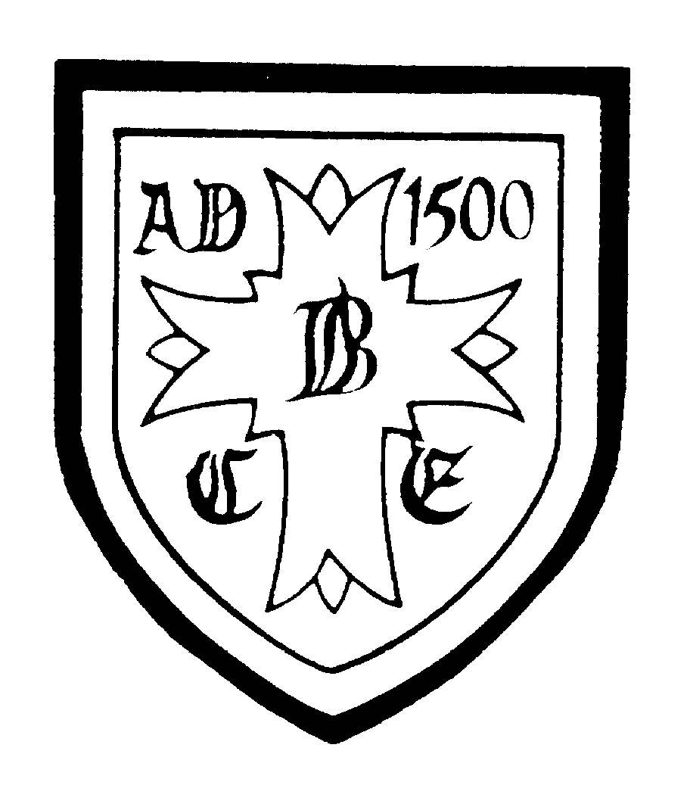
Church Lane, Berkswell, Coventry, CV7 7BJ
01676 532141
office@berkswell.solihull.sch.uk

Key Stage 2 Teacher 0.6 (MPS)
For September 2021 NOR 237 (including Nursery)

Berkswell CE Primary School is an ‘outstanding’, oversubscribed, one form entry school with a strong Christian ethos and a great sense of community.

The Governors are looking to appoint an experienced, dynamic and enthusiastic KS2 teacher who:

- will support and promote the Christian ethos and values of the school
- loves teaching and values the talents of all learners
- is enthusiastic and motivates children to expect the very best of themselves
- has high expectations
- will play an active part in our very successful team

We offer:

- a school where every individual child is of the utmost importance
- children who love school and are fully engaged in their learning
- an excellent team of supportive staff, governors and parents
- a commitment to continued professional development
- an enriching learning environment in a beautiful rural setting

COVID secure visits after school are very much encouraged; please telephone the school office to make an appointment.

Closing date: Noon, Tuesday 20th April
Interviews: Tuesday 27th April

The school is committed to safeguarding and promoting the welfare of children and young people and expects all its staff and volunteers to share this commitment. A DBS clearance and barred list checks is required for all successful applicants and appointments will be made subject to references.

