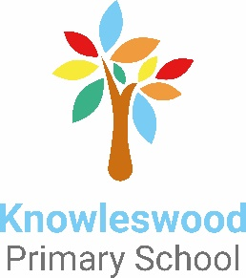
The Cavendish and Knowleswood Federation
Staff Information Pack

Welcome
Thank you for your interest in the Cavendish and Knowleswood Federation. We are immensely proud of our Federation and we want all those who become part of our community to feel valued, happy and respected, and to recognise their role in supporting our children to have the very best experiences. The Federation values team work and strives to develop a culture of excellence amongst staff through structured development opportunities, high expectations, support, and the celebration of success.
Our staff teams work together within the two schools and across the Federation in order to make the most of skills and areas of expertise. Continued professional development is offered and encouraged, and there is an annual plan of statutory training in place.

About the Federation
The Cavendish and Knowleswood Federation was formed in June 2019 by the joining of the two schools’ Governing Bodies. The Governing Body is proactive and its members strive to work alongside, support and challenge leaders. We welcome their diverse skills and vision in continuing to drive the Federation forward.
The Federation is led by our Executive Headteacher, Noreen Dunn. Noreen has been a Headteacher in both Bradford and Kirklees authorities and was Headteacher at Cavendish Primary School for 6 years before assuming the Executive Headteacher position. Alongside Noreen are; Jon Nixon, Head of School at Cavendish and Clare Cosgrove, Head of School at Knowleswood.

Our Children
We are incredibly proud of our children, they are at the heart of everything we do. The children enjoy engaging with their learning and feel safe and happy at school. Pupil voice is highly valued and both schools have proactive school councils. Children are supported with their mental health and well-being alongside making progress across the curriculum and preparing for successful futures. We provide varied and exciting curriculum experiences, which enable all children to take part and have special times to remember as well as develop knowledge and skills.

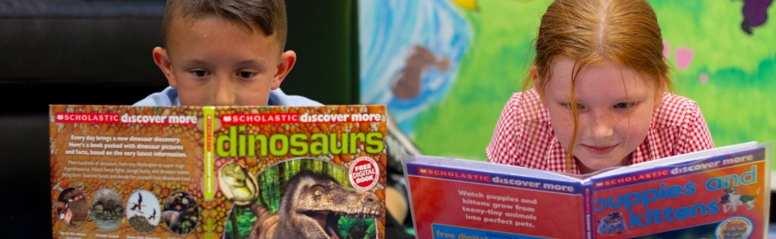

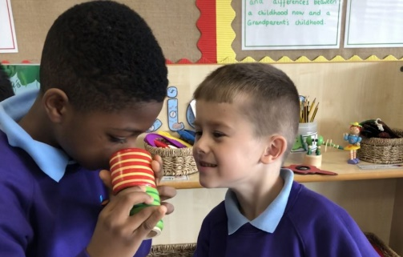
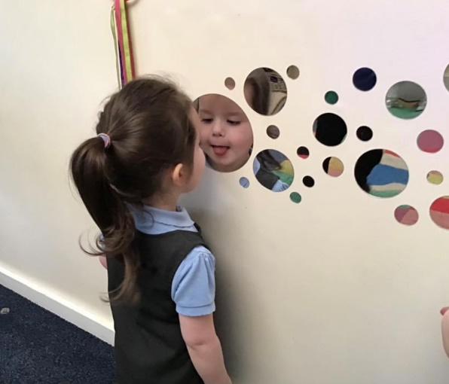
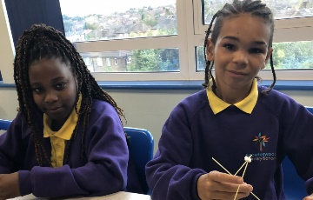

Our Ethos
The ethos of the Federation revolves around a safe, inclusive, engaging, meaningful school life with no limits on learning and high expectations for all!

Cavendish Primary School
Cavendish is a two-form entry community primary school situated in Eccleshill, Bradford, with fourteen classes catering for children aged 3 – 11 years and a 40/40 FTE place nursery. A higher than average proportion of pupils are eligible for pupil premium funding.

Knowleswood Primary School
Knowleswood is also a two-form entry community primary school situated in Holme Wood, Bradford, with fourteen classes catering for children aged 3 – 11 years and a 37/37 FTE place nursery. A much higher than average proportion of pupils are eligible for pupil premium funding.

School Grounds
Both schools are lucky to have extensive grounds which we take great pride in and use to enrich the curriculum. Each school has a vegetable garden and pond as well as a range of areas for sports, activities and quiet time. Cavendish boasts an enclosed orchard whilst Knowleswood is fortunate to have an outdoor classroom.

Our Communities
Parents and carers are positive about both schools and parent consultations, school performances, sports days and class assemblies are well attended. Our families are open to new initiatives or ideas and always offer to help where they can. The local and wider communities are supportive and both schools have strong links with outside agencies. We welcome visitors to school to provide a range of sporting activities, performances, talks and support with events throughout the year.

Further Information
If you would like any more information about the Federation or either school please use our website. Phone numbers can also be found on there if you would like to talk to anybody.

