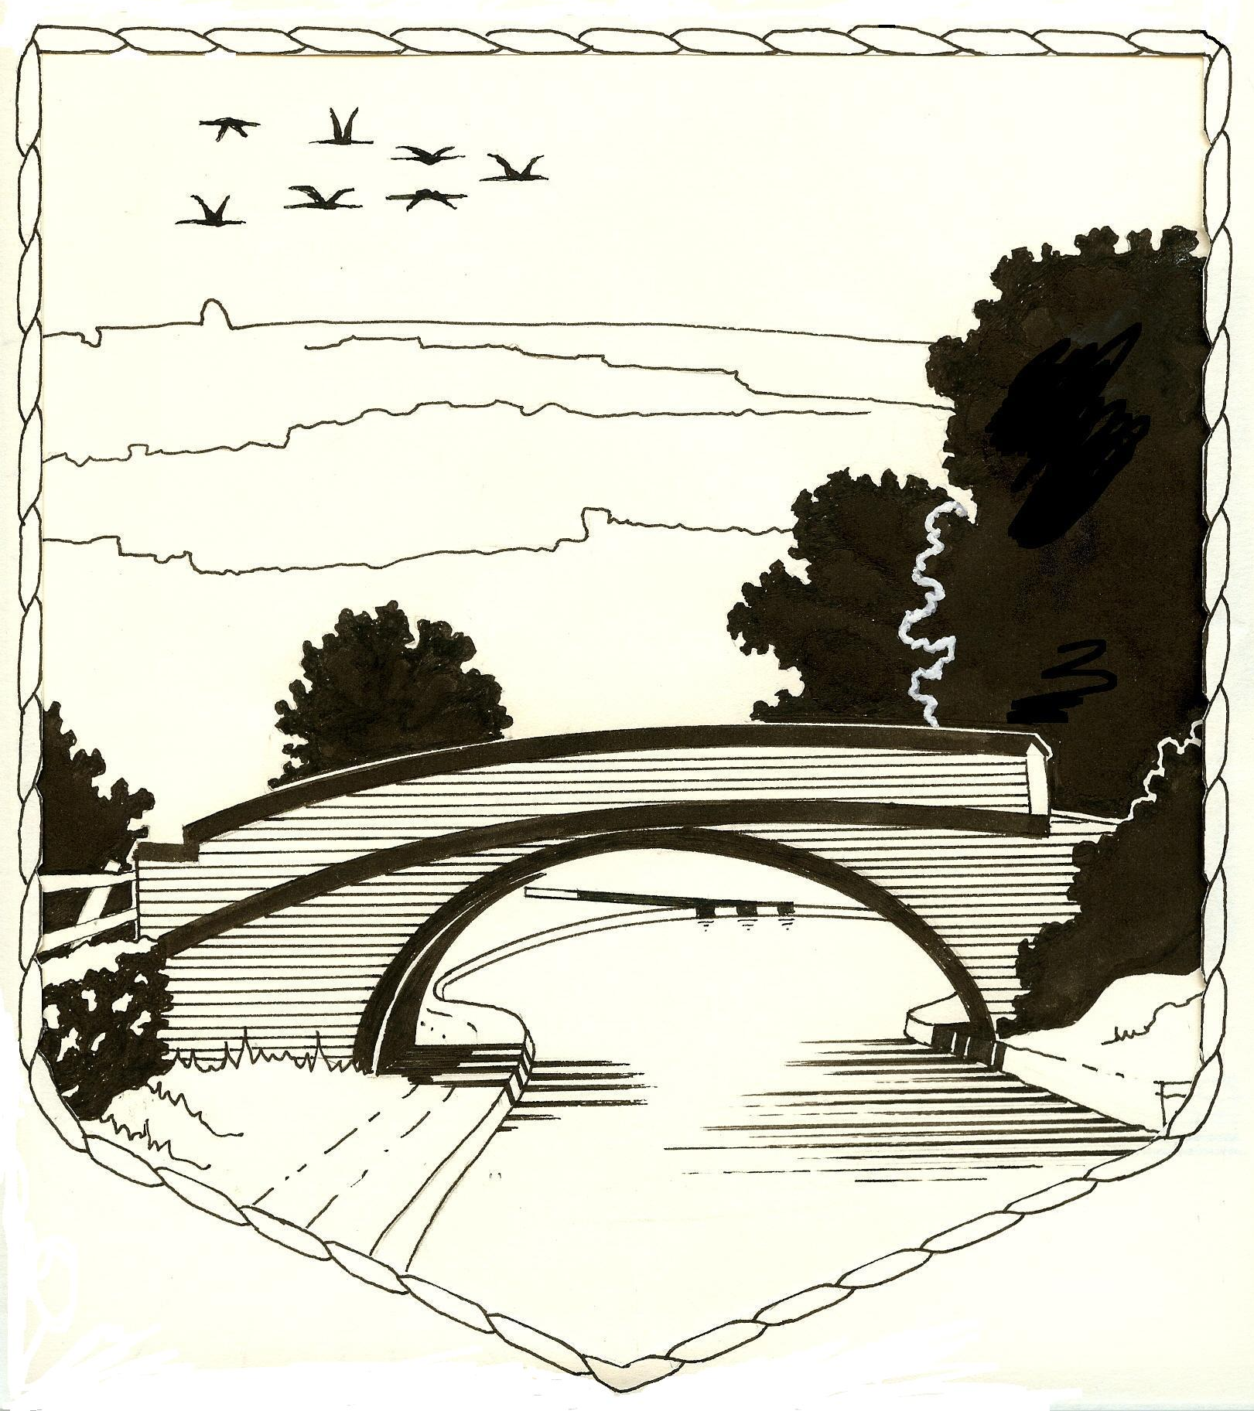
S† LAWRENCE CHURCH OF ENGLAND
VOLUNTARY AIDED PRIMARY SCHOOL

Dog Lane, Napton, Southam, Warwickshire CV47 8LU
Tel: 01926 812447
e-mail: office@stlawrenceprimaryschool.co.uk
www.stlawrenceprimaryschool.co.uk

Head teacher: Mrs Beth Hanna

Teacher

The governors of St Lawrence CE Primary School are seeking to appoint a teacher to join our happy growing school.

A two academic term (Spring and Summer) fixed term contract post, with a view to be made into a permanent position, has become available in this popular village school.

The post will commence January 2024 and we invite applications from M3 to M6.

We want to work with someone who will demonstrate enthusiasm, energy and a passion for excellence in core subjects. They should also clearly state their own curricular strengths. Do you have a passion for RE or an interest in art and design that you are keen to share with our children?

St Lawrence is a “happy and nurturing” church school, so the successful candidate needs to show that they will support the strong Christian ethos. A commitment to professional development within this church school is also a given.

Details of our friendly school can be found on our website at the address above. St Lawrence was graded ‘Good’ at the last Ofsted inspection (January 2020) and received a “Judgement 1” at the last SIAMS inspection (February 2024), demonstrating that the school lives up to its foundation as a church school.

For an application form please contact Anna in the school office on 01926 812447 or email: aperry@stlawrenceprimaryschool.co.uk

Applications should be directed to the school office and the closing date is 4th December 2024

Interviews will be held week commencing 9th December 2024

St Lawrence CE Primary School is committed to safeguarding children, and all appointments are subject to enhanced DBS checks in accordance with the code of practice.

‘A happy, church school that nurtures the unique talents of individuals and brings them together so that ‘they will soar on wings like eagles’

(Isaiah 40:31)

