

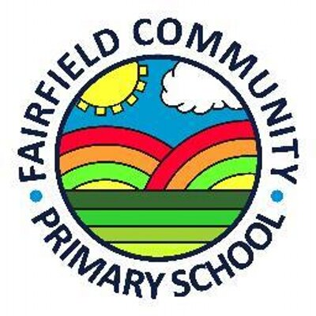

Full time KS2 Teacher - MAIN PAY SCALE
(depending on experience)
One year maternity cover

This post would be ideal for NQTs and/or more experienced teachers.

The role will include supporting/coordinating a curriculum area across all key stages of the school.

REQUIRED FROM THE START FROM 23rd AUGUST 2021

Fairfield Governors are looking forward to appointing a teacher who is a self-motivated, enthusiastic and an energetic classroom practitioner to work in our exciting and supportive school.

Rated good by Ofsted, Fairfield Community Primary School is a warm and friendly school with a highly motivated group of staff and wonderful pupils. If you would like to be a valued member of the Fairfield team, we would be delighted to hear from you.
Fairfield is also part of the Symphony Learning Trust that has outstanding learning and teaching at the heart of all its activities.
The Trust is a high performing Multi-Academy Trust.

Application forms and supporting documents can be found on the school website at www.fairfieldcpschool.co.uk. Apply by sending the completed application form and supporting letter to the Head teacher, Mr Mark Tuckwell (email: mtuckwell@fairfd.leics.sch.uk).
Closing date for applications: Monday 12th April 2021
Virtual Interviews: Thursday 22nd April 2021 (via TEAMS)

The successful candidate will have to undergo a DBS check before commencing their post and references, including the most recent employer, will be taken.
Fairfield is committed to high standards of safeguarding.

Cheshire Drive
South Wigston
Leicester
LE18 4WA
0116 2782424
office@fairfd.leics.sch.uk
FAIRFIELD COMMUNITY
PRIMARY SCHOOL

Head Teacher – Mr M Tuckwell
Assistant Head - Mrs C Harrison and Mr T Keene

