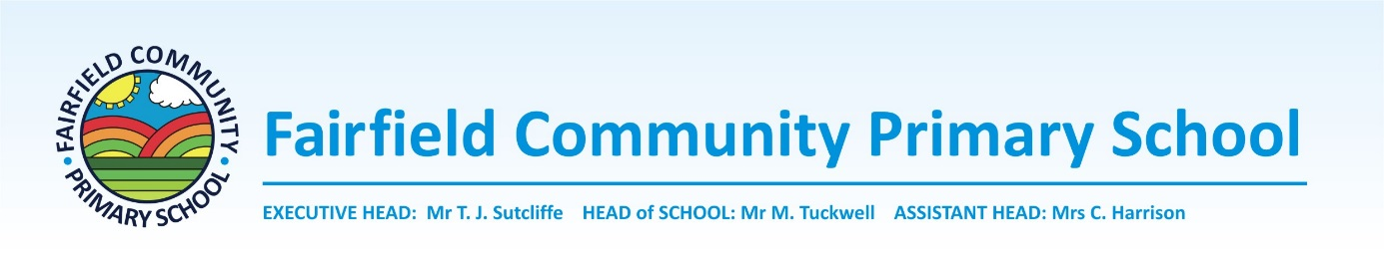

Job Description
CLASS TEACHER – Main Scale
The job description will be performed in accordance with the provisions of the school teacher’s Pay and conditions document and within the range of teacher’s duties set out in the document.

Job Purpose
To whom the postholder reports
Line Management
Duties and responsibilities specific to the post
- Deliver the best possible education to the children.
- Ensure high levels of safeguarding for all children.
- Provide professional leadership and management for their class in order to secure effective use of resources and teaching assistants.
- Be an active member of the teacher team, sharing ideas and resources.

- Together with the Headteacher and senior management team, the post holder is responsible for the development of pupils in the class and effective communication with all ancillary staff and adult helpers within the class and year group.
- To develop and implement policies and practices of the school.
- To plan effective medium and sort term planning for the class / year group.
- To support the school ethos.
- To contribute to the schools core development plan.
- To keep abreast of relevant CPD and national, local and school initiatives to maintain good subject knowledge.
- To ensure that displays are relevant and aesthetic in the school and the classroom area.
- To liaise with subject leaders in promoting subjects and resources within the classroom.
- To teach accordingly to the educational needs of the children.
- To ensure records are kept up to date.
- To ensure effective liaison with parents and governors.
- To assess termly in line with the schools assessment procedures.
- To deliver good/outstanding lessons where children build up their long term memory so every child can reach their full potential.
- To take extracurricular activities where appropriate
- To liaise with colleagues where appropriate to plan, moderate etc and build effective working relationships.
- To build good behaviour in line with our behaviour policy and our Routes To Resilience Curriculum.

- Headteacher, Senior Management Team and Phase leader.
- The year group teaching team.
- The post holder is also expected to interact on a professional level with all colleagues in order to promote a mutual understanding of the school curriculum with the aim of improving teaching and learning across Glen Hills.

General duties and responsibilities
To work within the framework of national legislation and in accordance with the provisions of the School’s Pay Policy, Staffing Policies and procedures, Professional Standards, conditions of service and Teachers Pay and Conditions.
In addition, the post is subject to compliance with:
- School policies and guidelines on the curriculum and school organisation.
- Common core of skills and knowledge for the children’s workforce.
All teachers have a responsibility to keep up to date with Safeguarding duties and responsibilities and to the welfare of all children they come into contact with.

The duties and responsibilities detailed within this job description are supplemented by those accountabilities, roles and responsibilities common to all classroom teachers.

