March 2025

Dear Applicant

Thank you for your interest in the class teacher vacancy we have at Garden Suburb Junior

School for September 2025. Currently, we have permanent and maternity/ fixed term contracts available.

Interested candidates are encouraged to visit the school prior to application

Please email the school office to make an appointment Email: [recruitment@gsjs.barnet.sch.uk](mailto:recruitment@gsjs.barnet.sch.uk)

Application forms should be completed online at: <https://teaching-vacancies.service.gov.uk/>

Interested candidates are encouraged to submit their applications as soon as possible. Lesson observations and interviews of successful candidates will be held on receipt of application forms.

**Please note appointments may be made before the closing date.**

**Closing Date:** Friday 18h April 2025 at 9:00am

The school had a very successful Ofsted inspection in May 2022. The report can be found on [www.**ofsted**.gov.uk/**reports**](http://www.ofsted.gov.uk/reports).

Further details about the school can also be found on our website [www.gardensuburbschools.co.uk](http://www.gardensuburbschools.co.uk)

Yours sincerely

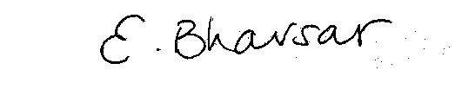

Mrs Eileen Bhavsar

Head Teacher