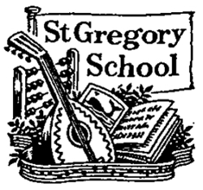
St Gregory CEVC Primary School – School Vision
“ Life In All Its Fullness “

Jesus said, “ I have come that you may have life in all its fullness. “ ( John 10:10 ).
At St Gregory CEVC Primary School it is through the love of Jesus Christ and the example that he gave us in the way that he lived his life that we strive to embrace life in all its fullness.
Life in all its fullness… for our children
At St Gregory, we nurture the development and wellbeing of the whole child. Academic rigour is married with opportunities in sport, art and music and our strong pastoral support and Christian ethos allows the children to feel valued and safe, so that they are confident to take risks and learn from their mistakes. We give our children as many chances as possible to try as many new things as possible and they gain confidence and resilience as a result. All this is underpinned by the teaching they receive that every person is made in the image of God and therefore deserving of kindness and respect.
Life in all its fullness… for our community
We are outwards looking and always asking ourselves what we can do to support those in our local community and beyond. From the staff and families in our wider school community to the vulnerable to care homes and our local churches and their congregations, we do all we can to listen, help and support and show the children what a difference they can make in the world through one act of kindness at a time.
Life in all its fullness… for all
Everyone deserves to experience life in all its fullness, regardless of gender, race, belief or orientation: we are all God’s children. We are all part of God’s beautiful world too and our children know it must be treated with care and respect. We are an inclusive, compassionate and caring school, where everyone is treated with dignity and respect and we recognise and celebrate each other’s values and strengths. The Bible shows us that God’s kingdom is a place for life in all its fullness for all creation.

